 St. Cuthbert’s RC Primary School
Newsletter 3 – Friday 30th August 2024
St Cuthbert’s CARES We are: Creative Active Respectful Equal Supported

Good afternoon, It has been another really busy week, with lots going on in school. There is, as always, lots of hopefully interesting and helpful information in this week’s newsletter. Thanks for reading it. As always, please get in touch with any questions you have?

Upcoming Events at St Cuthbert’s and Dates for your Diary

Updated Key Dates for This Half Term (Until October Holidays)

- Monday 2nd September – P7 Initial School Camp Information Meeting – see letter sent today.
- Friday 6th September – Termly Overviews to be issued
- Friday 27th September – P7 Class Assembly, 9.30am School Hall
- Friday 4th October – P6 Mass, 9.30am St Cuthbert’s Church
- Tuesday 8th October – Parent Consultations 1: 5-7.30pm
- Thursday 10th October – Parent Consultations 2: 4-6.30pm
- Friday 11th October – P5 Class Assembly, 9.30am School Hall

Please note that Fr Francis is travelling for the next 3 weeks and is now unfortunately unable to say scheduled Mass on 6th September. Therefore P6 Mass has been moved to 4th October and P4’s scheduled Mass will now take place after Christmas.

P1 Evening News Photo – Monday 2nd September

The Edinburgh Evening News photograph all P1 state school classes at the start of the academic year and publish these in a souvenir edition at the start of October. A letter was sent to P1 parents/carers on Tuesday of this week with more details, including how to order your copy. Any parent/carer who does not wish their child to be included in this photo should contact the school office. Please ensure that full school uniform is worn on this day. Thank you for your cooperation.

Parent Council Weekly Update

Our first meeting for this school year took place today. Minutes will be e-mailed to all parents and carers next week.

Should you wish to contact the Parent Council at any time, they can be contacted via e-mail at ptastcuthberts@gmail.com

News & Information

Meet the Teacher Afternoon

Thanks very much to all of those who attended Monday’s event. There was a great turnout and we hope you found the opportunity to meet your childrens’ new teachers a helpful and productive one.

Flu Vaccination Consent Forms

Thank you for the prompt return of so many flu consent forms. A member of the NHS Vaccination Team will be coming in to school next Tuesday, 3rd September to collate all the returned forms. Please return signed consent forms no later than Monday 2nd September. Late returns may result in your child being unable to be vaccinated.

Grass Cutting Update

We have made some progress this week with increasing the frequency of grass cutting for our grounds. City of Edinburgh Council have promised that this service will increase to a cut every 4 weeks going forward. The football pitch will also be re-lined at this time too.

Active School Clubs Update/P5 Football/ Rounders Club

Fiona Damen, our Active Schools Coordinator is working hard to organise this term’s clubs and we will share details about clubs and starting dates as soon as we have them. She is hoping to have clubs up and running week commencing 23rd September. More details re booking to follow soon.

P5 football started last week and P6 will also train today after school.

Finally, Miss Eckersley’s rounders club started successfully on Tuesday.

St Cuthbert’s Child Protection Coordinator & Policy

Please note that Mr Brack will continue to be our Child Protection Coordinator in St. Cuthbert’s school, back up Coordinator this year will be Mrs Munro. Please see attached Child Protection Policy and please ask if you have any questions.

Parent Footballs Donation

Thanks to our parent/carer Oktawian who kindly donated some footballs to us this week.

Goals for Field and Playground Resource for P1/2 Area

Work continues on the P1/2 Multi Play area and we are working with our staff and City of Edinburgh Council’s Learning Estate’s team to ensure that the construction area is kept safe and secure for pupil’s whilst work continues. We are still liaising with the same team to obtain an update on why the goals installation has been delayed.

Forrester/St Augustine’s Community Hub Football Clubs

See Appendix 1 at the end of this Newsletter

Pupil Voice at St Cuthbert’s

Sustainability group members have been selected already and we are working on electing our new House Captains and creating our Pupil Rights and Equalities and HWB groups. More information to follow in the coming weeks.

Learning at St Cuthbert’s

St Cuthbert’s HWB Pupils Meeting with First Minister

4 pupils from our school were part of an event to celebrate a clean sweep of Gold Sports Schools in St. Augustine’s Cluster schools as well as 20 years of Active Schools. The pupils represented the school in exemplary fashion as always. Thanks to Mrs Munro for accompanying them and to Miss Tulloch for her ongoing coordination of Health and Wellbeing in our school!

School Improvement Plan Summary Shared

Please note that this has now been shared with parents via the parental information area of our website. It was also shared with the Parent Council today. Please ask if you have any questions re its content.

Twitter Days Confirmed

From next week teachers will post a weekly sample of learning from their classes on the following days:

P1 - Thursday P2 – Thursday
P3 – Friday P4 – Wednesday
P5 - Thursday P6 – Wednesday
P7 - Wednesday

Tweets started this week and we hope you find them helpful. Please feel very welcome to give us any feedback re the contents of our tweets.

Violin Tuition P4-7 Update

Mrs Egan began working with P4 and P5 pupils as well as P6 and P7 pupils this week. P4 will work with violins and P5 pupils will learn violin. Mrs Egan will keep us updated with progress.

Art Club P4-7

Letters were sent out this week and art club will begin on 4th September. Thanks to Mrs Gill (formerly Miss McDade for giving her time to this).

Mobile Library P1-3 and School Library

The mobile library visited us on Thursday and pupils from the above classes all had the opportunity of borrowing a new book, which will be changed on a three weekly basis. These books are kept in class on request of the library staff.

All classes will have the opportunity to borrow a book from the school library on a weekly basis. These books can be taken home.

Upcoming Class Trips

P4 will visit the Money Museum on the 11th of September and P7 are scheduled to visit the Risk Factory on 21st November.

Homework Update

Staff have also been discussing homework with a view to producing a new homework policy for school year 2024-25. We will also consult with our parent council to get a representative parent voice on this subject.

The plan is for homework will begin for P1-2 week starting 2nd September and will commence for P3-7, week commencing 16th September 2024.

Catholic Education and Parish Update

Purchase of Sacramental Workbooks

The school received £800 from the Archdiocese in January of this year, which has enabled us to buy a class set of Bibles and access to Fischy Music Programme. Our latest purchase from these funds is to buy workbooks for Reconciliation/Confessions, First Holy Communion and Confirmation. These cost us £137 in total.

Class Masses and Sacramental Registration Meeting

Please see a list of class Masses to the October break above. Please note the change of dates for P6 and P4 Mass due to Fr being away during September. We are also awaiting a date and time from the Parish for a meeting for those parents/carers wishing to register their children for the sacraments of Reconciliation, First Holy Communion and Confirmation. We’ll share this info when we have it.

Mary Garden Update

We are grateful to our parent volunteers who are working hard to create a shrine house for our newly redecorated statue of Our Lady. Once this is created we will liaise with Fr Francis to confirm a date for the official blessing and reopening of the Garden.

CHILDREN’S LITURGY AT ST CUTHBERT’S CHURCH

This will restart this Sunday 25th August at 9.30 Mass and it will continue every 2nd weeks.
All children attending primary school are invited to come along. Parents, please encourage your children to attend as they can participate in the mass through prayers, songs and readings which are suitable for their age.
**************************************

Nursery Update

Meet the Nursery Team

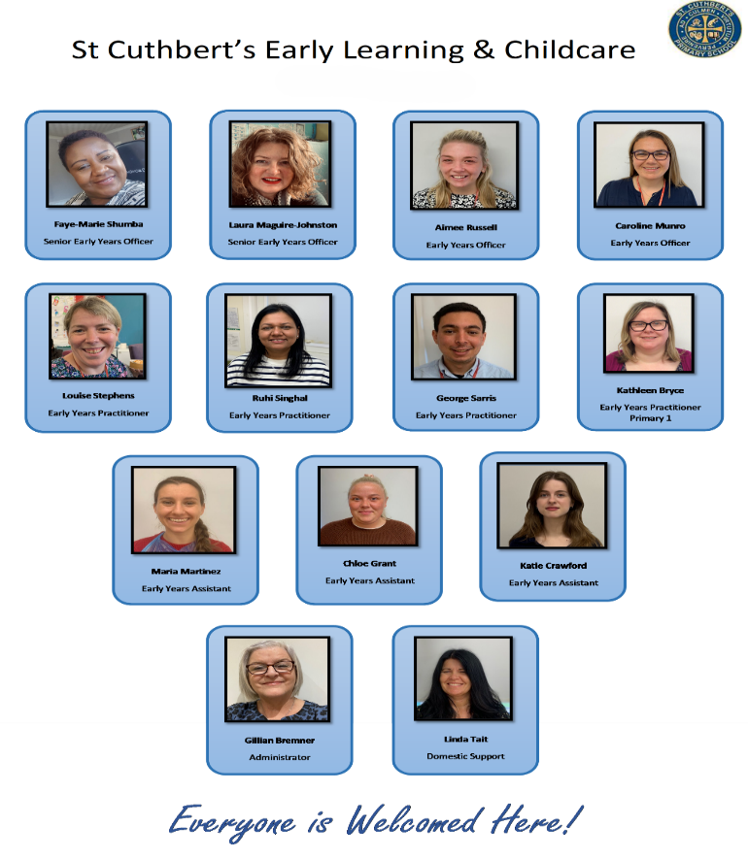

Headlice- a pesky problem
Head lice and nits can be a regular occurrence in young children. They don’t have anything to do with dirty hair and are usually picked up from head-to-head contact. Head lice can sometimes make your childs head itchy and they may describe the feeling of something moving in their hair. You may notice them scratching or rubbing their head more.

Head-to-head contact - very common in early years!
The only way to be sure someone has head lice is by finding live lice or eggs. You can do this by combing their hair with a special fine-toothed comb (detection comb). You can buy these online or at pharmacies.

How to get rid of head lice
You can treat head lice without seeing a GP. Treat head lice as soon as you spot them. A local pharmacist will be able to recommend treatments – these are also available at supermarkets.
You should check everyone in the house and treat them on the same day if they have head lice.
If your child has long hair, tying it back makes it harder for lice to attach to the bottom of hair strands, where they prefer to live.

Remember, there’s no need to keep your child off nursery if they have head lice but treating them before attending may prevent the spread.

See NHS Guidance https://www.nhs.uk/conditions/head-lice-and-nits/

Appendix 1

Dear Parent,

Please see below information regarding our upcoming block of term-time football classes for boys and girls.

All sessions take place at our Forrester / St Augustine's Community Sports Hub and range from age 3 to S1.

Friday Football
Friday Football is a fun, developmental football programme for boys and girls aged P1 - S1. The sessions focus on developing confidence on the ball through 3 main themes: 'Protect The Ball', 'Beat The Player' & 'Attack The Space'. These themes are delivered primarily through skill practices, game-related practices and small-sided matches. These sessions are outdoor.

P1-P4 : Fridays 2.00-2.55pm https://getedinburghactive.spydus.co.uk/cgi-bin/spydus.exe/ENQ/WPAC/EVSESENQ?SETLVL=&RNI=123854

P5-S1 : Fridays 3.00-3.55pm https://getedinburghactive.spydus.co.uk/cgi-bin/spydus.exe/ENQ/WPAC/EVSESENQ?SETLVL=&RNI=123871

Mini Kickers
Mini Kickers is our fun, developmental introductory programme, which focuses on building motor skills and physical literacy through the enjoyment of football. These sessions are indoor.

Age 3-4 : Saturdays 9.00-9.45am https://getedinburghactive.spydus.co.uk/cgi-bin/spydus.exe/ENQ/WPAC/EVSESENQ?SETLVL=&RNI=123818

Age 4-5 : Saturdays 10.00-10.45am https://getedinburghactive.spydus.co.uk/cgi-bin/spydus.exe/ENQ/WPAC/EVSESENQ?SETLVL=&RNI=123836

If you would be interested in finding out more information or booking a place, please visit the links above.

Alternatively, if you have any questions, please don't hesitate to get in touch.

We hope to see you soon! 🙂

Thanks,

Jack

Jack Beesley | Football Development Officer | Sports and Outdoor Learning Unit | Schools and Community Services | The City of Edinburgh Council | Forrester / St Augustine’s Community Sports Hub, Broomhouse Road, Edinburgh EH12 9AE |

Finally

We wish you and your families a restful and relaxing weekend and look forward to seeing you all on Monday.

Mr P Brack, Head Teacher and all at St Cuthbert’s School

