

St Cuthbert’s R.C. Primary School

Numeracy and Maths Policy
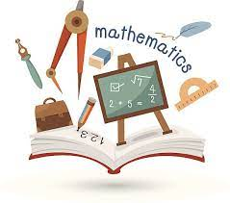

August 2023
Review August 2024

To face the challenges of the 21st century, each young person needs to have confidence in using mathematical skills, and Scotland needs both specialist mathematicians and a highly numerate population.
Building the Curriculum 1
Maths and Numeracy – St Cuthbert’s Vision
Learners at St. Cuthbert’s Primary School study Maths and Numeracy to develop skills for learning, life and work. They should value Maths and Numeracy and have an awareness of its importance and relevance to their daily lives. This will enable them to become functioning adults who are able to think mathematically enabling them to reason and problem-solve in a variety of contexts.
At St. Cuthbert’s Primary School, our staff teach plan and teach engaging Maths and Numeracy lessons that involve a variety of Learning and Teaching approaches, which direct the children’s learning. Staff provide progressive, broad, coherent and meaningful learning experiences that are relevant, challenging and enjoyable. Expectations of all learners are high and we aim for progress to be made by all children. Confidence is built in our learners by applying their Maths and Numeracy learning in real life and different contexts. Staff regularly ask pupils to explain, justify or prove their thinking, talking through the strategies they have used to solve particular problems.
St. Cuthbert’s Primary School aims to ensure that all Curriculum for Excellence Numeracy and Mathematics Experiences and Outcomes, relevant to the age and stage of our learners, are fully addressed.

Our Aims
We aim to create a rich and stimulating environment providing experiences to engage learners of all ages, interests and abilities. Each classroom has a numeracy and maths working wall which is kept updated. Wherever possible we will use cross- curricular links and contextual opportunities. Our school values (CARES) and the UN Convention for the Rights of the Child are intrinsic in all that we plan and teach.
Maths and Numeracy are tools for everyday life, allowing us to make sense of the world around us and become:
- Successful learners
- Confident individuals
- Responsible citizens
- Effective contributors

Links to Curriculum for Excellence
Maths and Numeracy experiences will provide opportunities to develop the seven principles of CfE:
- Challenges and enjoyment
- Breadth
- Progression
- Depth
- Personalisation and choice
- Coherence
- Relevance

Learning and Teaching
The Maths and Numeracy outcomes are designed to stimulate children’s interest and promote creativity and innovation. We aim to deliver carefully planned, well-paced learning and teaching activities using a mix of approaches including:
- Planned active learning with opportunities to observe, explore, investigate, experiment and play
- Use the CPA (concrete, pictorial, abstract) approach at every stage
- Outdoor learning will be used as an opportunity to connect Numeracy and Maths with their environment. E.g. angles and tessellation
- Development of problem-solving strategies
- Development of mathematical thinking skills
- Development of mental agility skills
- Use of relevant contexts, indoors and outdoors, familiar to young people’s experiences
- Appropriate, effective use of technology
- Building on the principles of Assessment is for Learning
- Collaborative and independent learning
- Where appropriate children may select the level of differentiated tasks to allow for personalisation and choice
- Making links across the curriculum through thematic work
- Sharing their understanding and explanation of thinking through discussion
- Each year the school will take part in Maths week Scotland which will raise the profile of Numeracy and Maths as well as encouraging cross curricular links

Structure of Lessons
We plan for and structure our lessons on the 4-phase model.
- Mental Agility/Recap on previous knowledge/ Introductory hook/relevance of learning.
- Share Learning Intention and Success Criteria
- Teaching/Learning Experience/Activity or activities
- Plenary/Assessment

Midlothian’s Numeracy and Mathematics GLOW group has produced the table below with advice on classroom expectations. These may be useful to you.
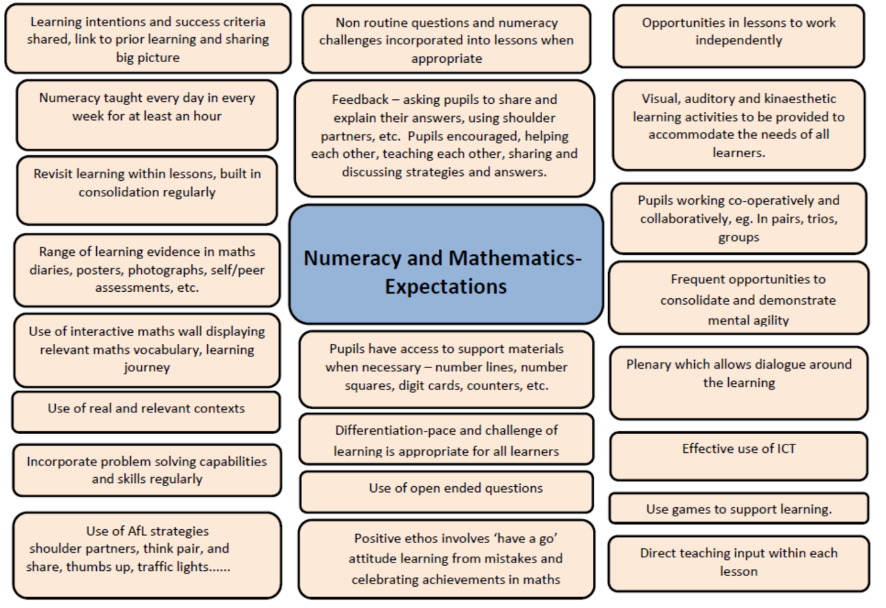

Numeracy & Maths Learning Walls
All classes should have an interactive learning wall with pupil produced content re Maths vocabulary, what they have learnt and how they learnt it.

Pupil Voice/Ownership of Learning
Pupil should have regular opportunities to share strategies, ask questions and identify next steps in their learning.

Planning Maths and Numeracy
- Year Plans should show some elements of Maths being taught in a context. Some will be taught as discrete subjects
- Staff will use St. Cuthbert’s planners (adapted from CEC progression planners) to plan Maths and Numeracy. They include SEAL and the benchmarks
- Staff should record which areas are to be covered by highlighting and then dating when experienced
- The mental agility framework must be used
- SEAL planners are used in Early and First level in addition to the St. Cuthbert’s planners
- Topics will be revisited regularly
- Numeracy/Maths will be taught every week, and timetables should show Maths and Numeracy sessions at least 4 times a week with each session being of 1 hours duration.

Assessment
Teachers will use their professional judgement to assess children, in both formative and summative ways
- NSA assessments will be carried out at Primary 1, 4 and 7 (see Collegiate and Formal Assessment Calendars)
- White Rose Maths end of block assessments
- MUNP assessments will be used, where appropriate (see Collegiate and Formal Assessment Calendars)
- SEAL (Stages of Early Arithmetical Learning) assessments if necessary
- Curriculum for Excellence Levels will be assessed using the Benchmarks as set out by Education Scotland. These will show when children have achieved a level
Tracking and Monitoring
- Termly meetings with SMT to discuss and track pupil progress, ensuring pace and challenge
- Tracking document to be completed termly before the meeting
- Experience and outcomes tracker in the forward plan to be completed termly
- Maths and Numeracy will be moderated across the school yearly or termly as required by Improvement Plan.
Meeting Learners Needs
A variety of strategies are used to ensure that all children’s needs are met and they leave St. Cuthbert’s Primary as confident mathematicians. SEAL (Stages of Early Arithmetical Learning) strategies and the CPA (concrete, pictorial, abstract) approach are used throughout the school to consolidate basic number knowledge. Work is differentiated appropriately. There are opportunities for children to be challenged in a variety of ways within their Numeracy and Maths learning.

Resources
At St. Cuthbert Primary School we have a wide range of Numeracy and Maths resources. Every classroom is equipped with a numeracy box, appropriate to their level. This box remains in the classroom and has a list of resources inside. If any of these resources need replacing, please speak to the Numeracy Co-ordinator. The numeracy box should be accessible to the children, encouraging independence. It includes resources such as counters, dice, digit cards, shapes, place value counters etc. There is also a wide range of equipment stored in the Staffroom/Support for Learning room.
Staff must use the St. Cuthbert’s planners and the mental agility framework, but can choose to teach their lessons from a range of resources such as:
- SEAL
- Teejay
- White Rose Maths
- Heinemann Active Maths, workbooks, photocopy templates and games
- Class Maths and SEAL boxes
- Sumdog
- iPads/Promethean Boards
- Outdoor Learning

Marking, Feedback and Presentation
- A number of Assessment is for Learning strategies should be used, including peer and self-marking. It should be clear to parents/carers where self or peer assessment has been employed. All learning in P3-7 should be traffic lighted, P1-2 to introduce this gradually.
- Children should have regular feedback on their progress, verbal or written and where verbal this should be indicated.
- Pupils in P4-7 will learn the correct layout to use when presenting work in a Maths jotter. This will be consistent across the school.

Parental Involvement
- Termly Overviews to outline and explain Numeracy and Maths learning
- Homework
- Maths curriculum morning once a year
- Staff will provide meaningful Maths and Numeracy key strengths and next steps for each child at Parent Consultations and when reporting

Transfer of Information
Teachers will pass on the following information to the next teacher:
- St. Cuthbert’s numeracy and maths planners and mental agility framework
- Experiences and outcomes tracking sheet
- White Rose Maths yearly overview
- MUMP assessments with score and areas requiring consolidation
- Maths groupings with levels
- SEAL group sheets showing where to start

