St Cuthbert’s Primary School Homework Policy

2024-25



St Cuthbert’s CARES: We are Creative Active Respected Equal and Supported

Homework provides our learners with the regular opportunity to consolidate in class learning and develop key study skills.

This policy was developed in response to a consultation with parents/carers, learners and staff. It will be reviewed regularly to ensure that it continues to meet the needs of our school.

Aims
Through this policy we aim to provide a general structure and broad understanding about of homework. The purpose of homework is to:
● share learning with parents / carers and provide opportunities for them to be involved in their children’s learning
● consolidate and develop core skills in literacy and numeracy
● encourage in every child the responsibility, confidence and self discipline needed to learn independently
● allow learners to develop a positive attitude towards their learning

How and When homework will be issued and Returned
Every class will issue homework on a Friday asking for it to be completed and when required handed in for the following Thursday. This timescale is informed by parent requests for time over the weekend to complete homework with their children. In terms of whether homework should be provided electronically or in paper form, feedback from staff, learners and teachers is that paper copies of homework (with links to electronic resources) is the preferred medium for our school context, allowing all pupils equal access to the task.

Content and types of homework
At all stages a variety of tasks will be provided by teachers to reinforce learning in literacy, numeracy and interdisciplinary learning. The nature and complexity of the task will depend on the age and stage of the child, but should actively engage children in their learning whenever possible.

Role of School, Pupils, Parents and Carers in relation to Homework Tasks

Please see diagram below
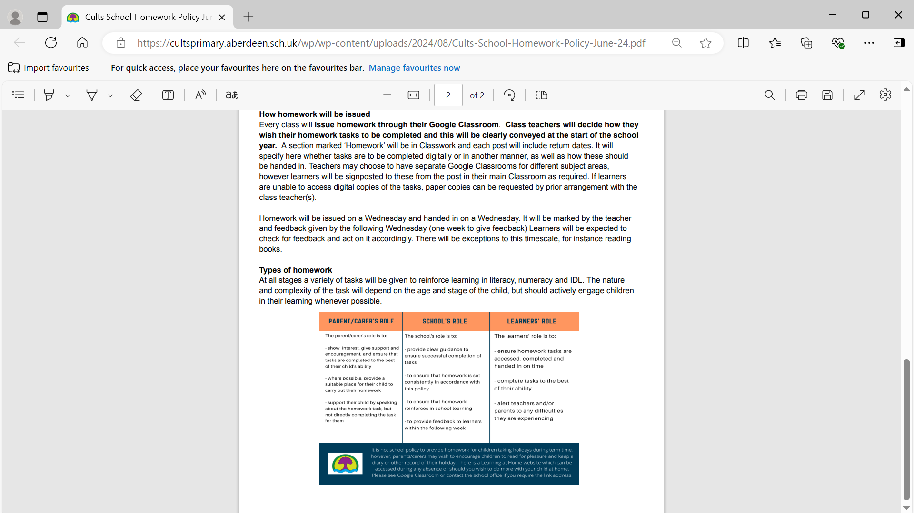

Please contact us if you have any questions about our homework policy. We will consult with you again later in the year to canvass your views on this subject.

St Cuthbert’s Primary School – August 2024

