 St. Cuthbert’s RC Primary School
Newsletter 5 – Friday 13th September 2024
St Cuthbert’s CARES We are: Creative Active Respectful Equal Supported

Good afternoon, we have reached the first milestone in the school the year; The September weekend, time seems to have flown this year. There is, as always, lots of hopefully interesting and helpful information in this week’s newsletter. Thanks for reading it. Please get in touch with any questions you have about the contents of the Newsletter.

Upcoming Events at St Cuthbert’s and Dates for your Diary

September Weekend Holiday

Please be aware that the school, like other Edinburgh schools will be closed on Monday 16th September for the autumn holiday. Staff and pupils return on Tuesday 17th September.

Updated Key Dates for This Half Term (Until October Holidays)

- Friday 27th September – P7 Class Assembly, 9.30am School Hall
- Friday 4th October – P6 Mass, 9.30am St Cuthbert’s Church
- Tuesday 8th October – Parent Consultations 1: 5-7.30pm
- Thursday 10th October – Parent Consultations 2: 4-6.30pm
- Friday 11th October – P5 Class Assembly, 9.30am School Hall

Please note that Fr Francis is travelling for the next few weeks and is now unfortunately unable to say scheduled Mass on 6th September. Therefore, P6 Mass has been moved to 4th October and P4’s scheduled Mass will now take place after Christmas.

Parent Council Weekly Update

Our next meeting is due to be held at 11am on Friday 27th September. All parents/carers are very welcome.

Should you wish to contact the Parent Council at any time, they can be contacted via e-mail at ptastcuthberts@gmail.com

News & Information

Active School Clubs Update

Fiona Damen, our Active Schools Coordinator has confirmed that online bookings for this term’s clubs will be ready to go live on Tuesday 17 Sept at 6pm. Look out for this information next week.

Parent Consultations Online Booking

On Tuesday of this week information about booking a slot for our forthcoming Parents Consultation evenings on 8th and 10th October was sent via email to all parents.
This option is now live and will continue to be so until Sunday 22nd September at 8pm. Parents who have not managed to secure a slot by then will be allocated an available slot during the week commencing 23rd September. This information will be communicated via a letter detailing the date and time allotted.
If you have any issues with trying to book a slot please contact the office, who will endeavour to help you.

Parking/Turning Request

It has been brought to our attention that some cars which may belong to parents and carers have been reversing into the area in front of our main gates to enable them to turn, unintentionally causing alarm to our pupils. It would be great if this could stop happening when there are children present. Thank you.

P7 Lagganlia Deposit Payment

There is now a facility on Parentpay to secure your child’s place for the P7 Lagganlia trip (3-7th March 2025) by paying the £95.00 deposit. A letter was sent home this week, via pupils, giving details of this trip and the costs involved.

Milk Ordering from 22nd October – 26th June 2025

All parents who have not already ordered milk for this coming year should have received a Parentpay option to purchase milk for their child from Tuesday 22nd October until 26th June 2025. The cost for this is £33.32; being 23p per day for a 189ml tetrapak, which the children consume just after their mid-morning break. This option will be the final one for this academic year and the facility to pay for this will close on Friday 18th October. If you wish to order for your child, please do so, using Parentpay before this date. This payment is non-refundable.

School Lunches: Ordering for after the October break:

Please ensure that if you wish your child to receive a school lunch for the week after our October break (22/23/24/25 October) then your child’s menu choice must be made no later than Wednesday 9th October. There will not be a facility to order for that week after that date.
Spooky Day Menu – Thursday 31st October
There will be a special Spooky Day menu offered on Thursday 31st October. This menu is now uploaded on to Parentpay and is available for you to order for your child. There will however only be 2 choices available. Eyeball Sub (beef meatballs in a sub roll) or the vegetarian option; Maggoty pie ( bean, cheese and potato pie). There will be NO baked potato option.
There will also be Trick or Treats offered to all children (spooky jellies with orange pumpkin cookies) or Scary Fruit with gingerbread ghosts.
If you wish your child to have this special menu please ensure that you order no later than Wednesday 23rd October. If you order your child’s meals weeks in advance, please check that your option has still been retained.

Flu Immunisations Next Week

These will take place in school on Friday 20th September for pupils whose parents/carers returned the forms. Thanks to all those who did.

Open Day – Edinburgh Primary Schools

All Edinburgh schools will take part in an Open Day on Wednesday 6th November. This is an opportunity for new parents, carers and children to come and visit our school and have a tour and chat with staff and experience what St Cuthbert’s Primary has to offer. It is especially aimed at parents and carers of pupils due to start P1 in August 2025.
If you or anyone that you know is interested in finding out more about St Cuthbert’s the times are as follows:

9.15am -10.15am
11.00am – 12noon
1.30pm – 2.45pm.

If however you can’t make this date please contact us to arrange an alternative date for a visit.

Goals for Field and Playground Resource for P1/2 Area

Our goals are now fully functional in our playground and the children are enjoying their use. Work is still ongoing on the multi-play area in our P1/2 playground.

P1 Health Checks

Thanks to those who returned the forms. We now have a date for this, which is the morning of Tuesday 1st October in the school hall.

Our School Football Teams and Edinburgh Football Trials

Our P6 team took part in a high scoring 7-7 draw at the weekend whilst our P5 team drew 2-2 with Bonaly Primary. Big thanks to Chris, Sean and Stevie for giving their time to this.

We also had two P7 pupils representing our school at trials for the all Edinburgh Primary Select at Meggetland on Wednesday.

Pupil Voice at St Cuthbert’s

Mrs Munro submitted the Hands Up Scotland – Transport Survey that all schools take part in each year and which our Pupil Rights and Equalities Group coordinated. They will meet with me next week to create a child friendly version of our School Improvement Plan.

The Sustainability Group made their first visit to our community garden at Hutchison today. They harvested a bumper crop of vegetables from seeds that they had planted earlier in the year. They have also been working hard with Miss Eckersley on their display board.

Our HWB Group will meet for the first time this year next Tuesday.

After last week’s successful launch, our second group of House Captains will lead this week’s Assembly.

Learning at St Cuthbert’s

Staff Training on the Circle Framework and Document

Our teaching staff took part in training provided by our Additional Support for Learning team on Thursday. This training was based around Education Scotland’s Circle Framework and document which aims to help staff make their classroom inclusive learning spaces designed to meet the needs of all learners. This training will impact positively on our practice going forward.

School Website Now Up to Date

Miss Eckersley and myself have been working on revitalising our school website. We now have the website up to date but will continue to add to it as and when there is new information to share. We will also continue to add Newsletters every Friday. Please feel very welcome to have a look at the changes re the link below:
https://st-cuthberts-primary.com/

School Library Update

Mrs Igoe and Mrs Ferry have been working really hard on redesigning our library space and updating pupil records on our system. All classes should be visiting the library on a weekly basis to borrow a book from week beginning 16th September. Some may be able to start a bit earlier too. Please contact us with any questions.

Class Trips This Week

P4 visited the Money Museum on the 11th of September and had an enjoyable time learning about the history and development of money. Look out for some exciting Roman themed outdoor learning from this class in the coming weeks. Our other classes also have plans for outdoor learning which we’ll share in the coming weeks.

P5 swimming continues on Thursdays.

Catholic Education and Parish Update

Purchase of Catholic Themed Library Books

The school received £800 from the Archdiocese earlier this year, which has enabled us to buy a class set of Bibles, pay for access to the Fischy Music Programme and workbooks for Reconciliation/Confessions, First Holy Communion and Confirmation. The remaining funds have been spent on Catholic themed books for our school library. We thank Sylwia our Church Rep for sourcing these.

Class Masses and Sacramental Registration Meeting

Please see a list of class Masses to the October break above. Please note the change of dates for P6 and P4 Mass due to Fr being away during September. We are also awaiting a date and time from the Parish for a meeting for those parents/carers wishing to register their children for the sacraments of Reconciliation, First Holy Communion and Confirmation. We’ll share this info when we have it.

Mary Garden Update

We are very grateful to our parent volunteers who worked hard to create a shrine house for our newly redecorated statue of Our Lady. Particular thanks are due to Mr and Mrs Wojcik. This work has now been completed and Our Lady is back home in our Garden. Once Fr Francis returns from his trip we will confirm a date for the official blessing and reopening of the Garden. Thanks also to those parent/carers who have maintained the Gardens so well.

CHILDREN’S LITURGY AT ST CUTHBERT’S CHURCH

This will restart this Sunday 25th August at 9.30 Mass and it will continue every 2nd week throughout the school term.
All children attending primary school are invited to come along. Parents, please encourage your children to attend as they can participate in the mass through prayers, songs and readings which are suitable for their age.
**************************************

Nursery Update

Cling film fun

This week we turned the table upside down, on top of another table and covered the legs of the table in cling film. We wrapped the clingfilm around the whole of the table so that the children could do some painting. Such a fun activity, not only because the children could really see the vibrant colours through cling film, but the large expanse of Cling film meant they could choose whether to paint standing up or sitting down!

Sing along with Aimee

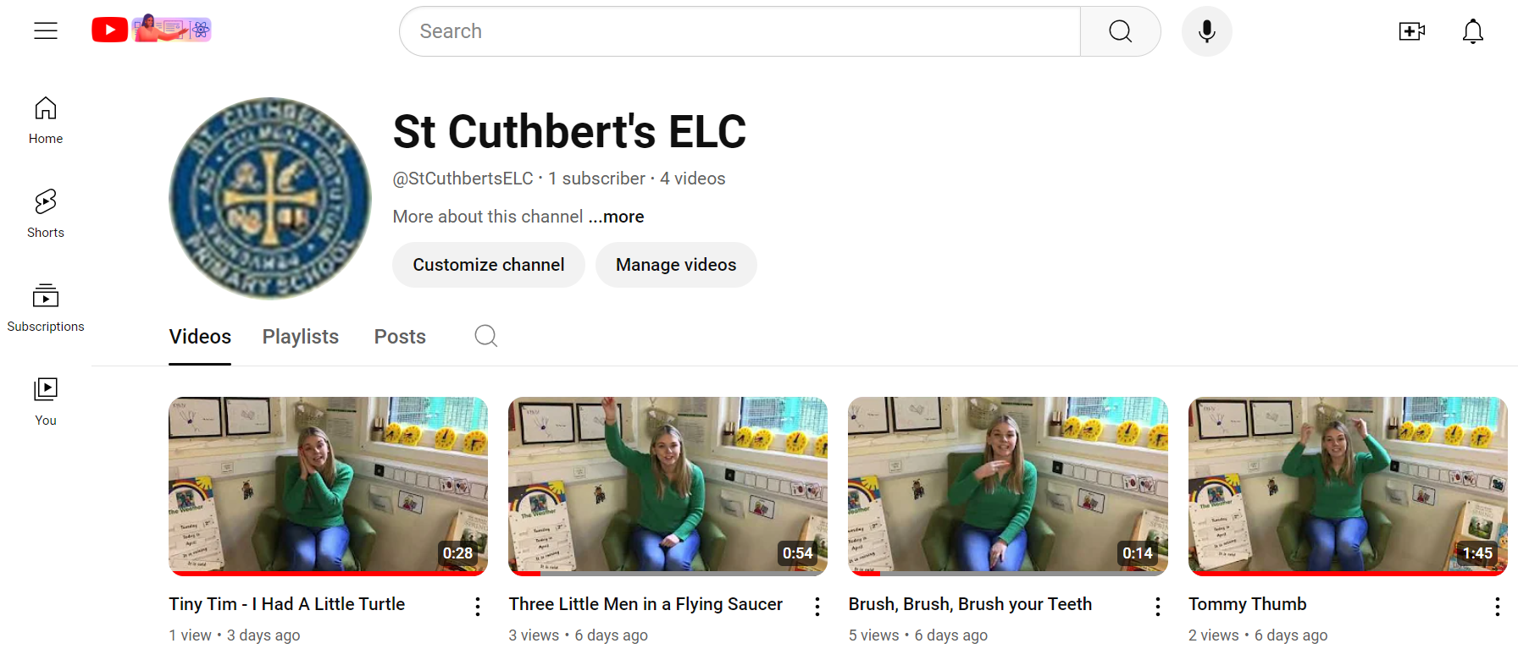
You can learn all of our favourite songs and sing along at home - on our new nursery YouTube channel.
https://www.youtube.com/@StCuthbertsELC

Read along with Caroline

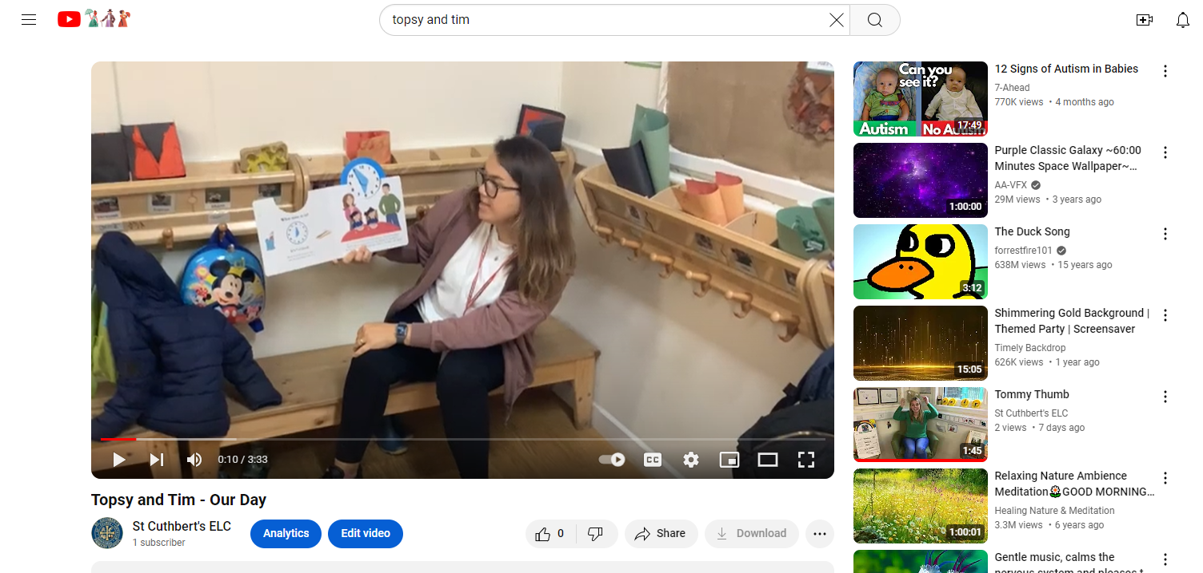

On the St Cuthbert’s nursery YouTube channel you can enjoy a bedtime story!
https://www.youtube.com/watch?v=ivaNoG4N2HA

Finally

We wish you and your families a restful and relaxing long weekend and look forward to seeing you all on Monday.

Mr P Brack, Head Teacher and all at St Cuthbert’s School

