 St. Cuthbert’s RC Primary School
Newsletter 19– Friday 10th January 2025
St Cuthbert’s CARES We are: Creative Active Respectful Equal Supported

Good afternoon and Happy New Year to you all. We hope that everyone had a restful and happy Christmas holiday. Thanks for reading this week’s Newsletter. As always, please get in touch with any questions you have this week’s Newsletter contents.

Upcoming Events at St Cuthbert’s and Dates for your Diary

Thank You

The staff would like to thank our pupils, parents and carers for their kind and generous Christmas gifts and cards.

Dates for Your Diary: January to April 2025

A full list of these were put to our teachers in draft form this week and we will publish the final version in this Newsletter next Friday, the 17th January 2025, once I receive feedback from our staff. In the meantime, please see dates for this year’s Scottish Performance and P7 School Camp drop in meeting below:

- Scottish Cultural Performance - Friday 24th January at 9.30am in the school hall.
- P7 Parents Drop-in Meeting Ahead of School Camp – Thursday 16th January 4-5pm

Choir Resumes on Monday 20th January

Choir resumes on the above date from 3.20-4.30pm. This term pupils will be preparing for their performance based on the musical Matilda which will take place on Wednesday 26th February. Pupils should be collected from choir or make their own way home as indicated by parents/carers on reply slips in term 1. If you wish to change collection arrangements from last term please email the admin@st-cuthberts.edin.sch.uk account and Mrs Robson will update our staff choir leaders.

P5 Football Resumes Today

P5 football resumes today. Chris has contacted parents/carers of those involved to make them aware. Today’s training will take part in the gym hall.

Parent Council Weekly Update

Our next two meetings will take place in the school Nurture Room on Fridays: 24th January and 7th March 2025 at 11am. As always, all parents/carers are very welcome to attend and the minutes of the meetings will be shared with all parents/carers via Parent Pay email.

Should you wish to contact the Parent Council at any time about anything related to their work, they can be contacted via e-mail at ptastcuthberts@gmail.com

News & Information

School Camp Documents and Drop In Meeting

A pack was sent out to families of pupils attending camp this week with an accompanying letter. The deadline date for the return of documents is Friday 17th January. We will also be holding a final drop in meeting for parents/carers on Thursday 16th January from 4-5pm in the P7 classroom. This is an optional opportunity for parents/carers to pass on any remaining information to or ask any final questions of our staff who will be accompanying the pupils to Lagganlia.

City of Edinburgh Council Football Programmes January 2025

Please see appendix 1 at the end of this newsletter with information from Jack Beesley, football development officer. This is being shared for the final time this week.

Attendance and Lateness Update

As stated previously, City of Edinburgh Council monitors attendance at all of its schools. Please see information below re the impact of absence and lateness on pupil learning. This term we will be contacting parents/carers of pupils with high levels of absence or persistent lateness, first verbally and if there are further recurrences in writing to request improvements in both attendance and punctuality.

St Cuthbert’s Primary School
St Augustine’s Learning Community

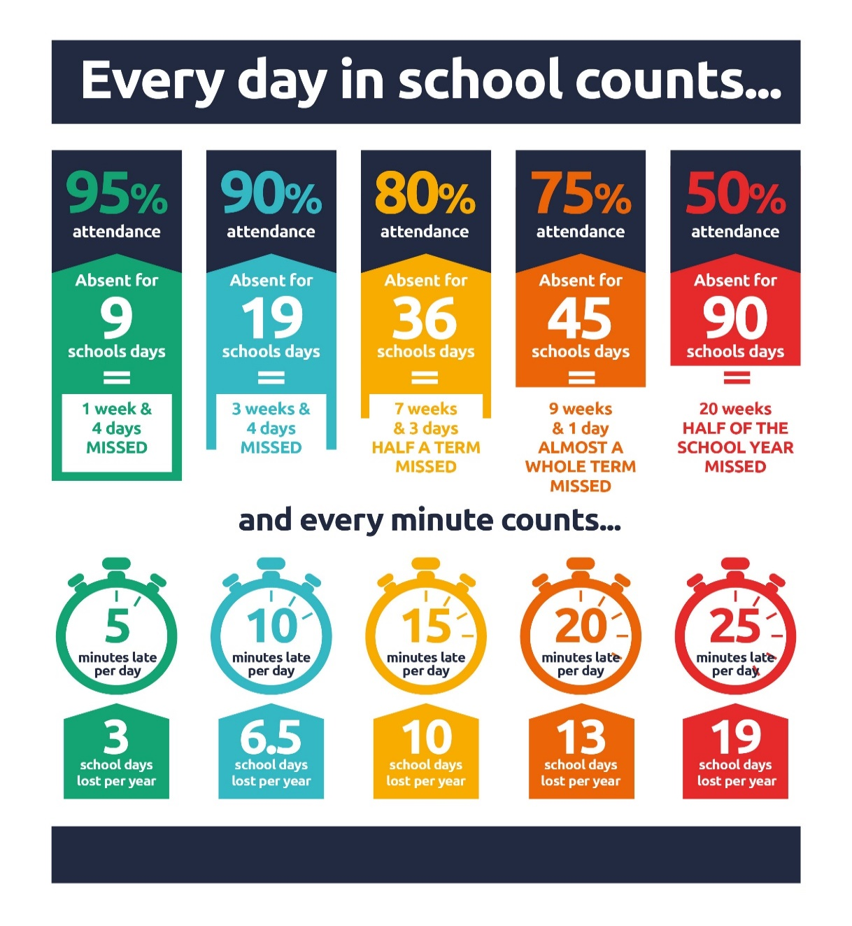

Kool School Fair Trade Uniform Christmas and New Year Sale – 10% Discount

We had problems with sharing this attachment last week so please see info below:

Koolskools have asked us to notify parents that for the first time ever they are running a *10% New Year discount window for Fairtrade/ECO uniform from 10 to 20 January 2025.

The idea of the mid-winter discount window is to offer a bit of extra help to those parents who, for whatever reason, need to buy more uniform mid-way through the school year.

Kool Schools is our fair-trade uniform partner. They also work with other Edinburgh schools. Their stock is made from materials provided by Fairtrade cotton farmers, who always receive a fair and sustainable payment for their crop. Their communities also receive a premium for projects such as building schools, hospitals, access to clean water and so on.

HOW TO ORDER
Go to the buying page on the Koolskools website on the following link - https://www.koolskools4u.co.uk/schools-list/ - and place your order. There will be a flat delivery charge of £4.99.

Orders take up to 10 days to turn around (up to 15 days during the busy June to September period) from the date of order placement.

Pupil Voice at St Cuthbert’s

Our Pupil Rights and Equalities group will meet next Tuesday afternoon and our Sustainability and HWB Groups on Thursday and Friday respectively.

Learning at St Cuthbert’s

Staff In-Service Day Training

On Monday 6th January, staff worked on a number of professional development areas including:

- Looking at ways to improve our support of pupils and their attainment
- Working on developing the use of visual symbols throughout the school to support pupils with Additional Support Needs
- Working together to agree a consistent approach to feedback and target setting from P1-7.
- Working together with colleagues from EAL Team to develop strategies for supporting EAL pupils with reading.

P1 Rolling Snack Provision

P1 have introduced a snack table as part of their play based learning which provides pupils with a daily opportunity to prepare food, enjoy conversations and practice important skills such as turn taking and tidying up. Pupils can choose from a selection of snacks such as toast, cereal and fruit. This has been very successful this week with pupils enjoying sharing food together whilst building on lots of important skills.

Language of the Month

As part of our ongoing efforts to promote equality all classes will learn and use some basic Hindi and Urdu words in class this term.

Miss Eckersley’s Health and Wellbeing Update

As you may be aware Miss Eckersley provides HWB teaching in all classes from P3-7 over the course of each week. Here is an overview of her plans for term 2 from January to Easter:

This term, PE sessions will take place both in the hall and outdoors. Please make sure your child has a suitable, warm PE kit on these days. The kit should include shorts or jogging bottoms, a jumper, a change of indoor shoes, and a jacket. Our main focus areas for learning this term will be Ceilidh Dancing and Circuit Training. We will be working on rhythm, endurance and strength. We will also be focusing on body awareness and control.
For Health and Wellbeing, we will be continuing our Building Resilience Programme. Our theme this term is 'Respect Yourself'. In this unit, we will be learning that 'There is no-one quite like me' 'Everyone has different strengths' and 'I can treat myself with respect.'

P6 Transition Maths Event

P6 will be taking part in a transition event linked to Mathematical learning at St Augustine’s High School Next Thursday.

Violin, Viola and Cello Tuition

This resumed for all pupils this week. Please note that there will be no Cello Tuition next week as Mr McVinnie will not be in school. It will however resume the following week commencing 20th January.

English as an Additional Language (EAL) Support Meetings

Mrs Mushtaq, our local EAL support teacher will be in school on alternate Fridays starting today. Should you wish to meet with her at any time, please contact the school and we can arrange for a meeting to be set up.

Catholic Education and Parish Update

P4 New Year Liturgical Service

Congratulations to P4 and Mrs Gill for a lovely Start of Term service today. They worked really hard to organise and practise for today’s event and it was a fitting way to mark the new year in school. We had originally planned this as a Mass but had to change plans as Fr Francis is currently in Nigeria and was unable to obtain a cover priest for us.

Sacramental Registration – Important Information

We have passed on all of the Sacramental Registration forms we had received before Christmas to the parish. If you have not submitted a completed form for your child registering them for the Sacraments in 2025 please contact Fr Francis directly after his return on 30th January.

Nursery Update

Nursery learning
This week we welcomed back the nursery children after the holiday. We also welcomed our new children and families who started their nursery journey this week.
The children have been very interested in the weather – exploring and experimenting with the ice and frost. Our new children have been learning new nursery routines and getting to know both staff and children.

Nursery safety
To keep children safe, please remember to close the nursery gate when entering and leaving, using the bolt and the hasp on top of the gate.

Nursery Sessions from January 2025

See details below:
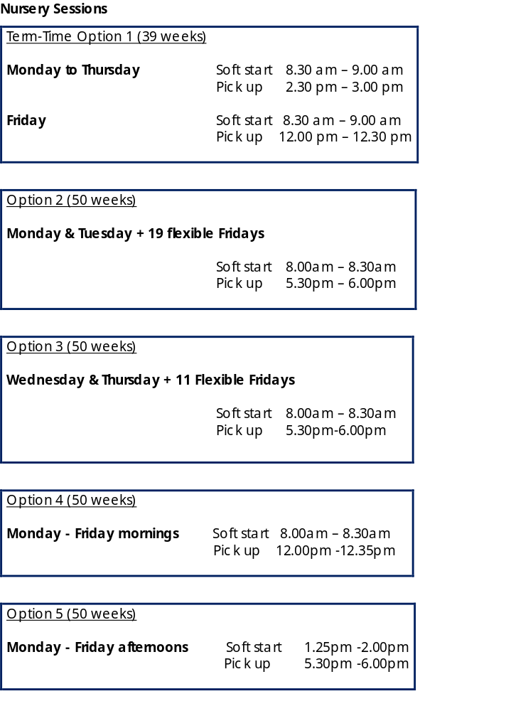

Finally

We wish you and your families a restful weekend.

Mr P Brack, Head Teacher and all at St Cuthbert’s School

Appendix 1 - City of Edinburgh Council Football Programmes January 2025

Dear Parent,

Please see below information regarding our upcoming block of term-time football classes for boys and girls.

All sessions take place at our Forrester / St Augustine's Community Sports Hub and range from age 3 to S1.

Friday Football
Friday Football is a fun, developmental football programme for boys and girls aged P1-S1. The sessions focus on developing confidence and enhancing competence on the ball through dribbling, passing, scoring and control. Sessions are outdoor on 3G astroturf so please bring footwear and clothing suitable for being outdoor.

P1-P4 : Fridays 2.00-3.00pm https://getedinburghactive.spydus.co.uk/cgi-bin/spydus.exe/ENQ/WPAC/EVSESENQ?SETLVL=&RNI=158736

P5-S1 : Fridays 3.00-4.00pm https://getedinburghactive.spydus.co.uk/cgi-bin/spydus.exe/ENQ/WPAC/EVSESENQ?SETLVL=&RNI=158749

Mini Kickers

Mini Kickers is our fun, developmental introductory programme, which focuses on building motor skills and physical literacy through the enjoyment of football. These sessions are indoor.

Age 3-4 : Saturdays 9.00-9.45am https://getedinburghactive.spydus.co.uk/cgi-bin/spydus.exe/ENQ/WPAC/EVSESENQ?SETLVL=&RNI=158706

Age 4-5 : Saturdays 10.00-10.45am https://getedinburghactive.spydus.co.uk/cgi-bin/spydus.exe/ENQ/WPAC/EVSESENQ?SETLVL=&RNI=158721

If you would be interested in finding out more information or booking a place, please visit the links above.

Alternatively, if you have any questions, please don't hesitate to get in touch.

We hope to see you soon! 🙂

Thanks,

Jack

Jack Beesley | Football Development Officer | Sports and Outdoor Learning Unit | Education (Wider Achievement & Lifelong Learning) | Children, Education & Justice Services | The City of Edinburgh Council | Forrester / St Augustine’s Community Sports Hub, Broomhouse Road, Edinburgh EH12 9AE | 07894 816 336 | @Edin_Football | @coe_sport | www.edinburgh.gov.uk

