 St. Cuthbert’s RC Primary School
Newsletter 20 – Friday 17th January 2025
St Cuthbert’s CARES We are: Creative Active Respectful Equal Supported

Good afternoon. We are now fully back into the swing of the new term and there is some key information in this week’s Newsletter. Thanks for reading it. As always, please get in touch with any questions you have regarding this week’s Newsletter contents.

Upcoming Events at St Cuthbert’s and Dates for your Diary

Dates for Your Diary: January to April 2025

- Friday 24th January – Scottish Performance, 9.30am School Hall
- Friday 24th March – Parent Council Meeting, 11am School Nurture Room
- Friday 24th January – Termly Overviews to be emailed to parents/carers
- Friday 7th February – P2 Class Mass, 9.30am St Cuthbert’s Church
- Friday 21st February – P3 Class Assembly, 9.30am School Hall
- Thursday 27th February – Coffee, Cake and Curriculum Morning 9.15-10.15am, school hall and classrooms
- Monday 3rd - Friday 7th March – P7 attending School Camp, Lagganlia
- Wednesday 5th March – Ash Wednesday Mass, school attending
- Thursday 6th March -World Book Day to be celebrated in school
- Friday 7th March – Parent Council Meeting, 11am School Nurture Room
- Friday 14th March P4 Class Assembly – 9.30am in School Hall
- Thursday 20th March – P3 Reconciliations, 6pm at St. Cuthbert’s Church
- Tuesday 25th :5-7.30pm and Thursday 27th March: 4-6.30pm Parent Consultations, School Hall
- Friday 4th April – Stations of the Cross Assembly P6, 9.30am School Hall

Mr Brack Out of School Tuesday and Wednesday Next Week

I will be supporting at another school on Tuesday and Wednesday of next week. If you wish to speak to a member of school management on these days, please contact Mrs Munro in my absence.

Scottish Performance Tickets (Sold out) and Solo Performers

Thanks to all of those who returned requests for tickets. Please note that as this is a whole school event we are restricted in the number of available tickets and that all tickets are now sold out. Apologies if you weren’t able to get a ticket. As advised on last week’s Newsletter, if your child is skilled in Scottish singing, dancing or instrumental playing they can perform solo as an addition to our class performances at this event. In order for this to happen, we need advance notice and information from parents/carers. Please let us know by end of day on Tuesday via school mailbox: admin@st-cuthberts.edin.sch.uk if you wish your child to perform.

Active Schools Update

Fiona is currently working hard to organise clubs for this term. The hope is to start these, week commencing 17th February 2025, with each club running for a duration for 4-8 weeks and able to take a maximum of around 20 pupils. More information to follow in the coming weeks.

Choir Has Now Resumed

Choir resumed this week – apologies about the confusion with dates last week. This term pupils will be preparing for their performance based on the musical Matilda which will take place on Wednesday 26th February. Pupils should be collected from choir or make their own way home as indicated by parents/carers on reply slips in term 1. If you wish to change collection arrangements from last term please email the admin@st-cuthberts.edin.sch.uk account and Mrs Robson will update our staff choir leaders.

Parent Council Weekly Update – Change of Second Termly Meeting Date

Our next two meetings will take place in the school Nurture Room on Fridays: 24th January and provisionally 14th March 2025 at 11am. As always, all parents/carers are very welcome to attend and the minutes of the meetings will be shared with our parents/carer body via Parent Pay email.

Should you wish to contact the Parent Council at any time about anything related to their work, they can be contacted via e-mail at ptastcuthberts@gmail.com

News & Information

Head Lice Update and Information

Please be aware that from time to time schools may experience cases of head lice and it is important for us to update parents and carers on a termly basis, re what to do in the event of a case being discovered. Please see link below with more information from the NHS on this topic.

https://www.nhs.uk/conditions/head-lice-and-nits/

Attendance and Lateness Update

As stated previously, City of Edinburgh Council monitors attendance at all of its schools. Please see information below re the impact of absence and lateness on pupil learning. This term we will be contacting parents/carers of pupils with high levels of absence or persistent lateness, for absence this will be verbally initially and if there are further recurrences in writing to request improvements. For lateness, the parents of any pupil late more than twice in the week will receive an initial text followed by a call if lateness persists.
St Cuthbert’s Primary School
St Augustine’s Learning Community

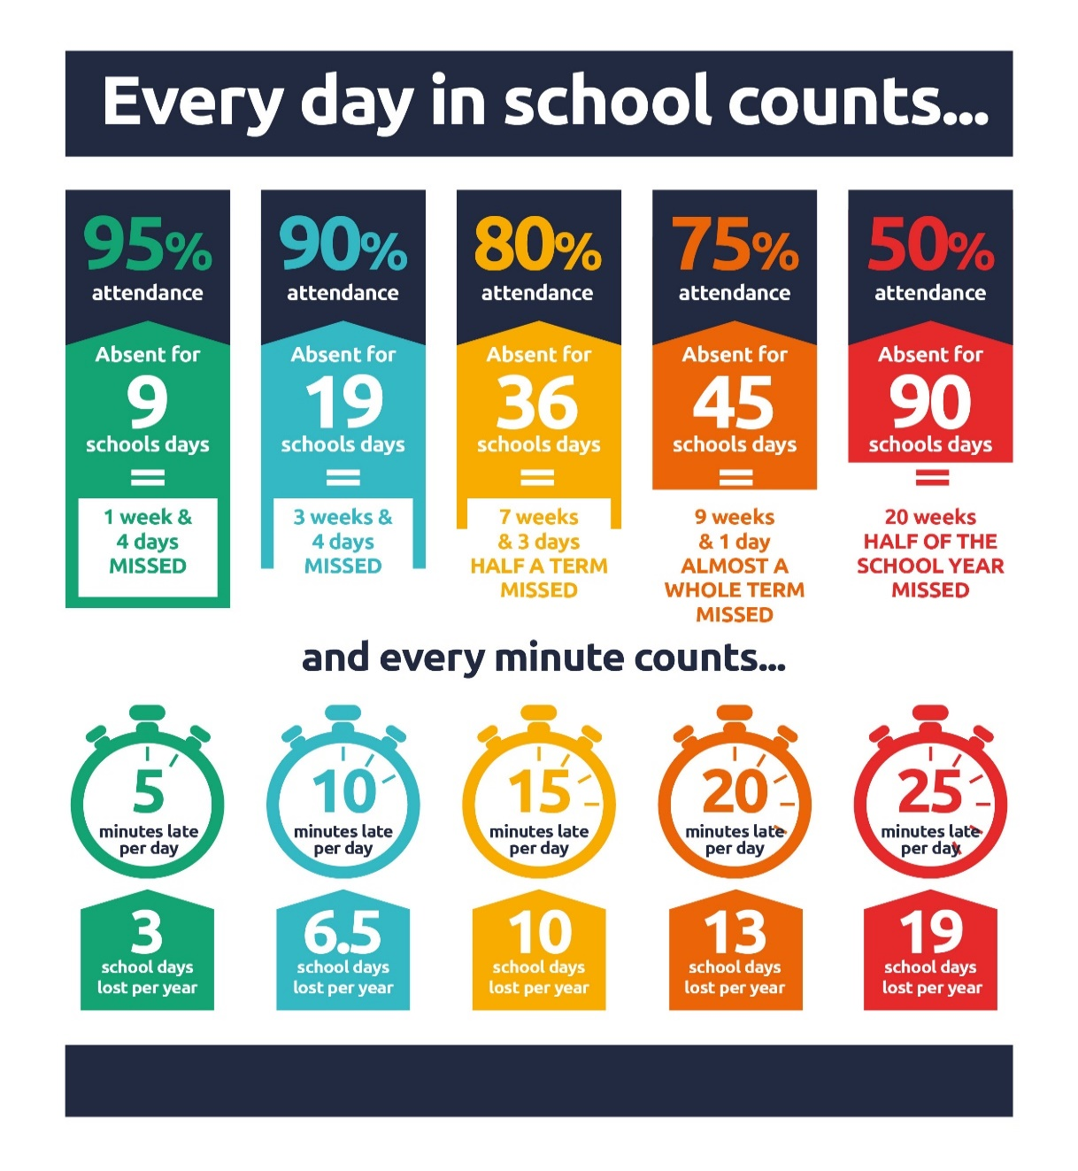

School Camp Documents , Drop In Meeting and Hoodies

The deadline date for the return of documents is today. Please contact us with any questions about these. Thanks also to those who attended our final drop in meeting on Thursday evening. We also hope to have some information to share re P7 Hoodies in the next week or so.

Pupil Voice at St Cuthbert’s

Mrs Mulvagh and I worked with our P6 pupils on Monday and Tuesday to define the qualities of an excellent learner and an excellent teacher at St Cuthbert’s.

Our Pupil Rights and Equalities group met with me on Tuesday afternoon to share their views on how plenaries/the end of lessons should be conducted in as productive way as possible. They had some great ideas which will feed into our shared practice this term – see below in Learning at St Cuthbert’s section. The pupils from the group will take part in shared practice meetings later this month and in early February.

Miss Eckersley met with the Sustainability group this week and they made another visit to our Hutcheson Community Garden. The children worked hard, clearing paths, moving soil and compost, weeding, and helping the community plots get ready for the year ahead!'

The HWB Group will meet next week.

Learning at St Cuthbert’s

P1 Work Bench

As well as their new rolling snack station described in last week’s Newsletter. P1 have this week introduced a technical skills workbench allowing pupils to use woodwork tools as part of their daily learning. This new station has been fully risk assessed and pupils are given protective clothing and goggles, numbers at the station are also limited. Its great to see how engaged the pupils are by these changes.

Shared Practice – Term 2

As shared previously, each term, the school management team visits classrooms for quality assurance purposes. Our teachers are kind enough to allow pupils from our School Rights and Equalities Group to take part in these activities to give a pupil feedback voice on our learning and teaching. This term, we also hope that teachers can also participate in these classroom visits to experience teaching in other classes share their own skills and learn from their peers. The focus will be on ‘plenary sessions’, which take place at the end of lessons and allow pupils and teachers to gauge what has been learned in a lesson and what next steps are. We hope to carry out these shared practice visits over weeks commencing 27th January and 3rd February.

Miss Eckersley’s Health and Wellbeing Update

As you may be aware Miss Eckersley provides HWB teaching in all classes from P3-7 over the course of each week. Here is an overview of her plans for term 2 from January to Easter:

This term, PE sessions will take place both in the hall and outdoors. Please make sure your child has a suitable, warm PE kit on these days. The kit should include shorts or jogging bottoms, a jumper, a change of indoor shoes, and a jacket. Our main focus areas for learning this term will be Ceilidh Dancing and Circuit Training. We will be working on rhythm, endurance and strength. We will also be focusing on body awareness and control.
For Health and Wellbeing, we will be continuing our Building Resilience Programme. Our theme this term is 'Respect Yourself'. In this unit, we will be learning that 'There is no-one quite like me' 'Everyone has different strengths' and 'I can treat myself with respect.'

P6 Transition Maths Event 23rd January

P6 will be taking part in a transition event linked to Mathematical learning at St Augustine’s High School Next Thursday.

American Flag Football – 30th January

Our P4-7 classes will take part in taster sessions run buy a qualified coach on the above date. If the sessions go well, the coach is hoping to set up a short 3 week, lunchtime club for P6 and P7 pupils later this term.

Violin, Viola and Cello Tuition

There were no Cello, violin or viola lessons in school this week as Mr McVinnie and Mrs Egan were not in school. We hope that tuition will resume next week as normal.

English as an Additional Language (EAL) Support Meetings

Mrs Mushtaq, our local EAL support teacher will be in school on alternate Fridays starting today. Should you wish to meet with her at any time, please contact the school and we can arrange for a meeting to be set up.

Catholic Education and Parish Update

Sacramental Registration – Important Information

We have passed on all of the Sacramental Registration forms we had received before Christmas to the parish. If you have not submitted a completed form for your child registering them for the Sacraments in 2025 please contact Fr Francis directly after his return on 30th January.

Nursery Update

Nursery Update

What we have been learning this week
This week the children have been celebrating Scotland’s national Baird – Robet Burns. The children have been making their own tartan and St Andrews flags. Next week we are all very excited about having haggis, neeps and tatties for snack!
In the garden, the exploration of ice continues, and the effects frost has on our plants and garden resources. Ice has also been a big hit in the water tray indoors.

St Cuthbert’s Nursery Information Hub
Have you checked out our St Cuthbert’s Early Learning and Childcare Padlets yet? It’s our digital notice board that’s a one-stop-shop for everything you need to know about nursery: policies, useful links, virtual tours, term dates, latest information and lots more!
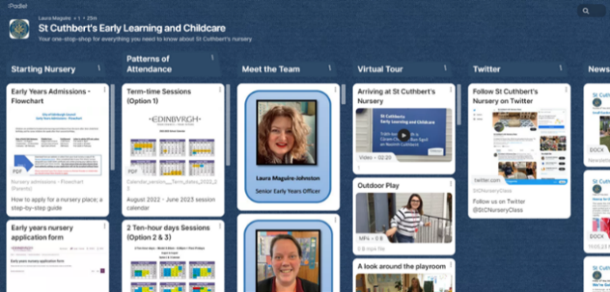
https://padlet.com/lauramaguire1/st-cuthbert-s-early-learning-and-childcare-le6mn1qf3x3w1xdz
Our second Padlet contains all our favourite song, stories and games – so you can join in at home!
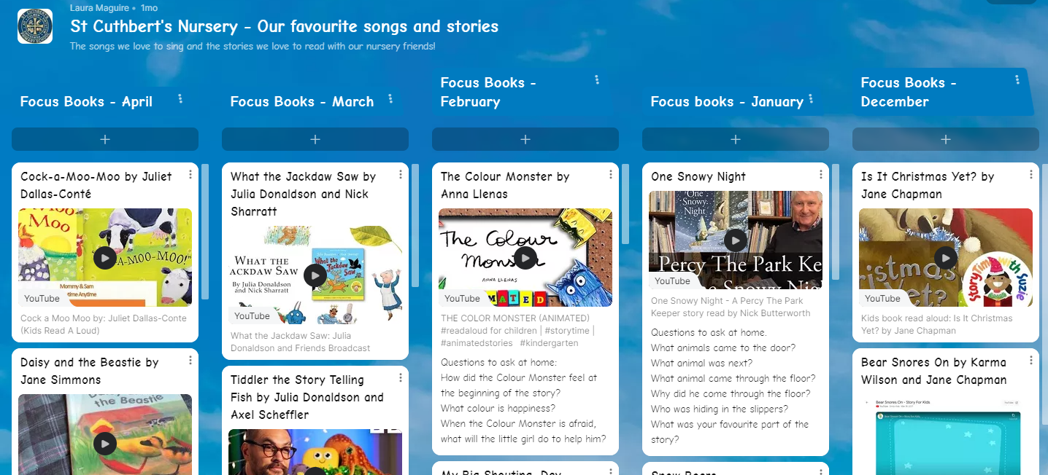
https://padlet.com/lauramaguire1/st-cuthbert-s-nursery-our-favourite-songs-and-stories-9gt6n1wax5ndhv6f
Both are updated frequently, and we can add anything you think would be useful to our St Cuthbert’s community, all suggestions welcome. Just click the links below!
Both Padlets can also be accessed on the school website:
https://st-cuthberts-primary.com/nursery/

Finally

We wish you and your families a restful weekend.

Mr P Brack, Head Teacher and all at St Cuthbert’s School

