 St. Cuthbert’s RC Primary School
Newsletter 26– Friday 7th March 2025
St Cuthbert’s CARES We are: Creative Active Respectful Equal Supported

Good afternoon and welcome to another very full Newsletter this week. Thanks for reading it and as always, please get in touch with any questions or suggestions you have regarding its contents.

Upcoming Events at St Cuthbert’s and Dates for your Diary

Dates for Your Diary: January to April 2025

- Monday 10th March – P7 Parents Transition Drop in Meeting, 2-3pm in school
- Friday 14th March P4 Class Assembly – 9.30am in School Hall
- Friday 14th March – Parent Council Meeting, 11am
- Monday 17th March – wear green for St Patrick’s Day
- Monday 17th March – P7 Parents Transition Drop in Meeting, 2-3pm in school
- Thursday 20th March – P3 Reconciliations, 6pm at St. Cuthbert’s Church
- Tuesday 25th :5-7.30pm and Thursday 27th March: 4-6.30pm Parent Consultations, School Hall
- Friday 4th April – Stations of the Cross Assembly P6, 9.30am School Hall

Active Schools Update: Easter Football Camps

Our clubs are all now full for this term. Please contact Fiona via text if you have any further questions (07769 922742) about Active School Clubs.

Please also see details of City of Edinburgh Council’s Football Camps over the Easter Holidays Appendix 1 below at the end of this week’s Newsletter.

Parent Council Weekly Update

Our next meeting will be next Friday 14th March 2025 at 11am in the Nurture Room of the school. As always, all parents/carers will be very welcome to attend.

Should you wish to contact the Parent Council at any time about anything related to their work, they can be contacted via e-mail at ptastcuthberts@gmail.com

P7 Transition Drop-In Afternoons

Mrs McCallum, Transition Teacher will be available in school for questions about St Augustine’s High School from any of our parents/carers whose children will be attending St Augustine’s next year. The dates and timings are below:

- Monday 10th March 2-3pm
- Monday 17th March 2-3pm

News & Information

Parent Consultations

An information letter was emailed this week. The Parent Booking system is now live to enable you to book a convenient appointment for Tuesday 25th March or Thursday 27th March. Available appointments are now becoming limited, so please book an appointment as soon as possible to avoid disappointment. If you wish an interpreter to be present for your consultation please contact the school office, via admin@st-cuthberts.edin.sch.uk, so that we can try to arrange this for you. This should be done no later than Monday 17th March. Thank you for your co-operation with this. Mrs Peake, our Support for Learning Teacher will attend on Tuesday 25th March. If you would like to see her and are not available that night please contact us separately.

Curriculum Morning/Parent/Carer Questionnaire

Thanks very much to all who attended our Curriculum morning yesterday. Another great turnout of around 80 parents and carers. We hope that you enjoyed your visit. It is our ongoing aim to make all of our parents and carers feel welcome and part of our wider community. Thanks to those who shared their views with us about the school’s progress via our online survey (we try to do this twice a year and appreciate all feedback received). The format is simple and designed to be understood and used by all parents/carers, without taking up too much of your time. If you didn’t get the chance to do so today, we will also be sharing the QR code to access the survey at our Parent Consultations mentioned above. Alternatively, it can be accessed below:



School Lunches – Easter Themed Menu

There will be an Easter themed menu offered on Wednesday 26th March. There will only be 2 options available on that day; Spring Chicken Pizza and Bunny Burger(vegetarian burger in a bun with cheese). There will be NO baked potato option available. If you have ordered meals in advance please log in to your account and make sure that your choice has not been dropped for that particular day. Please ensure that if your child wishes to have the themed lunch on 26th March that you have ordered online no later than midnight on 19th March.

Glee Competition Update & Practice Links

After their triumph, with the Matilda performance, our school choir have now moved on to preparing for their part in the Glee Competition scheduled for 20th March. A letter was sent out to choir members on Thursday with information for parents and carers. Please ask if you have any questions. The choir staff team have also asked that I share the three links below to allow the pupils to practice for the competition at home:

https://www.youtube.com/watch?v=3ISnD-zKkwQ To learn the sign language for the Clearest Blue song (a reminder to please practise as often as they can)

https://www.youtube.com/watch?v=uzbzMRyinyE Far Side of the World by Tide Lines

https://www.youtube.com/watch?v=QpFXXPruuqU Clearest Blue by CHVCHES

P.E Kits on P.E. Days

A number of teachers had fed back that their pupils are not bringing P.E kits to school and are doing P.E. in uniform which presents hygiene issues. P.E days are shared termly via termly overviews. Please check with the office if you are unsure.

P7 at School Camp

P7 have had a great time at Lagganlia this week. Thanks to Mrs Kelly, Mrs Ferry and Mrs Munro for giving of their time to support this memorable experience for our pupils.

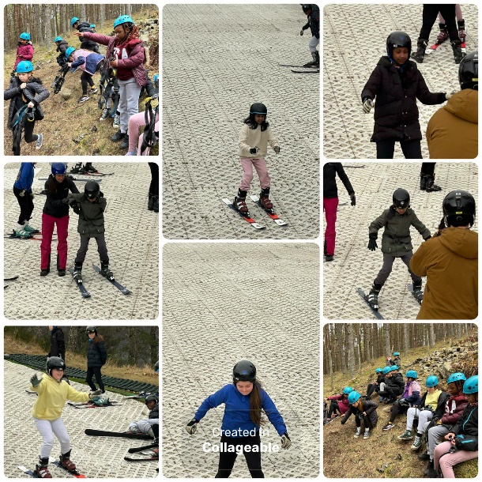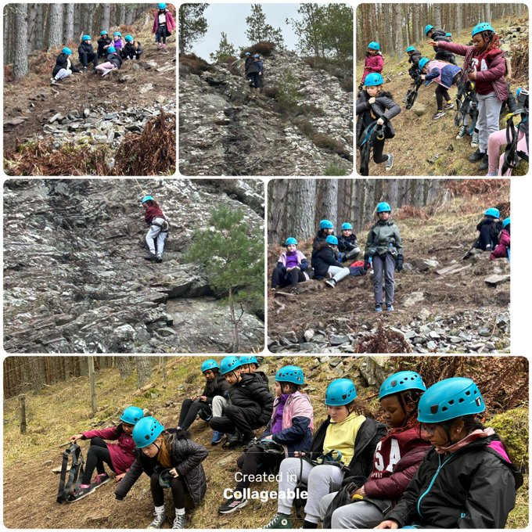

Swimming Gala

We will be sending P6/7 pupils to trials for the Edinburgh School Swimming Gala on Thursday13th March. Thanks to Mrs Damen for helping out with this.

Ramadan Prayer Room

Our Ramadan Prayer Room is now up and running on Mondays and Wednesdays. Thanks to Mrs Sheikh for her support.

Pupil Voice at St Cuthbert’s

The Pupil Rights and Equalities group will meet again next Tuesday to discuss plans for fundraising during Lent. This will be our first pupil lead meeting. They have added a new minutes section to their group display board in the main corridor.

Our Sustainability Group visited Hutchison Community Garden on Thursday. The children enjoyed planting trees, blackcurrant bushes, and sweet peas. We also took the time to compost our plot and water the gardens. They have also revamped their school display board.

Our HWB Group continued to work on their new display board this week. They will meet again next Wednesday.

Thanks to our P3 pupils who helped with this week’s class ‘Learning Conversation’ – see Learning section below – and to our P6 pupils who stepped up to run this week’s assembly in the absence of our P7’s.

Learning at St Cuthbert’s

P3 Learning Discussion

It was great to meet P3 this morning. We discussed pieces of work that they are proud of, looked at examples of feedback from their teacher and self assessment that had helped them learn before talking about target setting. In this regard, we looked at their weekly targets in the floorbook as well as termly targets in their workbooks and folders. Finally, we discussed what made them proud of their school, what changes we could make to improve our school and how the school allowed their talents to shine.

P4 National Standardised Assessments

P4 undertook their NSA’s this week. These comprise online tests in Numeracy, reading and writing and are a helpful snapshot of learning in Maths and Literacy on a particular day. They are used by teachers as additional evidence alongside their in depth day to day assessment. Please ask if you have any questions.

Catholic Education and Parish Update

Mary’s Meals Fundraising and Ash Wednesday Mass

Thanks to Colin and Jackie from Mary’s Meals who came in to school to present information about their charity on Tuesday afternoon. It was great to see the work they are doing and we hope to be able to support them via fundraising in each class. Fr Francis mentioned at Mass that almsgiving is an important part of Lenten observance, if your child is giving up anything for Lent and would like to donate the money saved to Mary’s Meals, we have a collection cup in each class which we will collate at the end of Lent and pass to the charity. Please note that this is purely optional. There is also a collection cup in the school office for any parent or carer who’d like to contribute. We’ll also be working with our Pupil Rights and Equalities Group to come up with additional ideas for this worthy cause.

Sacrament of Reconciliation -Thursday 20th March

Fr Peter Kelly has been a great help, visiting the school to prepare our pupils for their First Reconciliations. The Sacrament will be celebrated with a short service lead by Fr Francis on Thursday 20th March at 6pm, in St Cuthbert’s Church Hall. Thanks for your support of the pupils preparation at home too.

CHILDREN’S LITURGY AT ST CUTHBERT’S CHURCH DURING LENT

During Lent we would like to encourage children of school age to participate in the Children’s Liturgy during the 9.30 Mass in St Cuthbert’s Church.
The Liturgy Team will be leading the children in prayers, hymns, gospel readings and reflection in our beautiful newly decorated Liturgy Room over the next four weeks of Lent.
Dates: 9th, 16th, 23rd and 30th March.
After Easter the Children’s Liturgy will resume again on a fortnightly basis.
Please encourage your child/children to come along. and hear the gospel at a level suitable to them and discuss/reflect on the message from the readings.
Thank you.
Dorothy Johnstone (School/Church Liturgy and Music Co-ordinator)

Nursery Update

Spring has sprung

As the weather warms up and the sun is out, the children have been looking for signs of spring in the garden. Indoors we have been studying the life cycles of butterflies, bees and frogs. Our talented bunch put on a fantastic St Cuthbert’s talent show on Thursday, confidently performing wonderful songs and showing off their inventive Choreography!

Nursery Parent Consultation

Nursery Parent Consultations take place on Tuesday 2 and Wednesday 3 April, from 3-5:30pm. Please speak to one of the team to book your timeslot.

Finally

We wish you and your families a happy and restful weekend.

Mr P Brack, Head Teacher and all at St Cuthbert’s School

Appendix 1 – Easter Holiday Football Camps

Dear Parent/Guardian,

I hope you are well!

Please see below email regarding City of Edinburgh Easter Football Camp.

Our prices for 2025 remain at £70 per week or £35 for those entitled to Free School Uniform Grants or Free School Meal Grants (not the automatic free school meals for the younger ones). Payment must be made at point of booking; please select the appropriate rate at checkout. The camp will run Monday 7th – Friday 11th April.

As ever, places are limited and tend to be in high demand so act fast to avoid disappointment.

Please see the links below for booking and information. If you have any enquiries, then don’t hesitate to get in touch.

P1 – P4
https://getedinburghactive.spydus.co.uk/cgi-bin/spydus.exe/ENQ/WPAC/EVSESENQ?SETLVL=&RNI=173761

P5 – S1
https://getedinburghactive.spydus.co.uk/cgi-bin/spydus.exe/ENQ/WPAC/EVSESENQ?SETLVL=&RNI=173768

Hopefully we’ll see you again this year! 😊

Thanks,

Jack

Jack Beesley | Football Development Officer | Sports and Outdoor Learning Unit | Education (Wider Achievement & Lifelong Learning) | Children, Education & Justice Services | The City of Edinburgh Council | Forrester / St Augustine’s Community Sports Hub, Broomhouse Road, Edinburgh EH12 9AE | 07894 816 336 | @Edin_Football | @coe_sport | www.edinburgh.gov.uk

