 St. Cuthbert’s RC Primary School
Newsletter 27– Friday 14th March 2025
St Cuthbert’s CARES We are: Creative Active Respectful Equal Supported

Good afternoon and welcome to this week’s Newsletter. Happy St Patrick’s Weekend to all of Irish heritage. Thanks for reading it and as always, please get in touch with any questions or suggestions you have regarding its contents.

Upcoming Events at St Cuthbert’s and Dates for your Diary

Dates for Your Diary: January to April 2025

- Monday 17th March – wear green for St Patrick’s Day
- Monday 17th March – P7 Parents Transition Drop in Meeting, 2-3pm in school
- Thursday 20th March – P3 Reconciliations, 6pm at St. Cuthbert’s Church
- Thursday 20th March – Glee Competition, 6pm Central Hall (doors open at 5.30pm)
- Tuesday 25th :5-7.30pm and Thursday 27th March: 4-6.30pm Parent Consultations, School Hall
- Friday 4th April – Stations of the Cross Assembly P6, 9.30am School Hall

Parent Council Weekly Update

Minutes of the meeting will be shared with all families via email next week.

Should you wish to contact the Parent Council at any time about anything related to their work, they can be contacted via e-mail at ptastcuthberts@gmail.com

P7 Transition Drop-In Afternoons

Mrs McCallum, Transition Teacher will be available in school for questions about St Augustine’s High School from any of our parents/carers whose children will be attending St Augustine’s next year. The remaining date and timing is below:

- Monday 17th March 2-3pm

News & Information

Retiral of School App – An Explanation

We have decided to discontinue our use of the school app. The reasons for this are: firstly, that the app was brought in before we introduced email as a way of electronically communicating with parents/carers and that there is now no need to duplicate this communication. Our emailed letters and Newsletters go to the parent registered on our ‘Parent Pay’ system. We also publish information including our weekly Newsletter on the school website:

https://st-cuthberts-primary.com/

Finally, this decision allows us to free up the money spent on the app which has allowed us to purchase new whiteboards and books for P1 and P2. We hope that in the light of this information you will understand our decision but please contact us if you have any questions about it.

Parent Consultations Update

Since the booking system went live last week the appointment times are becoming very limited. To enable you to select a suitable appointment date and time, please log in to the parent booking system as soon as possible and before the closing date of Monday 17th March. Thank you for your co-operation with this.
If you are having difficulties with accessing the online system please contact the school office on admin@st-cuthberts.edin.sch.uk who will assist with booking a time slot. After the closing date, the office will then allocate appointments to those that have not managed to do so. The date and time allocated will be sent home with your child in paper format next week. If you require an interpreter to be present at your appointment time please e-mail the school office no later than Monday 17th March. This is to enable us to request the correct interpreter from central services. They require as much notice as possible to try and accommodate the request.

Mrs Peake, our Support for Learning Teacher will attend on Tuesday 25th March. If you would like to see her and are not available on that night please contact us separately to arrange an appointment with her.

Parent/Carer Questionnaire

It is our ongoing aim to make all of our parents and carers feel welcome and that they have a voice as part of our wider community. To this end, we are also keen to hear your views on the school’s progress via our online survey (we try to do this twice a year and appreciate all feedback received). The format is simple and designed to be understood and used by all parents/carers, without taking up too much of your time. If you didn’t get the chance to do so today, we will also be sharing the QR code to access the survey at our Parent Consultations mentioned above. Alternatively, it can be accessed below:

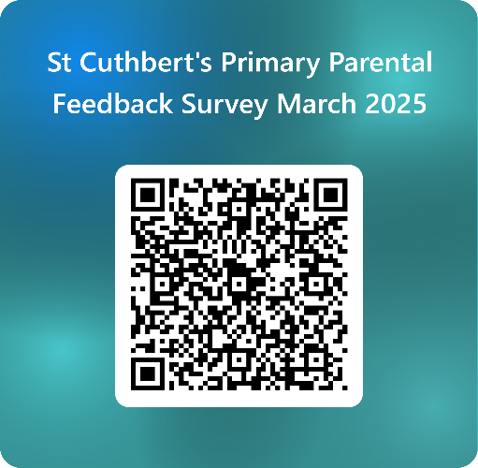

School Lunches – Easter Themed Menu

There will be an Easter themed menu offered on Wednesday 26th March. There will only be 2 options available on that day; Spring Chicken Pizza and Bunny Burger(vegetarian burger in a bun with cheese). There will be NO baked potato option available. If you have ordered meals in advance please log in to your account and make sure that your choice has not been dropped for that particular day. Please ensure that if your child wishes to have the themed lunch on 26th March that you have ordered online no later than midnight on 19th March.

Glee Competition Update & Practice Links

After their triumph, with the Matilda performance, our school choir have now moved on to preparing for their part in the Glee Competition scheduled for 20th March. A letter was sent out to choir members last week with information for parents and carers. Please ask if you have any questions. The choir staff team have also asked that I share the three links below to allow the pupils to practice for the competition at home:

https://www.youtube.com/watch?v=3ISnD-zKkwQ To learn the sign language for the Clearest Blue song (a reminder to please practise as often as they can)

https://www.youtube.com/watch?v=uzbzMRyinyE Far Side of the World by Tide Lines

https://www.youtube.com/watch?v=QpFXXPruuqU Clearest Blue by CHVCHES

P.E Kits on P.E. Days

A number of teachers had fed back that their pupils are not bringing P.E kits to school and are doing P.E. in uniform which presents hygiene issues. P.E days are shared termly via termly overviews. Please check with the office if you are unsure.

Swimming Gala Trials

We sent 10 P6/7 pupils to trials for the Edinburgh School Swimming Gala on Thursday13th March. Thanks to Mrs Damen for helping out with this.

Feedback from P2 and P3 Parents on Read,Write, Count Bags

The feedback is really valuable for the Scottish Book Trust to continue to receive funding to create the Read, Write, Count packs so your participation is valued.

https://www.surveymonkey.com/r/9DGDVZV

Pupil Voice at St Cuthbert’s

The Pupil Rights and Equalities group met with Mrs Munro on Tuesday. This was the first meeting chaired and minuted by pupils, a great step forward. This week the pupils discussed further plans for Lent, Ramadan and Eid as well as deciding on their chair and secretary for their next meeting.

Our Sustainability Group brainstormed ideas for our June 4th event. We reviewed the usage of our outdoor libraries, watered the plants, proposed creating posters to address littering on the playground and focused on promoting recycling bins in class.'

Our HWB Group met with Miss Tulloch this week. They worked on their evidence scrap book and completed their mental health focus on sharing anxieties by installing their ‘feelings box’ in the school reception area.

Learning at St Cuthbert’s

Reading: Staff Training Session

Our teaching staff spent time on discussing and revising our approach to the teaching of reading on Thursday evening. We came up with a good plan that allows for all the different skills involved; reading for enjoyment and choice, tools for reading, finding and using information and understanding, analysing and evaluating to be taught and revised over each school year. Please let us know if you are interested in learning more about this plan.

P4 Class Assembly

Congratulations and go raibh maith agat (thank you in gaelic) to P4, Mrs Gill and Miss Brown for their hard work preparing an excellent class Assembly relating to St Patrick, patron saint of Ireland.

P2 Learning Discussion Rescheduled

Due to both a class Assembly and also Parent Council Meeting happening on Friday, P2’s Learning Discussion will be rescheduled to Monday 17th March.

P1 National Standardised Assessments

We have shared analysis of P7 and P4’s National Standardised Assessments with our teachers and these will add to their existing data. P1 will undertake their assessments in reading and numeracy after the Easter Holidays.

Catholic Education and Parish Update

Mary’s Meals Fundraising

Our Pupil Rights and Equalities Group will consult with their classes re ideas for fundraising this Lent. In the meantime, please remember that pupils are very welcome, on an optional basis to bring in contributions to Mary’s Meals from any Lenten sacrifices they have made, giving up sweets, chocolate etc.

Sacrament of Reconciliation -Thursday 20th March

Fr Peter Kelly has been a great help, visiting the school to prepare our pupils for their First Reconciliations. The Sacrament will be celebrated with a short service lead by Fr Francis on Thursday 20th March at 6pm, in St Cuthbert’s Church Hall. Thanks for your support of the pupils preparation at home too.

CHILDREN’S LITURGY AT ST CUTHBERT’S CHURCH DURING LENT

During Lent we would like to encourage children of school age to participate in the Children’s Liturgy during the 9.30 Mass in St Cuthbert’s Church.
The Liturgy Team will be leading the children in prayers, hymns, gospel readings and reflection in our beautiful newly decorated Liturgy Room over the next four weeks of Lent.
Dates: 9th, 16th, 23rd and 30th March.
After Easter the Children’s Liturgy will resume again on a fortnightly basis.
Please encourage your child/children to come along. and hear the gospel at a level suitable to them and discuss/reflect on the message from the readings.
Thank you.
Dorothy Johnstone (School/Church Liturgy and Music Co-ordinator)

Nursery Update

Let’s dance!
The children have been tantalising their tastebuds this week – with the chance to sample the most exotic fruits! They have tried dragon fruit, passionfruit, mango, grapefruit and pomegranate. This culinary adventure will continue next week with coconut, blueberries and guava! If your child has a favourite, unusual fruit – please let the team know and we will put it to the St Cuthbert’s taste-test!

Nursery Books of the month - March

The Runaway Traffic Cone by Morag Hood

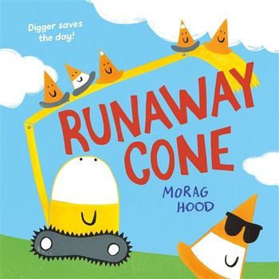
Digger, Traffic Light and the cones are all ready to start the roadworks one morning when they notice that something's wrong . . . Gary the traffic cone is missing!
A laugh-out-loud mystery adventure with fun, colourful illustrations and a twist at the end will leave our young readers excited for more.

Hen in the Bed by Katrina Charman

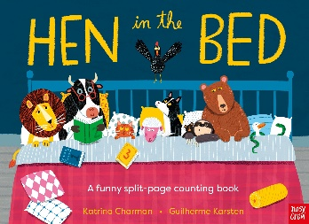
A silly, noisy twist on a favourite rhyme!
There were ten in the bed and the speckled hen said, “Roll over! Roll over!”. . .

Dick the Delightful Duck by Kaye Umansky and Ben Mantle

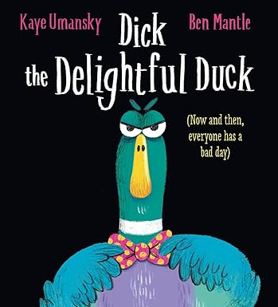
Even the most delightful ducks can have a bad day . . .
What's the matter with Dick the Duck? He's usually so kind and friendly!
But today Dick got out on The Wrong Side of Bed. He feels humpy and grumpy, cranky and cross. Can anyone help cheer him up?
We have all been enjoying this hilarious rhyming story by the much-loved author of the PONGWIFFY books.

Get cosy and listen to this one at home! https://www.youtube.com/watch?v=q7XxGijzgU4

Finally

We wish you and your families a happy and restful weekend.

Mr P Brack, Head Teacher and all at St Cuthbert’s School

