 St. Cuthbert’s RC Primary School
Newsletter 29– Friday 28th March 2025
St Cuthbert’s CARES We are: Creative Active Respectful Equal Supported

Good afternoon and welcome to this week’s Newsletter, the second last of this term. Thanks for reading it and as always, please get in touch with any questions or suggestions you have regarding its contents. Eid Mubarak to All of our Muslim Families for the upcoming celebrations due for Sunday or Monday.



Upcoming Events at St Cuthbert’s and Dates for your Diary

Dates for Your Diary: January to April 2025 (Updated)

- Wednesday 2nd April – Dance Club Parent Performance, 4pm in school hall
- Friday 4th April – Stations of the Cross Assembly P6, 9.30am School Hall

Parent Council Weekly Update:

Parent Council Easter Egg Raffle Information
P6 pupils will sell raffle tickets daily the week beginning 31st March. COST £1 per strip. A witnessed draw will be made each day in the school office. A draw for 2 giant eggs will be made at the P6 Assembly on Friday. All monies made will go to the Parent Council for their funds.
Treasurer Position

If anyone would be interested in taking over the Treasurer Position on our Parent Council please contact the Parent Council via the email address below.

Thank You

The school would like to thank the Parent Council for its latest support purchasing playground, sensory and craft equipment which has begun to arrive in school this week.

Should you wish to contact the Parent Council at any time about anything related to their work, they can be contacted via e-mail at ptastcuthberts@gmail.com

Other School News & Information

Class Photographs

Your child was given a letter this week with information about the Class photographs which will be taken on Thursday 24th April in the morning.
If you do not wish your child to be photographed, please return the tear off slip to the school office no later than Tuesday 22nd April. Thank you.

School Lunches for after Easter break

Please be aware that if you wish to order lunches (using the new menu now available) for after the Easter holidays, ordering for the first week back (22nd April) needs to be submitted no later than midnight on Wednesday 2nd April. Orders can be made for up to 90 days in advance. If you have any issues with this please contact the school office.

Easter Activities

Please see attachments sent with this Newsletter re Edinburgh Science Festival and Easter Basketball Camps. Apologies, these were not sent out last week but have been today!

P1/2 Scooter Parking Facility

This was installed on Tuesday. We hope it proves helpful.

Parent Consultations Update

Thanks to all of our parents and carers who came to our Parents Evenings and engaged constructively with parents/carers re their childrens’ learning. 96% of parents took part, we are grateful to all who did for their support and cooperation.

Parent/Carer Questionnaire (Link and QR Code Below) on School’s Progress – Closes Monday 31st March

It is our ongoing aim to make all of our parents and carers feel welcome and that they have a voice as part of our wider community. To this end, we are also keen to hear your views on the school’s progress via our online survey (we try to do this twice a year and appreciate all feedback received). The format is simple and designed to be understood and used by all parents/carers, without taking up too much of your time. Please see the QR code below. If you prefer to use a link, please also see this below (thanks to the parent who suggested this to us):

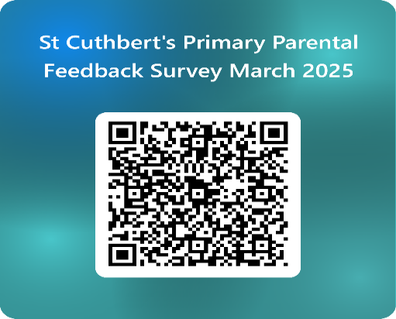

https://forms.office.com/e/FR1it17kgq

P5 & P6 Football Scores Update

The P5 and P6 football teams both played James Gillespie’s school last weekend with the P5 Team narrowly losing 5 goals to 3 and the P6’s winning 6-4.

P.E Kits on P.E. Days

A number of teachers had fed back that their pupils are not bringing P.E kits to school and are doing P.E. in uniform which presents hygiene issues. P.E days are shared termly via termly overviews. Please check with the office if you are unsure. See also comments in Pupil Voice section of the Newsletter.

Swimming Gala – Thursday 27th March

Eight of our P6 and P7 pupils attended the Edinburgh Swimming Gala at the Commonwealth Pool yesterday. All enjoyed the experience and many finished in the top 10 of their competition. Thanks to Mrs Hogg for accompanying the team and to Mrs Robson for coordinating the event.

Pupil Voice at St Cuthbert’s

The Pupil Rights and Equalities group met with Mrs Munro this week. They discussed the playground, P.E facilities – classes were surveyed and chose to change in toilets - and raising money for our Lent Charity – Mary’s Meals. They will go back to their classes to discuss three key learning questions from pupil version of How Good is Our School Document to feedback on and discuss next week.

Our Sustainability Group will meet again next week as Miss Eckersley is meeting with the city of Edinburgh council Sustainability Community of Practice this week to update them on our Sustainability work.

Our HWB Group met with Miss Tulloch on Wednesday. They discussed the idea of all pupils nominating a supportive adult that they can speak to in school about any anxieties they have. They will canvass their classes’ opinion on this and feedback to the group next week. We’ll update you on this after Easter.

Learning at St Cuthbert’s

P1 Learning Discussion

This will take place on Monday 31st March. We look forward to sharing more information with you in the final Newsletter of the term.

Learning Excursions This Week and Next Week

This week P5 took part in Outdoor Learning at Saughton Park with our partners from The Green Team. The class were involved in raft building and testing on the Water of Leith. This was linked with their recent science focus on buoyancy.

P7 also took part in an introductory experience to classical music. The ‘Art of Listening’ workshops delivered by a professional opera singer, pianist, and facilitator, explore different ways of listening in a fun and interactive way, while deepening pupils’ critical thinking skill. The workshops took place at The Hub on Castlehill, the home of the Edinburgh International Festival.

P4 & P5 Locomotive Building Engineering Workshops and Discovery Lab

Mrs Gill and Miss Mcelearney took part in STEM training before Christmas to enable them to work with Edinburgh University partners to host engineering workshops in school on Friday. The pupils had a great time using tools and wood to create basic working locomotives. A really enjoyable learning experience for both classes.

P5 will visit the Discovery Lab at the City Arts Centre on Monday to take part in science workshops and P4 will do the same on Tuesday.

P1 Spring Walk Tuesday 1st April

P1 will take part in outdoor learning with our Green Team Partners next Tuesday engaging in a Spring Nature walk to view local plant and wild life.

P1 Teaching Student

Our P1 team will be joined by a teaching student, Ms McKinly from next week up until 23rd May.

P6 Euro Quiz

Well done to our 4 Pupils who took part in this year’s quiz. We’ll hopefully hear soon if the qualified for the semi finals.

Catholic Education and Parish Update

P7 Transition Mass

This was a lovely occasion and as always our P7 pupils represented us superbly. Thanks to the parents who supported our pupils at the cathedral too.

Mary’s Meals Fundraising

All classes should now have a planned fundraiser, and we will send home information slips about these on Monday, please note although all will take part in activities, financial contributions requested are entirely optional. In the meantime, please remember that pupils are very welcome, again on an optional basis to bring in small individual contributions to Mary’s Meals from any Lenten sacrifices they have made, giving up sweets, chocolate etc to add to their class blue Mary’s Meals cup.

Fr Peter and Fr Francis

Fr Peter will be on retreat next week but will rejoin us to prepare P4 and P7 for First Holy Communions and Confirmations next term. Thanks also to Fr Francis for this term’s Masses and Sacramental Celebrations. We really appreciate the support of both of our brilliant priests at St Cuthbert’s.

CHILDREN’S LITURGY AT ST CUTHBERT’S CHURCH DURING LENT

During Lent we would like to encourage children of school age to participate in the Children’s Liturgy during the 9.30 Mass in St Cuthbert’s Church.
The Liturgy Team will be leading the children in prayers, hymns, gospel readings and reflection in our beautiful newly decorated Liturgy Room over the next four weeks of Lent.
Dates: 9th, 16th, 23rd and 30th March.
After Easter the Children’s Liturgy will resume again on a fortnightly basis.
Please encourage your child/children to come along. and hear the gospel at a level suitable to them and discuss/reflect on the message from the readings.
Thank you.

Dorothy Johnstone (School/Church Liturgy and Music Co-ordinator)

Nursery Update

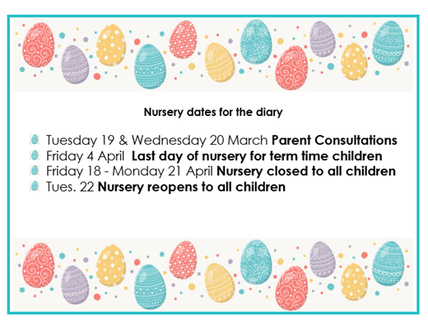

Finally

We wish you and your families a happy and restful weekend.

Mr P Brack, Head Teacher and all at St Cuthbert’s School

