 St. Cuthbert’s RC Primary School:
Newsletter 31– Friday 25th April 2025
St Cuthbert’s CARES We are: Creative Active Respectful Equal Supported

Good afternoon and welcome to this week’s Newsletter, the first of this term. We hope all who celebrated Easter had a good Easter and ask you to join us in praying for the soul of our late, much missed Pope Francis. We observed a minute’s applause for and learned about his life at today’s Assembly.



Upcoming Events at St Cuthbert’s and Dates for your Diary

Dates for Your Diary Final Term 2

These are currently with the teachers for discussion and sign off. I will share details in next week’s Newsletter.

Parent Council Weekly Update:

Playground Equipment

The playground equipment kindly supplied by the Parent Council has been distributed to all classes this week. It has been well used and appreciated by our pupils. Big thanks to the Parent Council for this help.

Easter Egg Raffle – Funds Raised

The Easter Egg Raffle in the last week of term was enjoyed by all of those who took part and raised an amazing £267.70 for Parent Council Funds, all of which will are used to support the school and its pupils.

Should you wish to contact the Parent Council at any time about anything related to their work, they can be contacted via e-mail at ptastcuthberts@gmail.com

Other School News & Information

Active Schools Clubs - Term 3

We shared information, timings and booking details of this term’s clubs with parents/carers on Wednesday via email. Clubs all commence next week. Please contact Fiona Damen via text on 07769 922 742 with any questions that you have.

‘Sleeping St Joseph’ Statue

Thanks to the kind parents who donated the statue of ‘Sleeping Joseph’ to our school. This is a statue favoured by the late, great Pope Francis, which depicts the sleeping St Joseph who was helped by angels in his dreams and invites us to confide our concerns to him. The statue is located beside the HWB Group’s ‘Feelings Box’ in our Front Reception area.

Piper for End of Term Leaver’s Procession Secured

We have been in touch with the piper who piped for us last year and he has agreed to pipe our P7 pupils and then the rest of the school out on the last day of term. The cost is £50 paid for via school funds.

Class Photographs

These took place on Thursday in school. Tempest, the company who took the photos will supply us with proofs and ordering information, hopefully by the end of next week. Orders will all be online. Further information to follow.

Payment for Matilda Trip for Choir Members – Deadline 29th April

Please note that the deadline for the payment of £15 for those choir members attending the Matilda performance at the Play House is as above. A reminder email was also sent earlier this week. Please contact us if you have any questions about payment for this exciting trip.

Online Safety Session for Parents/Carers Next Term

We were in touch with City of Edinburgh Council’s Senior Learning and Development Consultant on Child Protection before the holidays to request an Online Safety Information input for our parents and carers this term. We asked for an update this week and they are discussing how best to share this information with our parents. I’ll let you know when they get back to us.

St Augustine’s Open Morning – See Details Below:

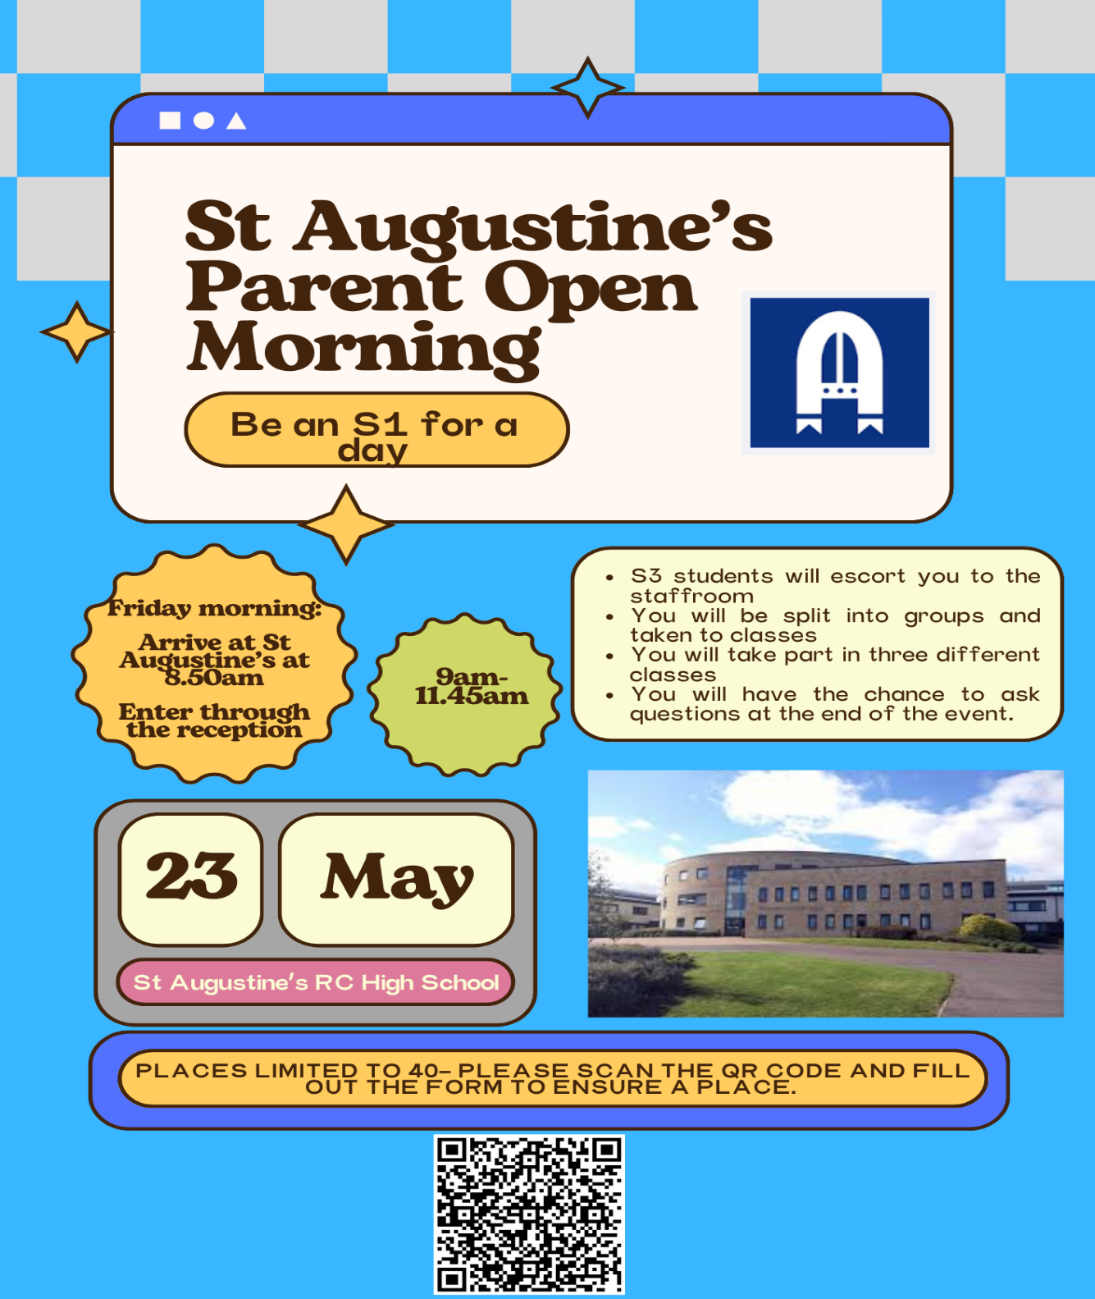
P5 & P6 Football Scores Update

On 5th April, our P5 team with a little help from 3 P6 players, held Pentland Primary to a 4-4 draw, a team they lost to 12-0 at start of the season, which shows how much they have improved! Well done P5!

Kool Skools Fairtrade Uniform Update

Further to Andy Ashcroft’s recent visit to our school and input to our parent council, he has asked us to remind parents that our school offers an ethical school uniform choice made with Fairtrade Cotton and post-consumer recycled polyester, manufactured and supplied by Koolskools (see below).

HOW TO ORDER
Go to the St Cuthbert’s Primary School buying page on the Koolskools website on the following link - https://bit.ly/42V5ekx - and place your order.
There will be a flat delivery charge of £4.99, whether you order just one or multiple garments.
Orders will take a maximum of 10 working days (15 days during the busy June to September period) to turn around, from the date of order placement.
*Please note that Koolskools are running a 10% early summer discount window from Friday 23 May to Monday 9 June 2025.
Please note that uniform items can also be purchased from B.E, our local supplier:
https://www.border-embroideries.co.uk/our-stores/edinburgh/

Business Manager
Mrs Teresa Rendall, our new Business Manager started with us this week. This term she will be working in tandem with Mrs Pamela Soutar before taking over sole responsibility in August 2025.

Pupil Voice at St Cuthbert’s

Meetings of our HWB and Pupil Rights and Equalities group will resume next week.

This week, our Sustainability Group planned their Laudato Si Assembly for later in May, planned their next visit to our Community Gardeen and watered plants in the school garden.

Learning at St Cuthbert’s

Attendance and Punctuality Update – March 2025

City of Edinburgh Council have shared last month’s attendance stats with us. Great news in terms of absence below 85%. This currently stands at 5.1% of our pupils, the lowest of all primary schools feeding into St Augustine’s. Unfortunately however attendance below 90% is still very high, with 24% of pupils (almost a quarter of the school) recording absence of this level in March. It is really important that pupils only miss school when strictly necessary. We have also seen a reduction in lateness last month. Every minute in school counts so please try your best to ensure that your child is on time as much as possible.

Parent Survey Feedback and Explanatory comments from School

Positives:

- Good communication
- High Quality Teaching and Learning
- Positive and Inclusive Ethos
- Welcoming and supportive staff

Thanks for all of these supportive comments!

Main Development Points and Responsive Comments From School

- More Clubs – please note that the school is very fortunate in terms of the number of parent and staff volunteers who provide clubs in: running, football, dance, rounders, art, gaelic football, choir all of which are done without cost and on a voluntary basis. If you are interested in volunteering to run a new club, you’d be very welcome; please contact Fiona Damen via text on 07769 922 742

- More Excursions – All classes have taken part in at least one excursion, even if this is a local visit as part of our outdoor learning. Some classes have been on a number of educational trips. We will however engage with staff about expanding opportunities of this nature going forward. We are also grateful to our Parent Council who provide a £100 contribution towards trips for all classes.
- Wider Pupil Involvement in Pupil Voice Groups. We do change and rotate the membership of these group every year but will look again at how these are organised for school year 2025-26

P6 & P7 Bikeability

P7 took part in this training on Wednesday 23rd April and P6 on Thursday 24th April. All listened well, followed instructions and put in a lot of effort during their sessions. It was great to see pupils who could not cycle before, learn to cycle! Well done to both classes. Big thanks to Mark Foster and Fiona Damen for their help coordinating this.

P7 Hub for Success – Future Further Education Programme

We have established a partnership in recent years with the Hub for Success Team to raise awareness of and aspirations to Further Education for our pupils. Their first visit to our school took place on Thursday 24th April.

P4 Excursions

P4 will visit the Forth Road Bridge/BEAR Scotland next Thursday in connection with their Science, Technology, Engineering and Maths learning over the last few weeks. As they are our First Communion Class this year and we are in the jubilee year of 2025, P4 will visit the Shrine at Schoenstatt, near the Campsie Fells on 7th May. Big thanks to the Parent Council for paying for the bus for this trip.

P6 Teaching Student

Ms Amber Brown began her 6 week placement in P6 this week. Ms Brown had a positive placement with Mrs Gill and P4 last term and we wish her well for her new placement.

Catholic Education and Parish Update

Mary’s Meals Fundraising

Thanks to all who contributed in any way to our fundraising for Mary’s Meals. We will be able to share the final amount raised in next week’s Newsletter.

P4 Schoenstatt Shrine Visit – Wednesday 7th May

As part of our Communion Preparations and to celebrate the jubilee ‘Year of Hope’, P4 will be visiting the Schoenstatt shrine near the Campsie Fells on the above date. Huge thanks to the Parent Council for agreeing to fund the coach to take them there.

CHILDREN’S LITURGY AT ST CUTHBERT’S CHURCH AFTER EASTER

After Easter the Children’s Liturgy will resume again on a fortnightly basis.
Please encourage your child/children to come along. and hear the gospel at a level suitable to them and discuss/reflect on the message from the readings.
Thank you.

Dorothy Johnstone (School/Church Liturgy and Music Co-ordinator)

Nursery Update

Parents’ and carers’ views and use of Early Learning and Childcare Survey
Parents’ and carers’ views and use of Early Learning and Childcare Parents’ and carers’ are being invited to take part in an online survey about their views and use of early learning and childcare (ELC) in Scotland, such as nurseries, family centres and childminders.
The survey is open to all parents and carers who have children aged 0-6 who have not yet started school. The research is being carried out by ScotCen, on behalf of the Scottish Government. The survey should take around 15-20 minutes to complete. For more information about the study, please visit the study webpage: www.natcen.ac.uk/ELCparents If you would like to take part, please go to: https://survey.natcen.ac.uk/ELCparents If you have any questions, you can contact the study team by email at ELCparents@scotcen.org.uk or by freephone on 0800 652 0201.

Parental Consultation Feedback
During every parental Consultation evening, the st Cuthbert’s team ask families to complete a questionnaire. The aim to gather valuable feedback on various aspects of the nursery, including childcare quality, staff, the environment, and child development. This feedback helps us understand parental perceptions and identify areas for improvement. This year both the feedback and comments were very positive. Thank you to all that took part.

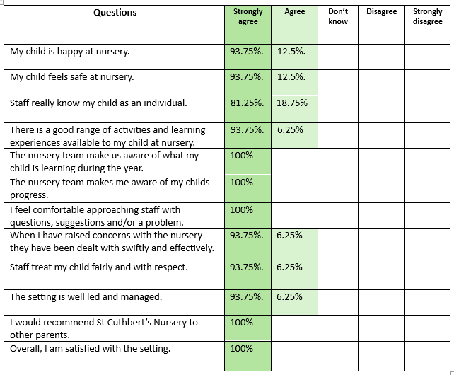
Comments/Feedback
“We are happy with [our childs] progress and appreciate your efforts on him.”
“I am happy with my kids progress in all aspects. Thank you.”
“I am Happy! Thank you all!”
“I cannot Thank St Cuthbert’s team enough. We are so grateful for the love, care and experiences that you provide [our child] with. Much appreciated.”
“It was a great Parents Consultation, connecting the dots that work for [my child].”
“Great job. Keep it up!”

Finally

We wish you and your families a happy and restful weekend.
Mr P Brack, Head Teacher and all at St Cuthbert’s School

