 St. Cuthbert’s RC Primary School:
Newsletter 33– Friday 9th May 2025
St Cuthbert’s CARES We are: Creative Active Respectful Equal Supported

Good afternoon and welcome to this week’s Newsletter. Thanks for reading it, please let us know if you have any questions about its contents.

Upcoming Events at St Cuthbert’s and Dates for your Diary

Dates for Your Diary Final Term 2

- Friday 9th May – Termly Overviews to be sent out
- Friday 16th May – P1 Class Assembly, 9.30am School Hall
- Friday 23rd May – Confirmations, 7pm St Cuthbert’s Church
- Thursday 29th May – Ascension Day Mass, 9.30am St Cuthbert’s Church
- Friday 30th May, School Sports Day, Option 1, 9.30am start, school grounds
- Tuesday 3rd June – Strings Showcase, 2pm School Hall
- Friday 6th June – P2 Mass, 9.30 School Hall if it rains on 30th May and School Sports Day, Option 2 is required on this date, we’ll rearrange P2 Assembly.
- Thursday 12th June – P7 Leaver’s Mass, 9.30am St Cuthbert’s Church
- Friday 13th June – St Cuthberts’ Got Talent Showcase, time to be confirmed, school hall
- Sunday 15th June – First Holy Communions, 9.30am St Cuthbert’s Church
- Friday 20th June – End of Session Reports issued
- Wednesday 25th June – P7 Leavers’ Assembly, 2pm School Hall
- Thursday 26th June, P7 Leavers’ Parade, 12.45pm School Playground
- Thursday 26th June, End of Term, School finishes for all classes at 1pm

Parent Council Weekly Update:

Our final meeting of the year will be on Friday 6th June in the school Nurture Room. All parents/carers are welcome to attend and share their ideas.

Should you wish to contact the Parent Council at any time about anything related to their work, they can be contacted via e-mail at ptastcuthberts@gmail.com

Other School News & Information

P7 School Camp 2026

A letter was sent out this week to gauge interest re school camp next year and also to allow for an extended window for payment to make the high cost more affordable. Please return the reply slip attached with letter and please also let us know if you have any questions.

P1 August 2025

We have sent letters this week to the families of pupils who City of Edinburgh Council have advised us have secured

Active Schools Clubs Update

All clubs are now up and running, please contact Fiona Damen via text on 07769 922 742 with any questions that you have about Active Schools. Fiona has also asked us to share details of judo clubs at Forrester High School. See below:
Activity | Day | Age | Time | Dates | Venue | Sign Up
Judo | Thursday | P1-P3 | 16:30-17:15 | 22, 29 May  5, 12 June | Gym Hall @ Forrester High School | Contact Johnny Imrie:  johnnyimrie93@gmail.com
Judo | Thursday | P4-P7 | 17:15-18:00 | 22, 29 May  5, 12 June | Gym Hall @ Forrester High School | Contact Johnny Imrie:  johnnyimrie93@gmail.com

P4-7 American Football - Thursday Lunchtime Club For 3 Weeks

A letter re the American Football club was sent this week. The club will run from 8th to 22nd May. Please return reply slip by close of play Wednesday 7th May, if you would like your child to take part.

Please also see appendix re Summer Football clubs at the end of this Newsletter.

Breakfast Club Staffing Changes

From Wednesday 7th May, Mrs Sherrie Hogg will be working with Ms Louise McVey in our Breakfast Club. Mrs Pat Wallace will be undertaking other duties to support the school going forward.

Divine Mercy Painting

Thanks to the kind parents who donated the ‘Divine Mercy’ painting and the other parents who framed it. The painting is located on our altar in the school’s Front Reception area. Our ‘Sleeping St Joseph’ statue, mentioned in last week’s Newsletter now has an explanatory title on the wall above it. We also introduced the statue to our pupils at Assembly last week. We’ll do the same for the Divine Mercy at our next Assembly.

Peace Garden Paint Refresh

Community Volunteers from Aegon will visit the school on Tuesday 6th May to paint the Peace Garden. If they have time, they will also paint the yellow friendship bench outside P1/2.

Class Photographs

An email was sent out on Monday with a class specific link for each class, enabling parents to order photos should they wish to do so. Please contact us with any questions.

Payment for Matilda Performance Trip for Choir Members

Please note that the deadline for the payment of £15 for those choir members attending the Matilda performance at the PlayHouse has now passed and Parent Pay facility is closed. We can however accept cash payment up until end of May. Please help us with this as if there is a short fall we will need to reconsider organising trips of this kind in future.

Online Safety Session for Parents/Carers Next Term

We were in touch with City of Edinburgh Council’s Senior Learning and Development Consultant on Child Protection before the holidays to request an Online Safety Information input for our parents and carers this term. We asked for an update last week and again this week, they are discussing how best to share this information with our parents. I’ll let you know when they get back to us.

P5 & P6 Football Scores Update

P5 lost a tough match away at Preston Street 7-3. P6 had a comprehensive 10-2 win away against Pentland. Well done to both teams and particular thanks to their coaches for their time and effort which ensures that both teams have the opportunity to play regularly.

P5 Football Fundraiser

Please see details below for an upcoming fundraiser for our P5 Football team. There is also a QR code and link for those who would like to contribute towards the teams’ fundraising.

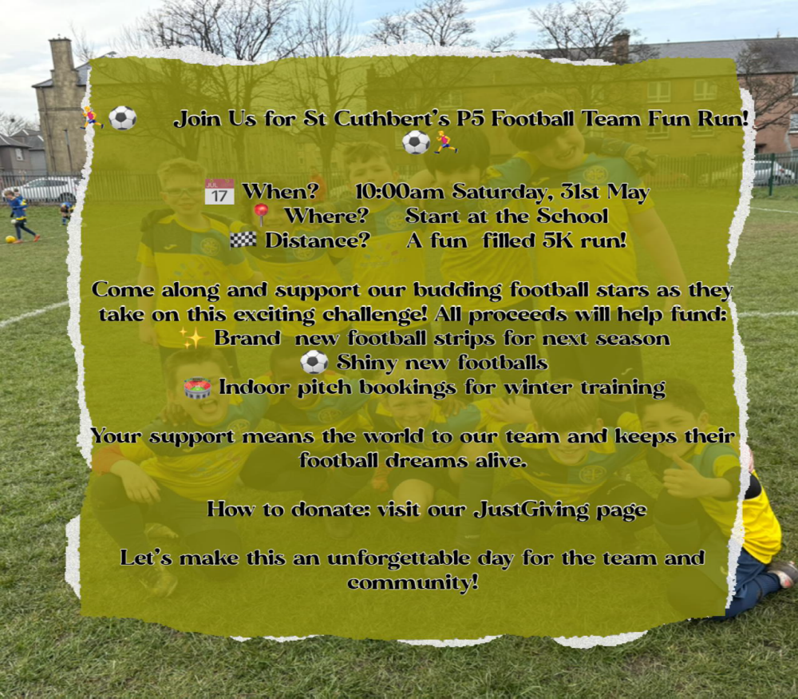
Just Giving details to support event: 

https://www.justgiving.com/crowdfunding/chris-evans-29?utm_medium=CR&utm_source=CL

St Augustine’s Open Morning – See Details Below:

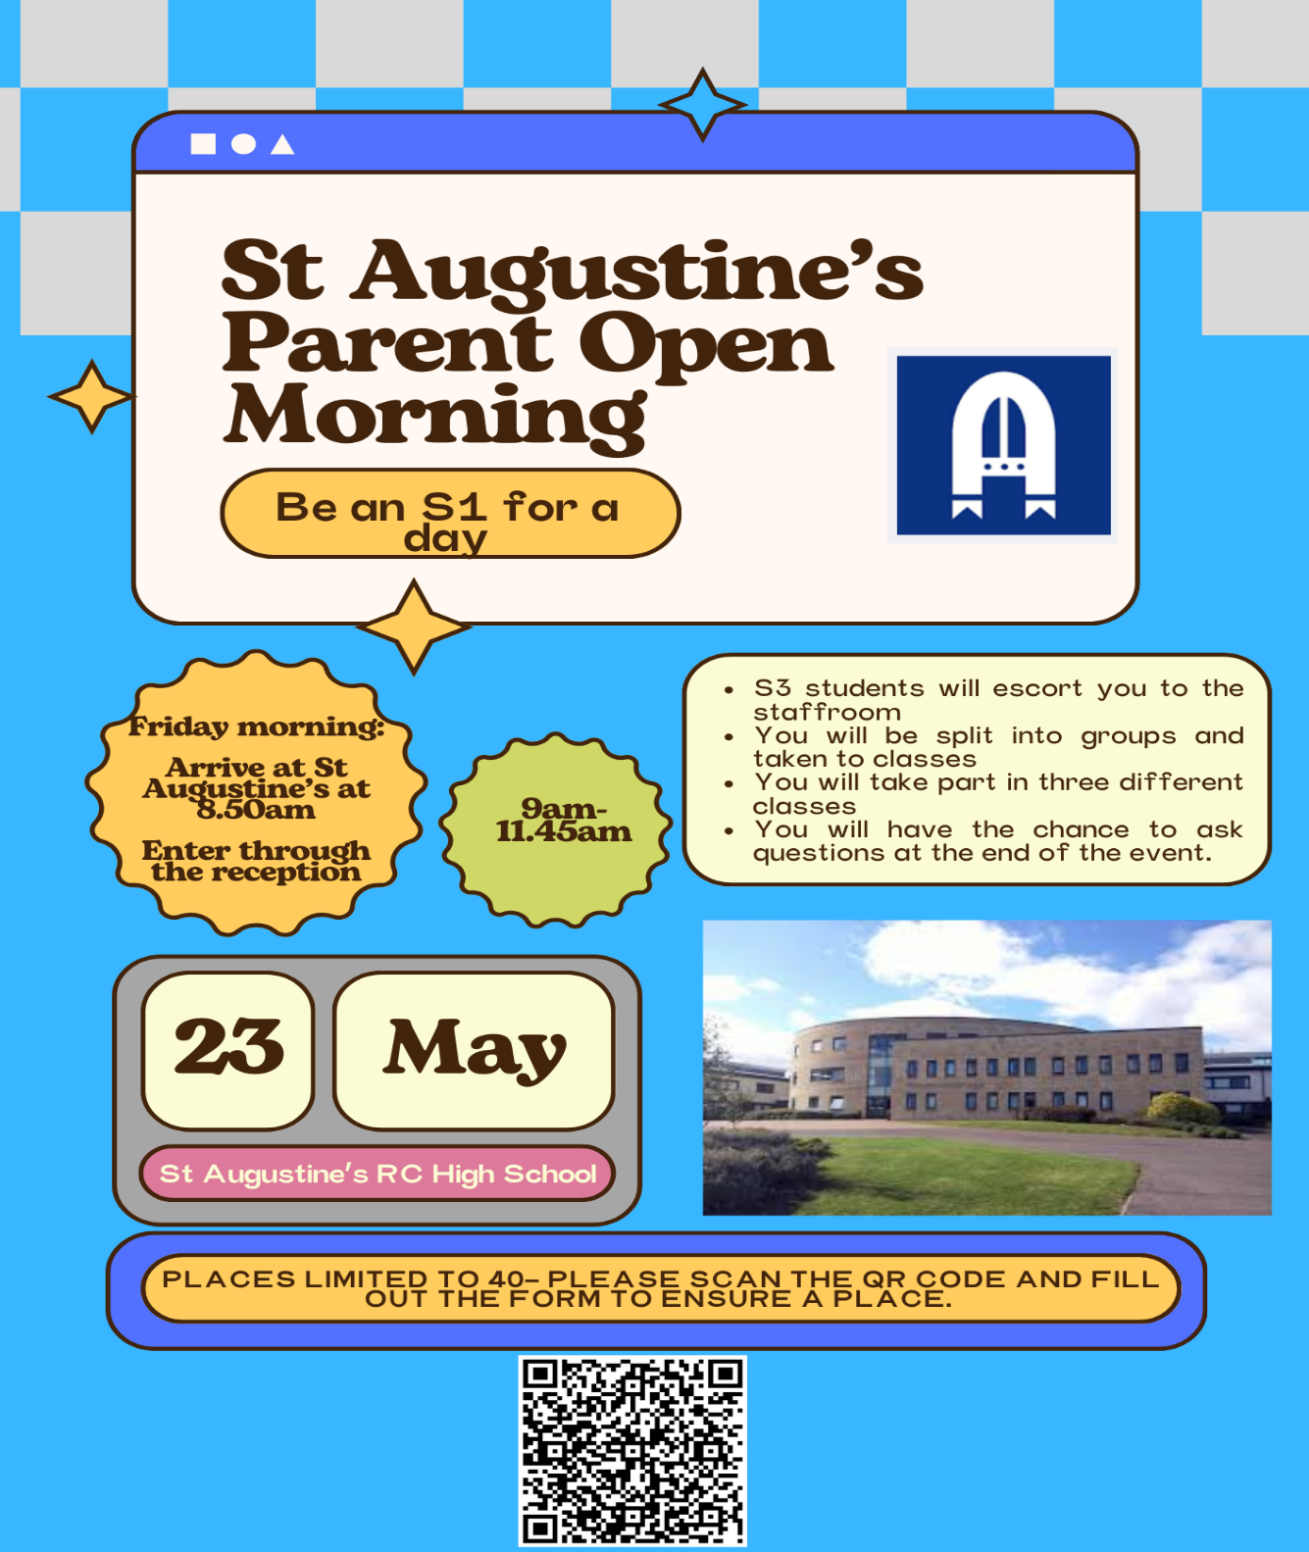

Pupil Voice at St Cuthbert’s

Our Pupil Rights and Equalities and HWB Groups will meet again next week.

Learning at St Cuthbert’s

Nurture Room Appeal

Our PSA staff are appealing for items to support our Nurture Work:

- Small cars
- Farm animals
- Dolls of all cultures
- Play food items
- Bead Maze

Nursery P1 Transition

School Management, Nursery and P1 staff met this week to plan transition activities for our pre-school nursery children to help them prepare for Nursery School. Further to this Mrs Bryce, our P1 EYP will be working in Nursery, in the mornings from Monday to Thursday until June to help her get to know the P1 pupils for next session before August. George Sarris from our Nursery will support Mrs Igoe in P1 during these mornings.

P7/S1 Transition

All P7 pupils attending state secondary schools in Edinburgh will visit their allocated High School from Tuesday 17th to Thursday 19th June.

P1/2/3 Transition

Staff in P1, P2 and P3 will meet on Tuesday’s in-service day to discuss a plan for pupils transitioning from P1 to P2 and P2-P3.

CAT Session 10 – Launching the Learning and Digital Skills

P4 Excursions

As they are our First Communion Class this year and we are in the Jubilee Year of 2025, P4 will also visit the Shrine at Schoenstatt, near the Campsie Fells on 7th May. Big thanks to the Parent Council for paying for the bus for this trip. There is however a charge for the retreat itself. As with the trip above the £2 charge for this trip can be paid for via Parent Pay. Deadline is close of play Wednesday 7th May. Thanks to all who have paid already. W

Apologies for asking for payment for two trips this term, we do try to keep paid trips to a minimum but hope you will understand the need to give the pupils the widest possible range of educational experiences.

Glee Competition Photos

Mrs Munro has asked me to let parents know that photos from the Glee Competition can be viewed on the MS Team – St Cuthbert’s Choir. She said that login details have been shared for this. Please ask if you have any questions. See example below:



Catholic Education and Parish Update

Fr Peter Working With Sacramental Classes Next Week

Fr Peter Kelly will be working with P4 and P7 next week to support their preparation for the Sacraments of First Holy Communion and Confirmation.

Mary’s Meals Fundraising Total Confirmed

Thanks to all who contributed in any way to our fundraising for Mary’s Meals. The final total raised was an excellent £259.40 which has now been sent to the charity. Huge thanks for your generosity.

P4 Schoenstatt Shrine Visit – Wednesday 7th May

As part of our Communion Preparations and to celebrate the jubilee ‘Year of Hope’, P4 will be visiting the Schoenstatt shrine near the Campsie Fells on the above date. Huge thanks to the Parent Council for agreeing to fund the coach to take them there.

CHILDREN’S LITURGY AT ST CUTHBERT’S CHURCH AFTER EASTER

After Easter the Children’s Liturgy will resume again on a fortnightly basis.
Please encourage your child/children to come along. and hear the gospel at a level suitable to them and discuss/reflect on the message from the readings.
Thank you.

Dorothy Johnstone (School/Church Liturgy and Music Co-ordinator)

Nursery Update

Finally

We wish you and your families a happy and restful weekend.
Mr P Brack, Head Teacher and all at St Cuthbert’s School

Appendix 1 – Summer Football Camps

Hi everyone.

I am delighted to announce that booking for our City of Edinburgh Summer Football Camps is now OPEN! 😊

Please visit the links below for more information and to book your place:

7th – 11th July

P1 – P4 https://getedinburghactive.spydus.co.uk/cgi-bin/spydus.exe/ENQ/WPAC/EVSESENQ?SETLVL=&RNI=180460
P5 – S1 https://getedinburghactive.spydus.co.uk/cgi-bin/spydus.exe/ENQ/WPAC/EVSESENQ?SETLVL=&RNI=180463

14th – 18th July

P1 – P4 https://getedinburghactive.spydus.co.uk/cgi-bin/spydus.exe/ENQ/WPAC/EVSESENQ?SETLVL=&RNI=180466
P5 – S1 https://getedinburghactive.spydus.co.uk/cgi-bin/spydus.exe/ENQ/WPAC/EVSESENQ?SETLVL=&RNI=180469

21st – 25th July

P1 – P4 https://getedinburghactive.spydus.co.uk/cgi-bin/spydus.exe/ENQ/WPAC/EVSESENQ?SETLVL=&RNI=180472
P5 – S1 https://getedinburghactive.spydus.co.uk/cgi-bin/spydus.exe/ENQ/WPAC/EVSESENQ?SETLVL=&RNI=180475

Please select the relevant age group based on the year group your child will be in for academic year 2025/26.

From the feedback surveys from our recent sold-out Easter Camp, parents told us:

- 100% agreed or strongly agreed that the staff were welcoming and friendly
- 100% agreed or strongly agreed that their children enjoyed their week
- 100% said they would come back

We look forward to hopefully seeing you this summer! 😊

Thanks,

Jack

Jack Beesley | Football Development Officer | Sports and Outdoor Learning Unit | Education (Wider Achievement & Lifelong Learning) | Children, Education & Justice Services | The City of Edinburgh Council | Forrester / St Augustine’s Community Sports Hub, Broomhouse Road, Edinburgh EH12 9AE | 07894 816 336 | @Edin_Football | @coe_sport | www.edinburgh.gov.uk

