 St. Cuthbert’s RC Primary School:
Newsletter 34– Friday 16th May 2025
St Cuthbert’s CARES We are: Creative Active Respectful Equal Supported

Good afternoon and welcome to this week’s Newsletter. Thanks for reading it, please let us know if you have any questions about its contents.

Upcoming Events at St Cuthbert’s and Dates for your Diary

Dates for Your Diary Final Term 2 (Updated re P2 Assembly and Dance Showcase)

- Friday 23rd May – Confirmations, 7pm St Cuthbert’s Church
- Thursday 29th May – Ascension Day Mass, 9.30am St Cuthbert’s Church
- Friday 30th May, School Sports Day, Option 1, 9.30am start, school grounds
- Tuesday 3rd June – Strings Showcase, 2pm School Hall
- Friday 6th June – P2 Assembly, 9.30 School Hall if it rains on 30th May and School Sports Day, Option 2 is required on this date, we’ll rearrange P2 Assembly
- Wednesday 11th June – Dance Club Showcase, 4.45pm at St Augustine’s High School Theatre – letters to follow.
- Thursday 12th June – P7 Leaver’s Mass, 9.30am St Cuthbert’s Church
- Friday 13th June – St Cuthberts’ Got Talent Showcase, time to be confirmed, school hall
- Sunday 15th June – First Holy Communions, 9.30am St Cuthbert’s Church
- Friday 20th June – End of Session Reports issued
- Wednesday 25th June – P7 Leavers’ Assembly, 2pm School Hall
- Thursday 26th June, P7 Leavers’ Parade, 12.45pm School Playground
- Thursday 26th June, End of Term, School finishes for all classes at 1pm

Parent Council Weekly Update:

Our final meeting of the year will be on Friday 6th June in the school Nurture Room. All parents/carers are welcome to attend and share their ideas.

Should you wish to contact the Parent Council at any time about anything related to their work, they can be contacted via e-mail at ptastcuthberts@gmail.com

Other School News & Information

School Lunches/Cyber Attack on City of Edinburgh Council

Further to the e-mail sent out on Monday with regards to Parentpay deleting all the menu selections made from this week right through until the end of term, our lunch figures given to the kitchen yesterday are greatly reduced. On our email, Parents were advised to log in to their Parentpay account and select menu choices for their child/children from next week through until the end of term.

If you haven’t done so already, Please log in to your account, this weekend and if there has been no menu choice selected for next week Tuesday 20th – Friday 23rd May, you will need to send your child in with a packed lunch as the kitchen will be unable to supply a lunch other than for those already booked. Please also select menu choices for the rest of the term if your child wishes a lunch on any day. I am sorry about this inconvenience, but this was an error out with our control. Your co-operation is very much appreciated.

P7 School Camp 2026 – Deposits Due by 23rd June

A letter was sent out last week to gauge interest re school camp next year and also to allow for an extended window for payment to make the high cost more affordable. Deposit of £100 is due by 23rd June. Please return the reply slip attached with letter and please also let us know if you have any questions about payment.

Rag Bag Collection – Deadline Tuesday 3rd June

On Wednesday information about the upcoming Rag Bag collection was send via e-mail to all parents. All items that you wish to donate must be placed in the container in the front playground, no later than the evening of Tuesday 3rd June 2025.
Please ensure items are in a securely tied plastic bag. Rag Bag can accept good quality clean Men’s, Ladies and Children’s clothing, belts, bags and paired shoes (tied together).
The bags will be collected and transported to the Rag Bag factory where they will be sorted and graded for reuse or recycling.

P1 Places for August 2025

We have sent letters this week to the families of pupils who City of Edinburgh Council have advised us have secured a place in our P1 class for school year 25-26. If you have not heard from City of Edinburgh Council, please contact them on 0131 200 2000.

P1 Induction Day – Wednesday 4th June 1.30pm

All parents/carers of pupils attending St Cuthbert’s in August 2025 are welcome to attend this event; meet our P1 staff, receive a welcome pack, learn all about our school community and meet catering, active and after school club staff. There will also be the chance to talk to our School Leadership team and Admin staff to ask any questions that you have.

Inter-scholastics P7/6 – Monday 26th May 2025

We held trials for this year’s Interscholastics team on Wednesday. Letters will go out to those pupils who will be taking part next week. Miss Robertson will lead the team at this event.

Summer Football Camps – City of Edinburgh Council

Please also see appendix re new Summer Football clubs at the end of this Newsletter.

April Attendance and Punctuality Update

The percentage of pupils with absence below 85% for April was a relatively low 5.6%. Thanks to all for their support with this. However, attendance under 90% is still a very high 18.5%. Please try wherever possible to send your child to school everyday. As City of Edinburgh Council advise, every minute spent in school counts in relation to learning. Please also try to ensure that wherever possible your child arrives at school on time, as this too has a positive impact on learning.

Payment for Matilda Performance Trip for Choir Members – deadline end of May

Parents who have managed to pay for their child’s ticket have received a confirmation slip, thanking them for their payment. There is however still time to hand in a £15 payment before the end of this month if you haven’t managed to pay yet. Thanks for your cooperation.

Online Safety Information for Parents/Carers This Term

As explained in last week’s Newsletter, City of Edinburgh Council are not currently able to provide online safety sessions for parents/carers. They have however provided the following links for us to share with you:

Keep Children Safe Online: Information, advice, support - Internet Matters

Keeping children safe online | NSPCC

Safe-and-happy-online-March-2021 - RSHP

Online Safety Act: explainer - GOV.UK

Keeping children safe online - Parent’s questions answered | Barnardo's

Online Behaviour & Safety | Parent Club

P5 & P6 Football Teams Update

Our P5 team lost a close game to Sciennes 4-3 on Saturday. P6 won 10-2 away to Prestonfield.

P6 took part in the EPSSA Cup qualifying group stages on Tuesday night. Although the team were unable to achieve any victories, they tried hard and played well. Thanks to all of the parents and carers who supported them too.

Koolskools Fairtrade Uniform Summer 10% Discounts

23 May to 9 June 2025; 30 June to 13 July 2025

Koolskools have asked us to notify parents that this year they will be running two summer 2025 10% online discount windows for Fairtrade/ECO uniform – from Friday 23 May to Monday 9 June inclusive; and from Monday 30 June to Sunday 13 July inclusive.

Koolskools hope that parents will order well ahead of the anticipated August rush to buy school uniform!

HOW TO ORDER
Go to the buying page on the Koolskools website on the following link - https://www.koolskools4u.co.uk/schools-list/ - and place your order. There is a flat delivery charge of £4.99.
Orders take a maximum of 10 working days to turn around (15 working days between June and September) from the date of order placement.

We will share a separate document with a list of uniform items available and prices.

Embroidered Uniform Items – BE Uniforms

Please note that Borders Embroidery continue to be our main supplier of embroidered uniform. Please see link to their website below:

https://www.border-embroideries.co.uk/

Pupil Voice at St Cuthbert’s

Our Pupil Rights and Equalities Group met on Tuesday and discussed our Rights Respecting Schools display board and how it could be improved to reflect use of rights in our school. They came up with some great ideas.

Due to Excursions, sports trials and other events in school, our HWB Group was unable to meet this week but will meet again next week.

Our Sustainability Group visited the Community Garden to weed and plan lettuce, beetroot and radishses. They also practiced for their Laudato Si Assembly on May 22nd as well as doing their usual weekly tasks to maintain our plants and planters across the school grounds.

Learning at St Cuthbert’s

Learning Walks

Myself and Mrs Munro visited all classes on Thursday to monitor pupil engagement and knowledge of their learning. The visits were extremely positive with all classes displaying focus, engagement and pupil knowledge of learning.

Support for Learning Liaison Meetings

Our P1,P2, P3 and P6 teachers all met with Mrs Peake, our Support for Learning Teacher this week to plan for pupil learning supports for August 2025.

Staffing for School Year 2025-26/Meet the Teacher

Interviews are being held across Edinburgh on Thursday 23rd May to fill school vacancies for 2025-26. Once these are held and results processed we will be in a better position to plan our staffing for next year. I will keep you informed as to our progress. There will also be a meet the teacher afternoon for pupils at a date to be determined during week commencing 16th June.

Benedetti Foundation Day

Congratulations to our P6 violinists and cellists who attended this event and did the school proud. Please see photo from music teachers below:

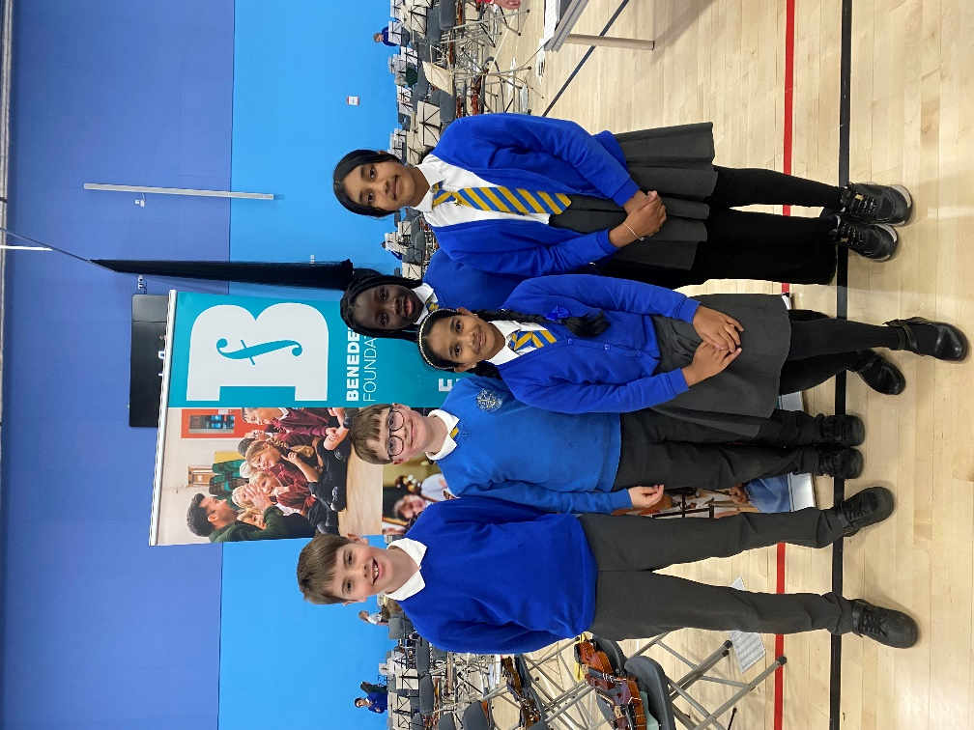

Nursery P1 Transition

Our Nursery Leaders have shared this year’s transition programme with their parents. This will include visits to the P1 class, P.E Lessons, visits to the lunch hall, Assemblies and Mass. Our P1 Teacher will visit Nursery for an afternoon in June, whilst Mrs Bryce will continue to get to know the children who are coming to St Cuthbert’s next year through her work in the nursery.

P7/S1 Transition

All P7 pupils attending state secondary schools in Edinburgh will visit their allocated High School from Tuesday 17th to Thursday 19th June.

P1/2/3 Transition Update

Myself and our P1-3 staff met after school on Wednesday to discuss plans for transition to P2 and P3 for our current P1 and P2 classes. We have decided that visits to classes and playgrounds will take place on 3 Tuesdays, beginning 21st May. Pupils will visit their classrooms for next year, receive a tour of upper school area and learn where to line up and hang up coats and bags.

Class Excursions and National Youth Choir of Scotland (NYCOS)Workshop This Week

P4 visited Saughton Park on Wednesday morning to learn about local trees and fauna.
P5 visited The Water of Leith, also on Wednsday for Outdoor Learning connected to their curricular work on Natural Disasters, particularly in relation to flood plains and flooding.
P3 took part in their second singing workshop with NYCOS.

Catholic Education and Parish Update

School Rosary in Honour of Our Lady in the Month of May – Friday 16th May

Thanks so much to all of the pupils, parents and staff who attended this lovely event. There can be few better things than an open air rosary to Our Lady in the month of May. Thanks to Sylvia and all involved in organising the prayer.

Fr Peter Working with Sacramental Classes

Fr Peter Kelly will be working with P4 and P7 throughout this term to support their preparation for the Sacraments of First Holy Communion and Confirmation.

Sacrament of Confirmation – Friday 23rd May

We look forward to the celebration of the sacrament of Confirmation on Friday 23rd May at 7pm in St Cuthbert’s Church. The pupils have been working hard to prepare. Thanks for all parents involved in this preparation as well as to Mrs Peake and Fr Peter for their work in school.

Nursery Update

The Shape of things to come
In nursery, children often learn about shape by noticing the properties of 3D shapes through play, creating structures or arrangements and noticing which shapes stack and which roll.
This week they have been experiencing 3D shapes by feeling models and running their fingers along the faces, curved surfaces, edges, and vertices.
We were also looking for opportunities for children to notice common 3D shapes in the real world. For example, noticing that an unopened cereal box is a cuboid, or a football ball is a sphere.


Sunny days are here again!
St Cuthbert’s nursery children love being outdoors in the garden and with nicer weather on the horizon they may be out for longer. Can we please ask that you bring in suncream for your child and hand it to a member of the team? It will be marked with your child’s name, so we always know we are using your preferred sun cream on your child. On days when the UV index is set to be medium or high, please apply suncream to your child before coming to nursery. Ensure your child is dressed in suitable clothing and that shoulders are covered, ideally light-weight cotton clothing suitable for the sun, with long sleeves and long legs. Please provide a sun hat when UV levels reach 3 or above, preferably Legionnaires design (i.e. with an extended back and side to shield children’s neck and ears from the sun).

Finally

We wish you and your families a happy and restful weekend.
Mr P Brack, Head Teacher and all at St Cuthbert’s School

Appendix 1 – Summer Football Camps

Hi everyone.

I am delighted to announce that booking for our City of Edinburgh Summer Football Camps is now OPEN! 😊

Please visit the links below for more information and to book your place:

7th – 11th July

P1 – P4 https://getedinburghactive.spydus.co.uk/cgi-bin/spydus.exe/ENQ/WPAC/EVSESENQ?SETLVL=&RNI=180460
P5 – S1 https://getedinburghactive.spydus.co.uk/cgi-bin/spydus.exe/ENQ/WPAC/EVSESENQ?SETLVL=&RNI=180463

14th – 18th July

P1 – P4 https://getedinburghactive.spydus.co.uk/cgi-bin/spydus.exe/ENQ/WPAC/EVSESENQ?SETLVL=&RNI=180466
P5 – S1 https://getedinburghactive.spydus.co.uk/cgi-bin/spydus.exe/ENQ/WPAC/EVSESENQ?SETLVL=&RNI=180469

21st – 25th July

P1 – P4 https://getedinburghactive.spydus.co.uk/cgi-bin/spydus.exe/ENQ/WPAC/EVSESENQ?SETLVL=&RNI=180472
P5 – S1 UNFORTUNATELY THIS GROUP IS NOW FULL

Please select the relevant age group based on the year group your child will be in for academic year 2025/26.

From the feedback surveys from our recent sold-out Easter Camp, parents told us:

- 100% agreed or strongly agreed that the staff were welcoming and friendly
- 100% agreed or strongly agreed that their children enjoyed their week
- 100% said they would come back

We look forward to hopefully seeing you this summer! 😊

Thanks,

Jack

Jack Beesley | Football Development Officer | Sports and Outdoor Learning Unit | Education (Wider Achievement & Lifelong Learning) | Children, Education & Justice Services | The City of Edinburgh Council | Forrester / St Augustine’s Community Sports Hub, Broomhouse Road, Edinburgh EH12 9AE | 07894 816 336 | @Edin_Football | @coe_sport | www.edinburgh.gov.uk

