 St. Cuthbert’s RC Primary School:
Newsletter 36– Friday 30th May 2025
St Cuthbert’s CARES We are: Creative Active Respectful Equal Supported

Good afternoon and welcome to this week’s Newsletter. Thanks for reading it, please let us know if you have any questions about its contents.

Upcoming Events at St Cuthbert’s and Dates for your Diary

Dates for Your Diary Final Term 2 (Next Week’s Activities Highlighted)

- Tuesday 3rd June – Strings Showcase, 2pm School Hall – all parents and carers of strings pupils welcome to attend.
- Friday 6th June – P2 Assembly, 9.30 School Hall - if it rains on 30th May and School Sports Day, Option 2 is required on this date, we’ll rearrange P2 Assembly
- Friday 6th June – Final Parent Council Meeting of Term 11am, Nurture Room
- Wednesday 11th June – Dance Club Showcase, 4.45pm at St Augustine’s High School Theatre – letters to follow.
- Thursday 12th June – P7 Leaver’s Mass, 9.30am St Cuthbert’s Church
- Friday 13th June – St Cuthberts’ Got Talent Showcase, time to be confirmed, school hall
- Sunday 15th June – First Holy Communions, 9.30am St Cuthbert’s Church
- Friday 20th June – End of Session Reports issued
- Wednesday 25th June – P7 Leavers’ Assembly, 2pm School Hall
- Thursday 26th June, P7 Leavers’ Parade, 12.45pm School Playground
- Thursday 26th June, End of Term, School finishes for all classes at 1pm

Parent Council Weekly Update:

Our final meeting of the year will be on Friday 6th June in the school Nurture Room. All parents/carers are welcome to attend and share their ideas.

Should you wish to contact the Parent Council at any time about anything related to their work, they can be contacted via e-mail at ptastcuthberts@gmail.com

Other School News & Information

School Sports Day

Big thanks to all parents and carers who attended today. We hope you and the children enjoyed the event as we did. Big thanks to the Parent Council for the ice creams.

New and Pre-loved Uniform – Wednesday Mornings Before School in Main Playground

We have received and are keen to distribute a range of new and preloved uniform items for all age ranges. These will be available from the playground outside of our school office on Wednesday mornings until the end of term. There are no costs for any of these items.

Breakfast Club 2025-26

In order to gauge demand for our breakfast club and as an annual requirement by Edinburgh Council, any parent who is interested in their child attending Breakfast Club from August onwards should complete a registration form either by requesting one in person from the school office or via e-mail, admin@st-cuthberts.edin.sch.uk. ALL forms must be returned to the school office no later than Monday 16th June 2025. Breakfast club may be offered Monday to Friday from 8am – 8.55am term time. The cost would be £1.50 per day per child. In line with council directives for schools to become cashless, parents would be required to make payment at least a month in advance and book their child in via a parentpay link. Once responses have been received, we will supply further information.

School Lunches Update

As mentioned in last week’s newsletter, due to the cyber attack on City of Edinburgh Council, it appears that Parentpay have deleted all the menu choices made from 12th May until 26th June; the end of term.
If you haven’t already done so could you please log in to your meal options and ensure that if you want a school lunch for your child that your chosen menu options until the end of term are still registered. The kitchen are unable to supply a particular lunch for your child if one has not been ordered. We apologise for this inconvenience, but this was an error out with our control. Your co-operation is very much appreciated.

Hawaiian Luau – Special Summer Menu Choice- Thursday 19th June(P1-6 pupils)

On Thursday 19th June the kitchen will be offering a Special Hawaiian Luau menu. The options available will be:
Huli Huli BBQ chicken with sweet potato fries, mini corn and tropical salad bar
OR
A vegetarian option of
Fishless finger island slider with mini corn and tropical salad bar.
PLEASE NOTE THERE WILL BE NO BAKED POTATO OPTION THAT DAY.
They will then have a choice of pineapple cake with coconut cream or Mango iced smoothie with tropical fruit salad.
If you wish your child to have a school lunch on that day please order no later than Wednesday 11th June.

St Cuthbert’s Got Talent – Friday 13th June (Deadline Extended to Monday 2nd June)

We are hoping to have an Assembly (maybe two, depending on numbers) on the above date to allow pupils to showcase a particular talent, for example in singing, dancing or playing an instrument. A letter was sent out this week to help us assess numbers. Please note that only those pupils whose parents have returned the slip can perform. See deadline date above.

Mobile Phones in School

Can I ask that all parents/carers remind children as we will do that mobile phones should not be produced on school premises and should be handed to and collected from teachers at the start and end of each day.

Considerate Parking

Please avoid using PDSA car parking, specially disabled bays at drop off and collection times. We have received complaints about this from the local community.

EDAN Hub Awareness Information

Information for this new service offering support for parents of ASN children was sent out on Monday of this week. Please contact us if you would prefer a paper copy.

P7 School Camp 2026 – Deposits Due by 23rd June

A letter was sent out last week to gauge interest re school camp next year and also to allow for an extended window for payment to make the high cost more affordable. Deposit of £100 is due by 23rd June. Please return the reply slip attached with letter and please also let us know if you have any questions about payment.

Rag Bag Collection – Deadline Tuesday 3rd June

On Wednesday information about the upcoming Rag Bag collection was send via e-mail to all parents. All items that you wish to donate must be placed in the container in the front playground, no later than the evening of Tuesday 3rd June 2025.
Please ensure items are in a securely tied plastic bag. Rag Bag can accept good quality clean Men’s, Ladies and Children’s clothing, belts, bags and paired shoes (tied together).
The bags will be collected and transported to the Rag Bag factory where they will be sorted and graded for reuse or recycling.

P1 Induction Day – Wednesday 4th June 1.30pm

All parents/carers of pupils attending St Cuthbert’s in August 2025 are welcome to attend this event; meet our P1 staff, receive a welcome pack, learn all about our school community and meet catering, active and after school club staff. There will also be the chance to talk to our School Leadership team and Admin staff to ask any questions that you have.

Inter-scholastics P7/6

Congratulations to our Interscholastics team who took part in the annual Interscholastics Athletics event at Meadowbank Stadium on Monday and represented the school so well. Big thanks to Miss Robertson for leading the Team and also to our Parent Helpers who were a great support on the day!

Fire Evacuation Drill

Our final planned fire drill of this school year was held successfully on Tuesday morning. We do these drills termly to make sure we are prepared for all eventualities.

Dental inspections P1 & P7 Tuesday 3rd June

Routine inspections will take place next week for both classes. See letter home sent previously. As previously advised please let us know if you do not want your child to take part.

‘Green Story’ Award Winner

Miss Eckersley and her group took part in this eco focused writing challenge recently, writing sustainable stories for a competition run by Scotland’s Rural College. Both the school and one of our Sustainability Group members, Emil, won cash prizes for their efforts. Well done to all involved.

P5 & P6 Football Teams Update & Fundraiser Info for This Saturday

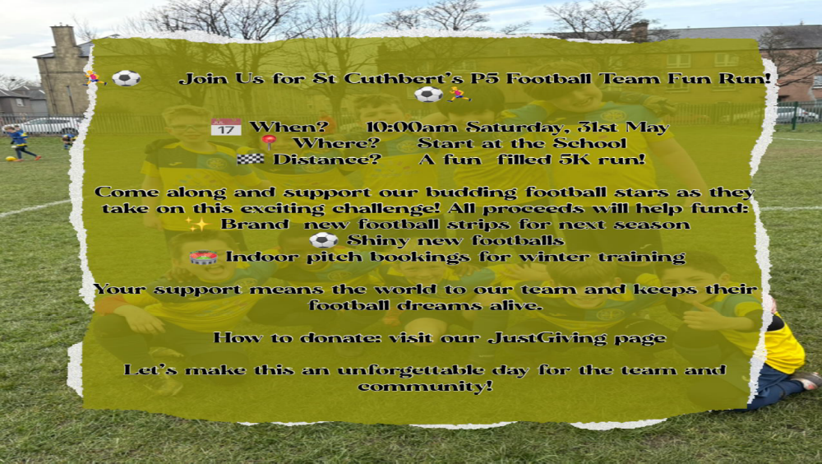

South Morningside avenged their defeat the previous week to beat our P5 side 6-2.
The P5s have now completed their last match of the season. Across the 26 matches played this season they have improved beyond all recognition and have competed well against all the teams they have played, claiming some good victories along the way.

The P6s lost 5-2 to Sciennes. They have their last match of the season at home to South Morningside on Saturday.

School Uniform Ordering

BE Uniform - Just a little reminder that BE uniforms are offering a 15% discount on all school uniform orders from now until Sunday 8th June 2025.
Koolskools our Fairtrade supplier are offering a 10% discount on orders placed from 23 May – 9th June and again from 30th June until 13th July 2025.
There is of course no obligation to purchase from either of these companies.

Pupil Voice at St Cuthbert’s

Our Pupil Rights and Equalities Group will meet again next week to discuss school improvement for school year 2025-26. This will be their last meeting of the school year.

Our HWB Group will meet for the final time this session next week.

Our Sustainability Group visited Hutchison Garden again this week to work on our school vegetable plot.

Learning at St Cuthbert’s

God’s Loving Plan Meeting: P6 and P7 – Lessons Start Next Week

Thanks to those parents who attended Monday’s meeting. Information leaflets were also sent home last week. Lessons will start in both classes next week.

P7 Hub for Success University Visit

P7 visited Napier University’s, Craiglockhart Campus on Thursday as part of their Hub for Success programme to raise their awareness of further education opportunities.

P6 Norwegian Warship Visit

As part of their WW2 learning, P6 visited a Norwegian war era warship docked at Leith. The opportunity of the visit was offered at short notice so we wish to thank all parents/carers for getting their children to school on time for the early departure.

P5 Transition Visit to St Augustine’s Craft, Design and Technology Department

P5 made a visit to St Augustine’s High School on Wednesday as the start of their transition journey. More visits and activities are planned for P6 and P7.

P4 Outdoor Learning Visit

P4 visited Saughton Gardens this week to compare Scottish rainforest with Southern Hemisphere Rain Forest. They have also attended an online presentation and question and answer session with a rainforest scientist recently in connection with their scientific work this term.

Staffing for School Year 2025-26/Meet the Teacher

Interviews were held across Edinburgh last week to fill school vacancies for 2025-26. Once the results of these are processed, we will be in a better position to plan our staffing for next year. I will keep you informed as to our progress. There will also be a meet the teacher afternoon for pupils on the afternoon of Tuesday 17th June.

P7/S1 Transition

Transition meetings with St Augustine’s staff were held in school this week. Please be reminded that pupils will take part in 3 Transition Days next month from Tuesday 17th to Thursday 19th June at their allocated High Schools.

P1/2/3 Transition Update

P1 and P2 made their third transition visits to their new classrooms on Tuesday afternoon. The visits were successful and will continue for one further Tuesday afternoon.

Catholic Education and Parish Update

Sacrament of Confirmation – Friday 23rd May

Congratulations to all pupils who received the Sacrament of Reconciliation last Friday. They represented the school very well. Thanks again to all parents and staff, particularly Mrs Peake, who helped prepare the candidates.

Ascension Day Mass – Thursday 29th May

Thanks to Fr Francis, Dorothy, Mrs Peake and our volunteer pupils from P2-7 for their part in leading this Mass. The pupils were superb representatives of the school.

Fr Peter Working with Sacramental Classes

Fr Peter Kelly will be working with P4 of First Holy Communion and Confirmation for the final time this year during week commencing 9th June

Nursery Update

It has been a very busy and exiting week for some of our nursery children.
First, they went off to try some school lunches. They carried their own trays and sat together at the school lunch tables. It was a big thumbs up from everyone.
Later, we celebrated Africa Day. Frida prepared some delicious food from Equatorial Guinea. The children had the opportunity to investigate different African communities and listen to different types of African music.
Next, we explored the world of The Everywhere Bear, our transition book, written by a nursery favorite, Julia Donaldson. The children have been discussing the themes and characters in the book at Together Time.
Children going to P1 in August have been taking turns to take Everywhere Bear home for an overnight visit. He has already had some exciting adventures..


Listen here to The Everywhere Bear: https://www.youtube.com/watch?v=RkjQe6Gz1Ak

The Everywhere Bear signed story:
https://youtu.be/YLfBZoY64E4

The Everywhere Bear song:
https://www.youtube.com/watch?v=T607y7ojw7Q

We ended the week with a visit to P1. The children discovered that there are so many new, interesting things to do when starting school that they didn’t want to leave!

Finally

We wish you and your families a happy and restful weekend.
Mr P Brack, Head Teacher and all at St Cuthbert’s School

