 St. Cuthbert’s RC Primary School:
Newsletter 39 – Friday 20th June 2025
St Cuthbert’s CARES We are: Creative Active Respectful Equal Supported

Good afternoon and welcome to this week’s penultimate Newsletter of term, Thanks for reading it, please let us know if you have any questions about its contents.

Upcoming Events at St Cuthbert’s and Dates for your Diary

End of Session Reports Sent Out Today

These were sent out today, we hope you find them informative. Please take time to read carefully and return your feedback form to your child’s class teacher or directly to school office. Please also contact us if you have any questions about their contents.

Dates for Your Diary Final Week of Term

- Wednesday 25th June – P7 Leavers’ Assembly, 2pm School Hall
- Thursday 26th June, P7 Leavers’ Parade, 12.45pm School Playground – all P7 parents/carers welcome
- Thursday 26th June, End of Term, School finishes for all classes at 1pm

Jotters, P.E Kit etc to go Home on Wednesday 25th June

All jotters and folders from this year, along with P.E kit, will be given to pupils to take home on this date. The only exception will be writing jotters which will be retained by new teachers until parents evening in October 2025. Please ensure that your child brings a bag on this date to carry things home.

Parent Council Weekly Update:

Meetings will resume again next year. First meeting date will be confirmed at start of next term.

Should you wish to contact the Parent Council at any time about anything related to their work, they can be contacted via e-mail at ptastcuthberts@gmail.com

Appeal for Parent Volunteers to help with School Garden

We would like to invite all parents and carers to join our school gardening support group! The aim of this group is to help maintain and improve the school’s outdoor areas for our children. Activities may include cleaning, weeding, and planting in various sections of the school.

Participation is on a voluntary basis, so we don’t expect everyone to attend every session—just come whenever you can. If you enjoy gardening, being outdoors, and supporting the school, please send an email to the school administrator with your name and phone number. We will then add you to our WhatsApp group.
Thank you!

Carla

Other School News & Information

P4&P5 Swimming Lessons Next Term

Thursdays Dalry Swim Centre, Dalry PS 1 - 1.50pm

- P5 (10 weeks) – 21/8/25 - 30/10/25
- P4 (7 weeks) – 6/11/25 -18/12/25

Breakfast Club Booking and Payments

Thank you to all the parents who have completed the registration forms and returned them by the deadline of 16th June. All parents who have now registered have had the Parentpay facility to pay for breakfast club added to their account. There will be no option to book and pay for breakfast club unless we have received a completed registration form and parents have received a confirmation letter of the days that they have booked. Thank you for your understanding as we negotiate this new method of payment. Please ask if you have any questions.
School Milk for August

The deadline for ordering milk for August has now closed. There may however be another opportunity available for ordering after the October break. We’ll keep you updated.

Further Update on School Lunches for 13/14/15th August

Further to the e-mail sent out yesterday about there being issues in ordering lunches for 13/14/15th August, we have today been informed by the Council that Parentpay will not be uploading menus to their system until Monday 23rd June. If you wish to order a meal for your child for 13/14/15th August this must be done from Monday 23rd June and no later than midnight on Wednesday 25th June. If you are unable to do this, then you will need to supply your child with a packed lunch for the first week back. Meals are free to all P1-5 inclusive, but parents need to order online. Pupils in P6 and P7 unless eligible for Scottish Child Payments or meet the criteria for free school meals will be required to pay £2.65 per day. We apologise for this inconvenience and thank you for your patience, however this is outwith the schools control.

Leavers Forms

Other than the pupils in P7 who we know are leaving at the end of this term, if you know that your child will not be returning to St Cuthbert’s in August, please request a Leavers form from the school office. The Council require this to be completed prior to them leaving the school. Thank you for your co-operation.

Clothes Recycling Point

The clothes recycling has now been collected and is open for use again. Thanks to all who donated. We’ll let you know about any commission we receive from this collection.

Remaining P7 Leavers’ Events

- Tuesday 24th June – P7 Bowling and Pizza outing to Fountain Park during School Day
- Wednesday 25th June – P7 Leavers’ Assembly, 2pm School Hall – all P7 parents/carers welcome.
- Thursday 26th June, P7 Leavers’ Parade, 12.45pm School Playground

KIC & Photographic Permission Forms.

Thank you for the fantastic response and return of the KIC and Photographic permission forms which were sent out on 19th May. Just a little reminder that in order for your child to be able to participate in any excursions, swimming sessions etc the forms need to be completed and returned no later than Monday 23rd June. If you have misplaced it, or didn’t receive one from your child please contact the school office, who will send one home for you.

P7 School Camp 2026 – Revised Deadline for Deposits now 26th June

A letter was sent out last week to gauge interest re school camp next year and also to allow for an extended window for payment to make the high cost more affordable. Deposit of £100 is now due by 26th June.

New Stage/Theatre Club Taster Sessions and Booking for Next Year

Taster sessions for this club aimed at P1-4 pupils went really well yesterday. An email explaining how to book a place for next term’s club has been sent to all parents/carers of pupils in these classes. Please ask if you have any questions.

School Uniform Ordering and Discounts

Koolskools our Fairtrade supplier are offering a 10% discount on orders placed from 23 May – 9th June and again from 30th June until 13th July 2025.
There is of course no obligation to purchase from either of these companies.

Pupil Voice at St Cuthbert’s

Our Pupil Voice Groups will resume next year.

Learning at St Cuthbert’s

‘Meet the Teacher’ Afternoon for Pupils This Week

All classes, including next year’s P1 met their new teachers on Tuesday afternoon. Next year’s P7 even met two teachers! It was a positive experience and will help the children prepare for their new class in August.

P1 Garden Party Excursion

P1 Had a great time visiting the grounds of Holyrood Palace today for a Garden Party experience. Thanks to our 7! Parent Volunteers too.

P4 and P5 Engineering Celebration Event - Update

Further to our successes reported last week, we now have more good news to share:
Luka and Aayan received full marks in the event and went straight to 1st place. Joshua and Dominik were commended and we also received a school recognition certificate! A great job from all concerned, congratulations to our pupils and Miss Mcelearney and Mrs Gill for supporting them.

Mobile Library and Summer Reading Challenge

The mobile library service visited us for the final time this year on Thursday. They will return with their new book bus next term.
We were also visited today by staff from Balgreen Library who informed the children about this year’s summer reading challenge which is available at all City of Edinburgh Council Libraries this summer

Catholic Education and Parish Update

First Holy Communions – Thank You!

All of our pupils represented their families and our school really well last week. It was a lovely community occasion. Thanks to our pupils, families, Fr Francis, Dorothy, Alannah, the parish volunteers, Mrs Gill and Miss Eckersley for their part in preparing for the big day. Please see photo below:



Nursery Update

We have been so lucky with the weather this week – it was sunny and warm on Thursday for our Transition picnic. We had lots of lovely snacks, fun games and Mrs Igoe came to read The Everywhere Bear – what a fantastic afternoon!
Next week is the last week of Term for term-time children - they will finish up next Thursday 26th June at 12:30pm. Nursery continues over the summer for all other children (Morning, Afternoon, Monday-Tuesday and Wednesday – Thursday sessions). Autumn Term starts Wednesday 13 August 2025
For our children going to school in August, Graduation is also on Thursday 26th June at 12:30pm - in the nursery Garden if its sunny, or in the school gym hall if it is a rainy day.

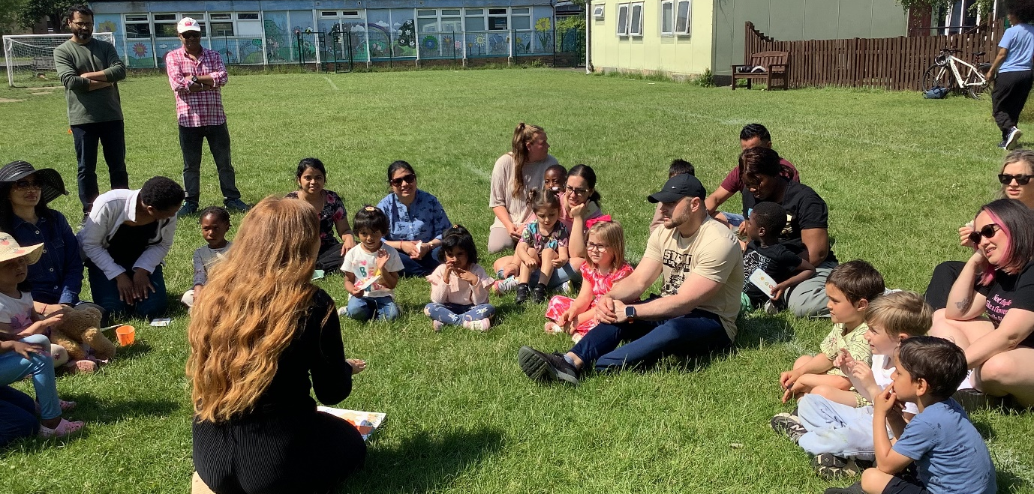

Finally

We wish you and your families a happy and restful weekend.
Mr P Brack, Head Teacher and all at St Cuthbert’s School

