 St. Cuthbert’s RC Primary School
Newsletter 2– Friday 22nd August 2025
St Cuthbert’s CARES We are: Creative Active Respectful Equal Supported

Good afternoon. Thanks for reading this week’s Newsletter. Please ask if you have any questions about its contents.

Upcoming Events at St Cuthbert’s and Dates for your Diary

How to View our Newsletter

We hope that you enjoyed the paper copy of our Newsletter shared last week. Please note that going forward from today, the Newsletter will be available in digital form only, via email to the person named on your child’s Parent Pay account (check your spam folder if you don’t have it by 1pm on a Friday). You can also access our Newsletter via our school website, see link below:

https://st-cuthberts-primary.com

Key Dates for This Half Term

- Monday 25th August – Meet the Teacher Drop in Sessions, in all classrooms (P1-2 3.10-4.10pm, P3-7 3.30-4.30pm)
- Monday 1st September – P1 Evening News Souvenir photo, please ensure all pupils are wearing school uniform. More information to follow.
- Thursday 4th September – School Photos (see below)
- Thursday 4th September – P7 Camp Drop in Meeting for any initial questions (3.30-4.15pm in P7 Classroom).
- Friday 5th September – P5 Class Mass (9.30am, St Cuthbert’s Church)
- Friday 5th September – Termly Overviews to be emailed to parents
- Friday 26th September – P7 Class Assembly (9.30am School Hall)
- Friday 3rd October – P6 Class Mass (9.30am, St Cuthbert’s Church)
- Tuesday 7th October – Parent Consultations Option 1 (5-7.30pm, Hall)
- Thursday 9th October – Parent Consultations Option 2 (4-6.30pm, Hall)

Parent Council Weekly Update – First Meeting Date Confirmed

Our first meeting for this school year has been confirmed for Friday 26th September at 11am in our Nurture Room – all welcome. The Parent Council has had an immensely positive impact on our school and you would be very welcome to join and help further develop the contribution of this important grouping to our community. Should you wish to contact the Parent Council at any time, they can be contacted via e-mail at ptastcuthberts@gmail.com

News & Information

Mrs Munro Leaving Date and New Acting Principal Teacher Start Date

We will wave Mrs Munro a fond farewell on Friday 12th September. We wish her all the very best for her Maternity Leave. She will be missed! Fortunately, we have an excellent replacement lined up: Mr John Crowley will be joining us as Acting Principal Teacher from St Joseph’s on Tuesday 16th September. I’m sure that you will all make him feel very welcome as he gets to know our school.

Breakfast Club Information and Update

Thank you for your patience and understanding as we negotiate the new procedure for booking and paying for Breakfast Club. ALL children must be registered BEFORE they can attend breakfast club. Bookings must be made no later than Wednesday at midnight for the following week(s). This is done via Parentpay (only those who have registered will have this option available to them) and payment must be made prior to attendance. Please do not make payment before you have booked your place(s). Step by step instructions to assist with this can be requested from the school office.

Flu Immunisations

This year our Flu immunisations will take place on Monday 22nd September in the school dining hall. All children should have brought home a consent letter, which should be returned to the school no later than Friday 29th August, if you wish your child to receive the Nasal Flu immunisation. Forms received after this date may result in your child being unable to receive the vaccination. If you did not receive a form and wish your child to receive the immunisation, please contact the school office.

School Photographs

A letter was sent home with all the children on Thursday about the upcoming family and individual photographs, which will be taking place in the school hall on Thursday 4th September.
Please be aware that if you wish your child to have a family photograph, due to time constraints, this can only with children that are currently in the school, unfortunately not nursery siblings. You only need to return the letter if you wish a family photograph to be taken or if you do not wish your child to have their photograph taken.

Annual Data Forms

Next week all children will be coming home with their Annual Data forms. These forms are required in order to keep information held about school pupils up to date. This is a requirement in our for us to complete a ScotXed pupil census. Information about the purpose for this information and what it is used for is clearly explained in the accompanying letter. It is important that EVERY PAGE is signed, whether there are changes to the information held or not. Please return these forms no later than Friday 12th September. Thank you for your co-operation and understanding.

Ginger Bread After School Club

If you wish to arrange after school care via our After School Club, run by private company ‘Ginger Bread Child Care’. Please call 07825925852.

Active School Clubs Update

Fiona, our coordinator is working hard behind the scenes organising a schedule of clubs for this term. She is hoping to start week commencing 22nd September and will share further information in the coming weeks. We’ll keep you updated.

Nut Allergies – Important Information

As communicated last week, we now have a number of pupils in school who have a nut allergy. For their safety, we would ask that no nut based products are brought into school i.e Nutella, peanuts, cashew nuts etc.

Apologies for any inconvenience caused but I am sure that you will agree with the need to ensure the safety of all pupils.

City of Edinburgh School Meals Survey

Please see QR Code below, if you wish to take part in this survey:



Learning at St Cuthbert’s

Learning Updates on School Website Commencing Today

Please look out for a new post each Friday on your child’s class page on our school website. Our website – along with information emailed - will replace Twitter/X as our main digital source this year. Please feel welcome to give us your feedback.

PE Information 25-26 - Important

The P,E. curriculum encompasses a variety of sports throughout the year including fielding sports outdoors as gymnastics, racquet sports and team games indoors. The appropriate clothing and footwear for PE is a T-shirt and shorts or leggings that provide flexibility of movement, and gym shoes / trainers. Long hair should be tied back and jewellery should be removed although studded earrings are acceptable. These are necessary for health and safety reasons and your co-operation is requested to ensure that pupils are equipped to participate in the PE lessons. Please note, no football strips should be worn in school as these often lead to incidents of rivalry. This is a policy that will continue up to High School.
Please ensure that all items of clothing are clearly labelled, particularly ties, sweatshirts and PE clothing which are often mixed up during the changing process.

Partner Agencies

We have been taking part in a series of initial planning meetings last week and this week with partner agencies, who support staff and pupils in the school. This includes: our new English as an Additional Language teachers Annie Page and Kim Almond, Additional Support for Learning teacher Jessica Privatera, Natalie Lodge our Speech and Language Specialist and Rachel Brown our school counsellor. All of them will add to the life and work of the school this year.

Staff Training Forward Planning & Digital Skills

Our staff team undertook training in forward planning on Thursday. The aim is to ensure consistency of planning across the school and to ensure all staff are following guidance laid down by City of Edinburgh Council. It was a productive session.

I met with Andrew McArthur, Digital Skills leader this week to plan the school’s digital strategy for the year ahead. We realise the importance of digital to the modern world and are keen to adapt and improve in this area. Look out for more information in the coming weeks.

Violin & Cello Tuition This Year

Mrs Egan worked with our P5-7 pupils for the first time this year on Wednesday. She will also work with interested pupils from P4 over the coming weeks to create a new P4 group. Mr McVinnie, our Cello Teacher visited us on Tuesday for the first time this year. We have managed to source 6 new cellos so he hopes to extend his support to groups in P5, P6 and P7 this year. We are grateful for the support of Helen and Chris which has helped us really extend the scope of our musical tuition to include a greater number of pupils each year.

P4 Trip to Pleasance for Fringe Performance on Monday

Letter went out on Monday about this exciting trip. Coach travel will be provided for us. We hope the class enjoy their festival experience.

P4 Music Workshop Began this Week

P4 started their musical tuition programme with Katrina McKinnon, choral director at St Mary’s Cathedral on Monday. These lessons will continue throughout the year. We are grateful for this opportunity.

P5 Swimming (10 Week Block Began 22nd August)

P5 attended swimming for the first time yesterday. P4 will start their lessons on Thursday, November 7th.

Attendance and Late Arrivals - Impact

City of Edinburgh Council monitors each school’s attendance and absent rates closely due do its impact on learning. We saw a real improvement in these things last year – thanks for your cooperation. Please continue to try wherever possible to avoid term time holidays and avoid late arrivals this year. If you are experiencing issues or barriers to attendance which we can help with, please contact the school. Please see info re the impact on learning of term time absence and late arrivals below:

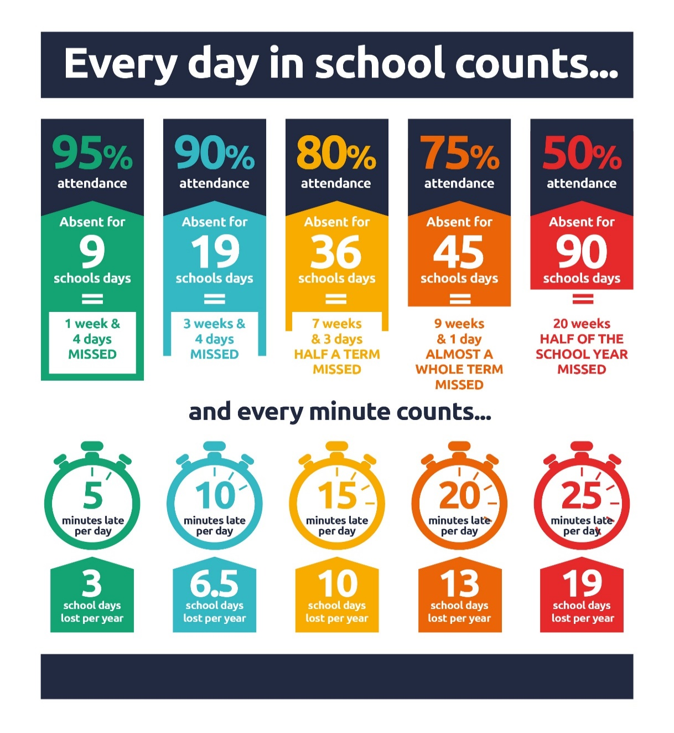

Catholic Education and Parish Update

Class Masses

Please see class Mass dates up to October half term holidays shared above. We hope to resume regular school visits from Fr Francis and or Fr Peter this term too.

City of Edinburgh Council Information

Term Time Football Classes from City of Edinburgh Council

Dear Parent/Guardian,

I hope you had an enjoyable summer and are looking forward to your children returning to school 😊

Please see below links to information and booking for our City of Edinburgh term-time football classes, resuming in a few weeks’ time.

Friday Football : ages P1 – S1
Starts Friday 22nd August @ Forrester HS

P1 – P4 https://getedinburghactive.spydus.co.uk/cgi-bin/spydus.exe/ENQ/WPAC/EVSESENQ?SETLVL=&RNI=196897
P5 – S1 https://getedinburghactive.spydus.co.uk/cgi-bin/spydus.exe/ENQ/WPAC/EVSESENQ?SETLVL=&RNI=196907

Friday Kick-Off : ages 13 - 16
Starts Friday 22nd August @ Forrester HS

https://getedinburghactive.spydus.co.uk/cgi-bin/spydus.exe/ENQ/WPAC/EVSESENQ?SETLVL=&RNI=196917

Mini Kickers : ages 3 - 5
Starts Saturday 23rd August @ Forrester HS
3 – 4 https://getedinburghactive.spydus.co.uk/cgi-bin/spydus.exe/ENQ/WPAC/EVSESENQ?SETLVL=&RNI=196877
4 – 5 https://getedinburghactive.spydus.co.uk/cgi-bin/spydus.exe/ENQ/WPAC/EVSESENQ?SETLVL=&RNI=196887

If you have any questions which aren’t answered by following the links above the please let me know. We would love to see you with us this year!

Thanks,

Jack Beesley | Football Development Officer | Sports and Outdoor Learning Unit | Education (Wider Achievement & Lifelong Learning) | Children, Education & Justice Services | The City of Edinburgh Council | Forrester / St Augustine’s Community Sports Hub, Broomhouse Road, Edinburgh EH12 9AE | 07894 816 336 | @Edin_Football | @coe_sport | www.edinburgh.gov.uk

Nursery Update

These will resume Friday 29th August 2025

Finally

We wish you and your families a restful and relaxing weekend and look forward to seeing you all on Monday.

Mr P Brack, Head Teacher and all at St Cuthbert’s School

