 St. Cuthbert’s RC Primary School
Newsletter 4– Friday 5th September 2025
St Cuthbert’s CARES We are: Creative Active Respectful Equal Supported

Good afternoon. Thanks for reading this week’s Newsletter. Please ask if you have any questions about its contents.

Upcoming Events at St Cuthbert’s and Dates for your Diary

Key Dates for This Half Term (Please note new date for issue of Termly Overviews_

- Friday 12th September – Termly Overviews to be emailed to parents
- Friday 26th September – P7 Class Assembly (9.30am School Hall)
- Friday 3rd October – P6 Class Mass (9.30am, St Cuthbert’s Church)
- Tuesday 7th October – Parent Consultations Option 1 (5-7.30pm, Hall)
- Thursday 9th October – Parent Consultations Option 2 (4-6.30pm, Hall)

Parent Council Weekly Update – First Meeting Date Confirmed

Our first meeting for this school year has been confirmed for Friday 26th September at 11am in our Nurture Room – all welcome. The Parent Council has had an immensely positive impact on our school and you would be very welcome to join and help further develop the contribution of this important grouping to our community. Should you wish to contact the Parent Council at any time, they can be contacted via e-mail at ptastcuthberts@gmail.com

Big thanks to Kerry, our Chair, for securing a grant for funding to support Karate club again this year!

News & Information

School Website

Please remember to check our new class pages on our school website:

These will include a snapshot of learning done by the class that week with a photo and accompanying text. We will also share a phot of each week’s certificate winners (unless it’s a Mass or Class Assembly week). We hope to add a new Parent Council Page before the October holiday too.

Homework to Start Week Commencing 15th September

Homework will start during week commencing 15th September. It will be given out on a Friday and due back on a Thursday in every class. It will always contain Literacy and Numeracy as well as an Interdisciplinary Learning task. The intent is to consolidate in class learning and provide an opportunity for parents/carers to talk to your children about their learning.

New Acting Principal Teacher Visits

Mr Crowley, our future Acting Principal Teacher, starting 16th September, made an initial visit to us on Thursday 4th September. He met staff and pupils to introduce himself in advance of his start date. He will return again next Thursday for a final visit.

P1 Health Checks – Thursday 11th September

These will take place in our library on the morning of the above date.

Flu Immunisations – Monday 22nd September

Completed forms must be in by Monday to ensure that your child can receive their immunisation or to confirm that you do not wish your child to receive immunisation. Please contact us before this date with any questions. Thanks for the high return rate- of forms so far.

School Photographs – Rearranged for Wednesday 17th September

Tempest asked us to pass on their apologies again. They will return on the above date and all arrangements that were in place will carry forward to this date.

Maths Week – An Appeal for Parent Volunteers: Week Commencing 22nd September

If you have a job which involves the use of mathematical skills and would be willing to speak to one or more of our classes during the above week. Please call us or email admin@st-cuthberts.edin.sch.uk

Annual Data Forms

Thanks for a fantastic response re return of these forms. If you haven’t already done so please return these forms no later than Friday 12th September. Thank you for your co-operation and understanding.

Active School Clubs Update

Fiona, our coordinator is working hard behind the scenes organising a schedule of clubs for this term. She is hoping to start week commencing 22nd September and will share booking information next week. Stage club is already up and running and we’ll let you know about choir as soon as we have an official start date.

Playground Development-Fairy Garden

Thanks to the kind donations of the Amador family, the P7 pupils have been painting and assembling Fairy houses and structures for our new Fairy Garden (to be housed in the Peace Garden in the main playground). We are looking for parent helpers to come in to help the P7 pupils and myself assemble the Fairy Gardens on Monday 22nd September 1.30 - 3.30pm. If you would like to come and help us please contact: Admin@st-cuthberts.edin.such.uk

We still need the following items for our garden :

- One packet of soil
- One packet of sand
- Two large plastic garden pots (similar to B and Q Verve Florus Terracotta bell plastic plant pot 55cm wide)
- Small heather plants

If you have anything like this at home please contact the office admin email address as above to let us know.

Thanks so much.

Mrs Skelly, Pupil Support Assistant

St Thomas of Aquins’ High School Info for Parents Intending to Send Children to S1 There in August 26

Please see appendix 1 below
Pupil Leadership and Learning at St Cuthbert’s

House Captains

Our House Captain Elections took place on Thursday afternoon. It was heartening to see how invested the P7 pupils were in leading this process. They did a great job! Our other classes also listened carefully and enjoyed taking part in the democratic process. The candidates found out today who the successful candidates were and received their badges. They will be announced to the rest of the school on Monday.

Other Pupil Voice Groups 2025-26

In our school we have three pupil voice groups: Pupil Rights and Learning, HWB and Laudato Si (Formerly Sustainability). The membership of the groups rotate on a yearly basis. We are also hoping to start a Digital Leaders Group this year.

The Pupil Rights and Learning Group met for the first time this year on Tuesday. We created a pupil friendly version of our School improvement Plan 25-26. The group will meet again on Tuesday 16th September to discuss the plan before sharing it with their own classes.

Our Sustainability Group will meet for the first time next Wednesday. With the HWB meeting for their inaugural meeting on Wednesday September.

The Pupil Rights and Learning Group will meet every two weeks and the other two groups every three weeks to allow time for them to consult with their classmates to ensure we hear the voice of the wider pupil community.

P6 Attending Outdoor Learning Challenge – Wednesday 10th September

Miss Christie and class will be taking part at this event in Holyrood Park next week. Thanks to our parent volunteers for supporting this opportunity for the class.

Edinburgh Theatre Company Taster Sessions P4-7 – Thursday 11th September

These will take place in our hall next week.

Staff Training on Outdoor and Digital Learning

Our staff team took part in training provided by Margon, from the Green team about how to use the school grounds for outdoor learning. It was a really positive session and will help us with our aim of using our grounds to support learning at least once a week for each class. On Monday 8th September, after school we will receive training on how to support reading using digital resources.

Stage Club

This took place on Tuesday night for the first time and seemed to be a real success. Thanks to all of those who attended.

Catholic Education and Parish Update

Mass at St Mary’s Cathedral with Relic of St Carlo Acutis – Monday 15th September 12.45pm

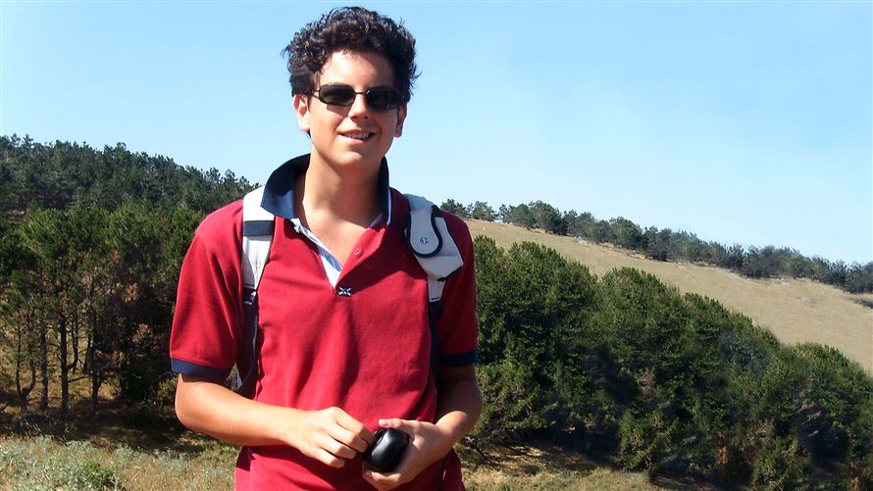

Carlo along with Pier Giorgio Frassatti, will be made a saint of the Church on Sunday 7th September by the Holy Father, Pope Leo XIV. The Cathedral will be holding Masses over the weekend in the presence of his relic. Mass on Monday is dedicated to schools, all families of Edinburgh school pupils are very welcome to attend.

P5 Class Mass

Thanks to Fr Francis, P5, Miss Donnelly and Dorothy for a lovely Mass on the feast day of St Teresa of Calcutta.

Nursery Update

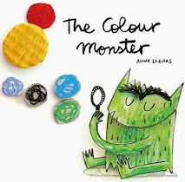
We love to read!
In nursery, books are everywhere. We especially love a Book of the Month. September see’s us exploring The Colour Monster by Anna Llenas. The Colour Monster is a wonderful book as well as a highly supportive resource which supports emotional development with strength. It's also useful for colour recognition and basic numeracy.
Join in at home: https://www.youtube.com/watch?v=aBPFplfLvZo

In our story groups we are discovering some lovely books this month.
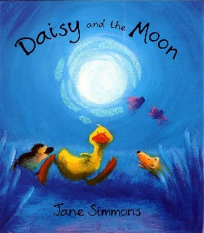
Daisy and the Moon by Jane Simmons
https://www.youtube.com/watch?v=wV4XMn5UMXU


How to Catch a Rainbow by Naomi Jones and Ana Gomez
https://www.youtube.com/watch?v=8XqnWZrD-Po

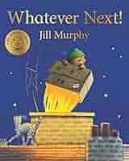
Whatever Next by Jill Murphy
https://www.youtube.com/watch?v=6c5cb0u0rPM


One Banana Two Bananas by Adam and Charlotte Guillain
https://www.youtube.com/watch?v=aBPFplfLvZo

Finally

We wish you and your families a restful and relaxing weekend and look forward
to seeing you all on Monday.

Mr P Brack, Head Teacher and all at St Cuthbert’s School

Appendix 1 – Info from St Thomas of Aquins

P6 and 7 Associated Primary School Parents invite to experience St Thomas of Aquin’s RC High School September and October 2025
Following on from Mr Santini’s communication to parents on 25th June, I would like to extend a warm invitation to all the P6 & P7 parents within the St Thomas’ Learning Community to attend an open morning event taking place between 11.30 am and 1.00pm on any of the following days at their convenience.
Sept 19th:
https://www.eventbrite.co.uk/e/1600559730239?aff=oddtdtcreator

Sept 26th:
https://www.eventbrite.co.uk/e/1627551724019?aff=oddtdtcreator

Oct 3rd:
https://www.eventbrite.co.uk/e/1627552476269?aff=oddtdtcreator

Oct 10th:
https://www.eventbrite.co.uk/e/1627581613419?aff=oddtdtcreator
During the open morning, parents and carers will have the opportunity to meet with our Headteacher, Mr Santini and myself ( Depute Headteacher S1-S3) , go on a tour of the school led by the S6 Leadership Team and attend a Question and Answer session ( Approx 20 minutes) with Mr Santini. We are hopeful that through this experience our prospective parents will be able to gain a direct experience of our school community and be able to feel and see our school in action.
If you are interested in taking part, please book a place via the links above . Please note that the maximum capacity for each event is 60 ( 2 adults per booking).
We look forward to meeting you then,
Kind regards
Isabelle Jean Pierre

Depute Head Teacher | St. Thomas of Aquin’s High School | 12- 20 Chalmers Street | Edinburgh | EH3 9ES
Website: www.st-thomas-of-aquins.org.uk
Twitter: @thomasofaquins

