 St. Cuthbert’s RC Primary School
Newsletter 5– Friday 12th September 2025
St Cuthbert’s CARES We are: Creative Active Respectful Equal Supported

Good afternoon. Hard to believe we have reached September weekend holiday already. Thanks for reading this week’s Newsletter. Please ask if you have any questions about its contents.

Upcoming Events at St Cuthbert’s and Dates for your Diary

Key Dates for This Half Term (Please note Monday Holiday This Week)

- Friday 12th September – Termly Overviews issued, please note that due to illness Miss Mcelearney wasn’t in school this week and her overview will be shared on Tuesday 16th September.
- Monday 15th September – Public Holiday, school returns on Tuesday 16th
- Friday 26th September – P7 Class Assembly (9.30am School Hall)
- Friday 3rd October – P6 Class Mass (9.30am, St Cuthbert’s Church)
- Tuesday 7th October – Parent Consultations Option 1 (5-7.30pm, Hall)
- Thursday 9th October – Parent Consultations Option 2 (4-6.30pm, Hall)

Parent Council Weekly Update – First Meeting Date Confirmed

Our first meeting for this school year has been confirmed for Friday 26th September at 11am in our Nurture Room – all welcome. Should you wish to contact the Parent Council at any time, they can be contacted via e-mail at ptastcuthberts@gmail.com

Big thanks to Kerry, our Chair, for securing a grant for funding to support Karate club again this year!

News & Information

Termly Overviews for August to December

Each class teacher has produced one of these and they have been emailed out this morning. We hope they are informative and helpful. Please see note above re P2 in calendar dates section, their overview will be shared next week. Please let us know if you have any questions about the contents of these overviews or require a paper copy.

Principal Teacher Change from Tuesday 16th September

Mrs Munro will depart on her Maternity Leave from Friday 12th September. We are extremely grateful for all of her hard work, expertise and commitment to our school over these last seven years and wish her well for impending motherhood!

We also look forward to meeting Mr Crowley, who made his final visit to us on Thursday and will join us as Acting Principal Teacher from Tuesday 16th September to June 2026. I am sure we will all, as a community make him very welcome.

Cauliflower Christmas Card Designs

Christmas card designs will be sent home on the 19th September for Parents and Carers to check over and order. All orders are done online through the company website. All order forms have a QR code that can be scanned to access the website. All artwork must be returned to school by the 26th September but the ordering window will be open until the 30th of September. If you would like to order nearer the end of the month, make sure you keep a note of the ordering instructions and individual pupil code.
If you have any questions about this please ask the class teachers and they will be able to help. Thank you!

Homework to Start Week Commencing 15th September

Homework will start during week commencing 15th September. It will be given out on a Friday and due back on a Thursday in every class. It will always contain Literacy and Numeracy as well as an Interdisciplinary Learning task. The intent is to consolidate in class learning and provide an opportunity for parents/carers to talk to your children about their learning. If you have any questions about homework in our school please let me know.

Annual Data Forms

Thank you to all who have already returned these forms. It is a requirement from Scottish Government, that the school verify that the information held about all children is both accurate and up to date. If the office have not already received this form, duplicate copies of the information held was sent home on Wednesday 10th September with the children concerned. Even if there are no changes to the information held, the forms still need to be signed at the bottom of the page and returned to the class teacher no later than Thursday 18th September please. Thank you for your co-operation and understanding. Please contact the school office with any questions you have.

P1 Health Checks – Thursday 11th September

These took place successfully in our library yesterday.

School Photographs – Rearranged for Wednesday 17th September

Tempest asked us to pass on their apologies again. They will return on the above date and all arrangements that were in place will carry forward to this date.

Flu Immunisations – Monday 22nd September

See above date. Please note that your child can only receive their immunisation if the form was returned.

Maths Week – An Appeal for Parent Volunteers: Week Commencing 22nd September

If you have a job which involves the use of mathematical skills and would be willing to speak to one or more of our classes during the above week. Please call us or email admin@st-cuthberts.edin.sch.uk

Parent Consultations 7th and 9th October 2025

Parent Consultations will take place in the school hall on Tuesday 7th October from 5pm-7.30pm and also on Thursday 9th October between 4pm – 6.30pm.
Bookings will again be made via the online portal Parents Booking. Information about how to access this will be sent by e-mail via Parentpay next week. Please note bookings will not be open until 7pm on the date stated in the e-mail. If you have any issues with booking a date/time then please contact the school office.
Active School Clubs Term 1 – Booking Open



Booking details were shared earlier this week. Please let Fiona know if you have any questions. She can be contacted via text and email on:

07769 922 742

fiona.damen@ea.edin.sch.uk

Jidel Judo at Forrester High School – Free Spaces Available

Fiona also asks that we share details re Jidel Judo on Thursdays at Forrester High School! The club have limited free spaces, but your child could try it for 4 weeks for free. Register interest by completing the Microsoft form, use this link:

https://forms.cloud.microsoft/e/0ent39pvwf to complete the form:

Playground Development-Fairy Garden

Thanks very much for the kind donations we have received after last week’s Newsletter appeal. We are still looking for parent helpers to come in to help the P7 pupils and myself assemble the Fairy Gardens on Monday 22nd September 1.30 - 3.30pm. If you would like to come and help us please contact: Admin@st-cuthberts.edin.such.uk

We still need the following items for our garden :

- Two large plastic garden pots (similar to B and Q Verve Florus Terracotta bell plastic plant pot 55cm wide)
- Small heather plants

If you have anything like this at home please contact the office admin email address as above to let us know.

Thanks so much, Mrs Skelly, Pupil Support Assistant

Pupil Leadership and Learning at St Cuthbert’s

Laudato Si/Sustainability Group

Met for the first time this week lead by Miss Pusker. Their focus this year will be on the UNCRC’s Global Development Goals, particularly in relation to:

- Zero Poverty and Hunger
- Clean Water and Sanitation
- Sustainable Cities and Communities

House Captains

the successful candidates were announced to their class last week and received their badges then. They were introduced to the school at today’s Assembly. They have made a great start and we look forward to working with them!

P6 Outdoor Learning Challenge

Miss Christie, Mrs Sheikh and class took part in this event in Holyrood Park on Wednesday. Pupils worked in two teams and took part in a range of outdoor stations. Thanks to our parent volunteers for supporting this opportunity for the class.

Nurture Classes

These will begin again from next week run by Mrs Skelly and Mrs Ferry. Pupils are nominated for support to enhance their self esteem, social, emotional and behavioural skills by staff and pupils attend on a weekly or fortnightly basis depending on the group that they are in. Letters will be sent to parents/carers of pupils involved next week. Parents have the right to withdraw their child from this support should they wish to do so. Please let us know if this is the case. We have very limited space but if you wish your child to receive this support and they have not been nominated for support this term please let us know. We can’t make any promises of additional places but we can discuss your thoughts with you.

Pupils Attending Edinburgh Football Select Trials

Congratulations to Rohan and Lawrie for taking part in this event on Wednesday and representing our school at city level. We wish them well. We also have Phoebe and Lila taking part in trials for the girls Emerging Football Centre for Edinburgh. Well done to all of them!

Edinburgh Theatre School Taster Sessions P4-7 – Thursday 11th September

These took place in our hall on Thursday. The children took part in some fun observation games, an acting exercise focused on physicality and facial expressions and then threw themselves into a fabulous dance routine from Matilda—singing along with such enthusiasm! Levels of engagement and enjoyment were really high.

Staff Training on Digital Learning

Our staff team took part in training provided by Andrew, our digital learning link with City of Edinburgh Council. We looked at reading resources on iPad to help support pupils as well as Apple Teach training on using iPads to enhance learning. Andrew will be coming in to support staff on both September 22nd and 30th to further our use of digital teaching resources, particularly in relation to Teams, One Note and Apple Teacher.

Catholic Education and Parish Update

St Cuthbert’s Feast Day Mass – Sunday 28th September

Fr Francis and I are keen to celebrate St Cuthbert, our school and parish’ patron saint at a special Mass on the above date. We have discussed making this a joint enterprise between school and parish, we will finalise details when he returns from his trip to Rome this week and share them with you.

Mass at St Mary’s Cathedral with Relic of St Carlo Acutis – Monday 15th September 12.45pm



Carlo along with Pier Giorgio Frassatti, will be made a saint of the Church on Sunday 7th September by the Holy Father, Pope Leo XIV. The Cathedral will be holding Masses over the weekend in the presence of his relic. Mass on Monday is dedicated to schools, all families of Edinburgh school pupils are very welcome to attend.

Nursery Update

Cuthbert’s Nursery Information Hub
Have you checked out our St Cuthbert’s Early Learning and Childcare Padlets yet? It’s our digital notice board that’s a one-stop-shop for everything you need to know about nursery: policies, useful links, virtual tours, term dates, latest information and lots more!

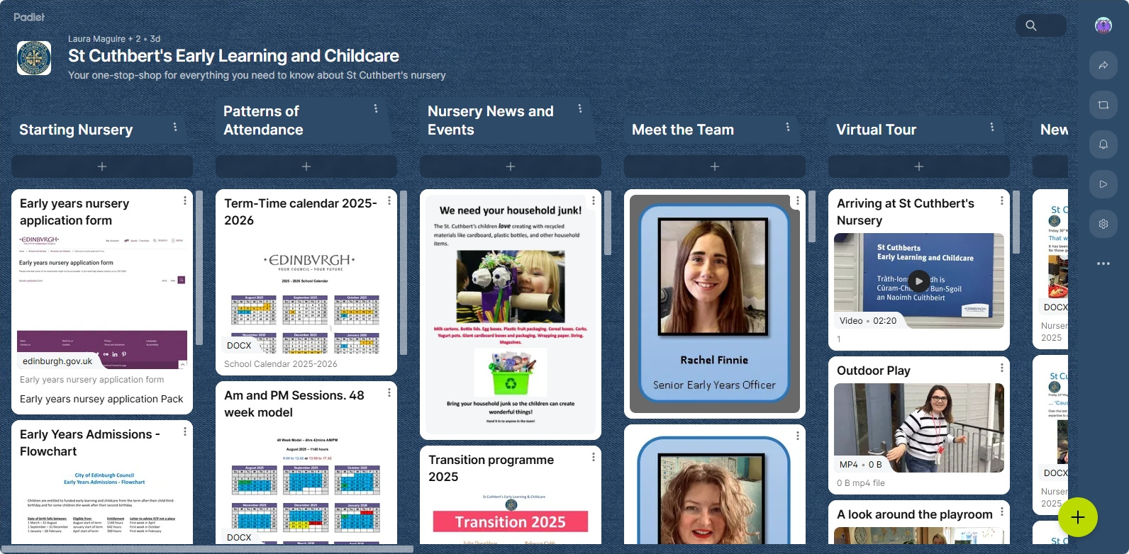
https://padlet.com/lauramaguire1/st-cuthbert-s-early-learning-and-childcare-le6mn1qf3x3w1xdz

Our second padlet contains all our favourite song, stories and games – so you can join in at home!
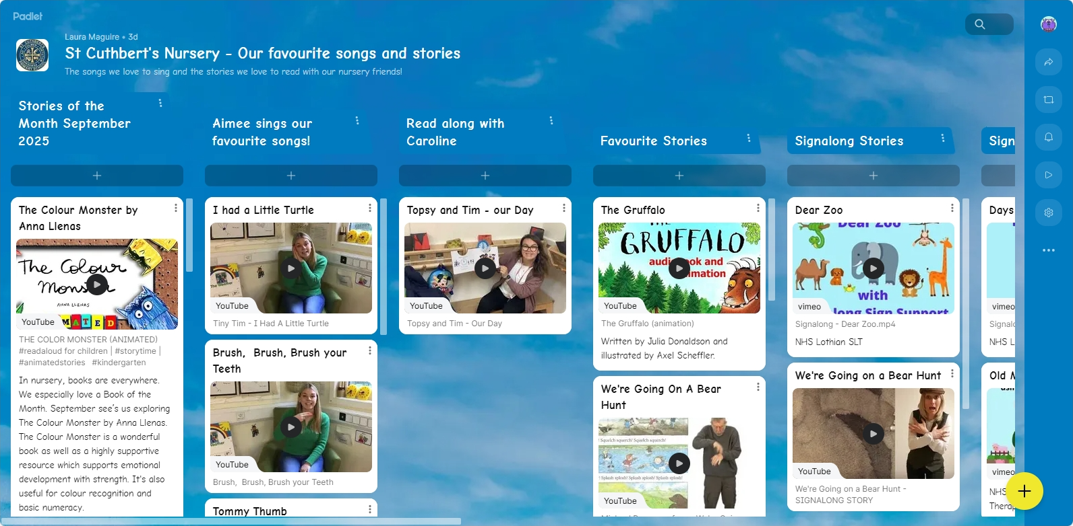
https://padlet.com/lauramaguire1/st-cuthbert-s-nursery-our-favourite-songs-and-stories-9gt6n1wax5ndhv6f

Finally

We wish you and your families a restful and relaxing weekend and look forward
to seeing you all on Monday.

Mr P Brack, Head Teacher and all at St Cuthbert’s School

