 St. Cuthbert’s RC Primary School
Newsletter 10– Friday 10th October 2025
St Cuthbert’s CARES We are: Creative Active Respectful Equal Supported

Good afternoon. Half Term already! Thanks for reading this week’s Newsletter which includes important information relating to our school and nursery. Please ask if you have any questions about its contents.

Upcoming Events at St Cuthbert’s and Dates for your Diary

October Holiday Return to School Date

Staff return to school on Monday 20th October, whilst pupils resume on Tuesday 21st at 8.55am

Parent Council Weekly Update

Halloween/All Saints Eve Disco

A letter was sent out this week with accompanying envelope to return £4 entry slip and requested contact details. Please ensure that these are returned if your child wishes to attend the event on Thursday 30th October.

Parent Council Page on School Website

We are currently working on this, we’ll let you know once its operational.

‘Iron on’ School Badges Available to Buy at Parent Consultations

Thanks to those who contributed towards our funds by buying these.

Should you wish to contact the Parent Council at any time, they can be contacted via e-mail at ptastcuthberts@gmail.com

News & Information

Parent Consultations and Feedback

Thank you to all parents and pupils who attended this week’s consultations. Due to feedback from parents and carers last year and wifi signal issues, we decided to move back to a paper based parent/carer views survey this term. Thanks to all who completed these. It was very touching to hear some of the lovely comments you made. Thank you! If you did not get a chance to do complete a feedback survey and would still like to, please contact our school office. Finally, one parent raised a question re why pupils are not permitted to ride bikes and scooters or kick balls in the playground before school. The reason for this, is that when this was allowed, we had a number of concerns raised re pupil safety so decided to put in place changes to meet these concerns. I hope that makes sense.

Staffing Update – Principal Teacher Cover Weeks Beginning 20th and 27th October

After the holidays, whilst Mr Crowley, our Acting PT, is back at St Joseph’s Primary school, Mrs Kelly will be out of class to support me in the running of the school. Mrs Hussain, a former class teacher and current supply teacher will cover P4 until Mr Crowley returns on 3rd November. Please ask if you have any questions.

Diwali Celebrations at St Cuthbert’s – Date Confirmed for 22nd October

These will take place on Wednesday 22nd October and will include parties in every class and dance performances for P1-3 and P4-7. Thanks to Ram, Suresh and all of our Indian community for their support.

Diwali Dance Performances will take place at the times below. Parents/carers of performers are very welcome to attend:

- P1-3: 1.45-2.05pm
- P4-7: 2.15-2.35pm

School Lunches

Special Themed Day Menu – Thursday 30th October

On Thursday 30th October there will be a special themed menu available. There will only be 2 choices offered (there will not be an option for baked potatoes). The options are chicken meatballs in a tomato sauce (Wizards Brains in Oozy red sauce) or Quorn vegan sausages swirled in pastry (Mummified sausages). Soup and dessert will also be themed and on offer.
Orders for this day must be made no later than midnight on Wednesday 22nd October. If you have ordered your child’s meals in advance please log in to your account and check that you have selected the correct option, as Parentpay have in the past deleted choices when made far in advance.
Your co-operation is very much appreciated, especially by the kitchen staff, who have to order ingredients in advance.

Active Schools Update from Fiona Damen (including new clubs for next term)

It has been great to see such an active term so far and Sports clubs so busy, can see why we are a Gold Schools Sports Award school!
We are delighted to offer 2 more free after school clubs after half term.

- Big thank you to Mrs Tulloch for starting our popular Dance club on Mondays 28 Oct- 8 December for P4-7. Click here to book online:
Dance St Cuthberts P4-7, Monday after school | Edinburgh Sports Unit

- P4 also attended a fantastic Oriam Sports Inspired event this month and we can now offer P4 pupils a follow on Multisport club on Wednesdays after school. This club will run from 5 November to 4 Feb 2026 ( starting back on 14 January) Please note if there are spaces we will open this up to P5 after half term. Click here to book online:
Multi sports St Cuthberts P4 Wednesday after school | Edinburgh Sports Unit

Many thanks to all those who give up their take to take clubs for our pupils to ensure they are active and healthy.
Have a lovely half term break when it comes

Thank you

Fiona

Borders Embroidery Autumn and Winter 15% Discount Offer

We're making it easier (and more affordable) for parents to get their child's school wear sorted. Take advantage of our 15% discount during these exclusive order windows:

📅Autumn Window: 6 -19 October 2025

📅 Winter Window: 15 December 2025 - 11 January 2026

Spread the word and let the parents know the updated dates to make the most of the 15% discount.

https://www.border-embroideries.co.uk

Christmas Cards Order Update

Your orders have now been sent off to the manufacturers. We are expecting the cards back towards the end of November. We’ll keep you posted.

Open Day for P1 Parents in August 2026 – Wednesday 5th November

Parents of children who would like to join our P1 class in August 2026 can visit our school for a tour and the opportunity to ask questions on the above date. No booking is required, just turn up for one of the 3 time slots below:

- 9.15-10.15am
- 11am-12pm
- 1.30-2.45am

There will be a tour of the school and a chance to ask questions of both school leadership and senior pupils. Please contact us if you require more information.

Attendance under 90% and Lateness

All Edinburgh Schools are asked to monitor and follow up absence, with particular focus on pupils with attendance under 90%. Statistics are published regularly and we will share these when we receive them. Please try to ensure that your child misses as little school as possible. We have seen an increase in late arrivals over the last two weeks, we understand that occasional late coming can occur but please try to avoid persistent late arrivals as this has a big impact on learning.

Parking Outside School

It has been brought to our attention that cars, possibly belonging to parents/carers, have been parked on street immediately outside school. Please try to avoid doing this in accordance with traffic signage.

Pupil Leadership and Learning at St Cuthbert’s

Laudato Si Group

The group met with Ms Pusker on Wednesday and planned for their focus on the following Sustainable Development Goals (SDG):

1. No Poverty
2. Zero Hunger
6. Clean water and sanitation
12. Responsible consumption and production

Their focus this week was on SDG 2, looking at seasonal eating. They harvested pears from our Mary Garden and shared these with the rest of the school. They also looked at article 12 in relation to home made rather than bought Halloween Costumes. They will share their work with the school at our next Assembly.

Digital Learning Update & Digital Leaders P1-7

Andrew McArthur, our Digital Learning link supporter visited school this week to help us update our shared P1-5 iPads. We also discussed the role of our new Digital Leaders Pupil Group and initial tasks for them, which started this week.

St Columba’s House Party

St Columbas’s won our first House Point Championship of the term. House points are won via displays of good choices and positive behaviour. Our P7 House Leaders organised a celebration party for all house members today. Big thanks to Mrs Hogg and Miss McVey for their support with this.

Firework Safety P6 and P7

Representatives of the Fire Brigade visited school on 8th October to talk to our P6 and P7 Classes re firework safety.

Catholic Education and Parish Update

P6 Class Mass

Well done to P6 for all of their hard work leading the Mass in honour of Our Lady today. Thanks to all those who brought flowers too for Our Lady’s statue. Big thanks to Miss Christie and Mrs Peake for organising Mass and to those parents and concerns who attended.

Learning About the Rosary

Sylwia, our Parent Council R.E rep, has been visiting classes this week to spread the word about the rosary to our P3 and P5 Classes. She will visit remaining classes after holidays. As part of this learning they have been decorating ‘rosary’ stones to decorate our Mary Garden.

Sacramental Registration Meeting and Celebration Dates Confirmed

The following dates have been confirmed with Fr Francis:

- Sacramental Registration Meeting – Wednesday 12th November 6pm, St Cuthbert’s Church.
- P3 Reconciliations – Thursday 26th March, 6pm St Cuthbert’s Church
- P7 Confirmations – Friday 8th May, 7pm St Cuthbert’s Church
- P4 First Holy Communions – Sunday 14th June, 9.30am St Cuthbert’s Church

Nursery Update

Is there a doctor in the house?
This month, we have been exploring the topic, “People Who Help Us" This introduces children to community helpers like police officers, firefighters, doctors, nurses, teachers, and postal workers to help them understand the world around them and the importance of these roles. Activities for this topic include role-playing, singing songs and reading stories.

The children’s interest has focused in on doctors, and we now have our own hospital and consultation room in the home corner!

This has led to an increased interest in the human body. We have been investigating body parts, what our bodies can do and what is underneath our skin. There has been lots of interesting discussions and discoveries.

Yesterday was very exciting. Joe, the crossing patrol officer came to visit and speak to the children. A lot of them know her already as they meet see her on the way to, and from nursery. The children asked lots of questions about her job, and we discussed how to be safe on the road.
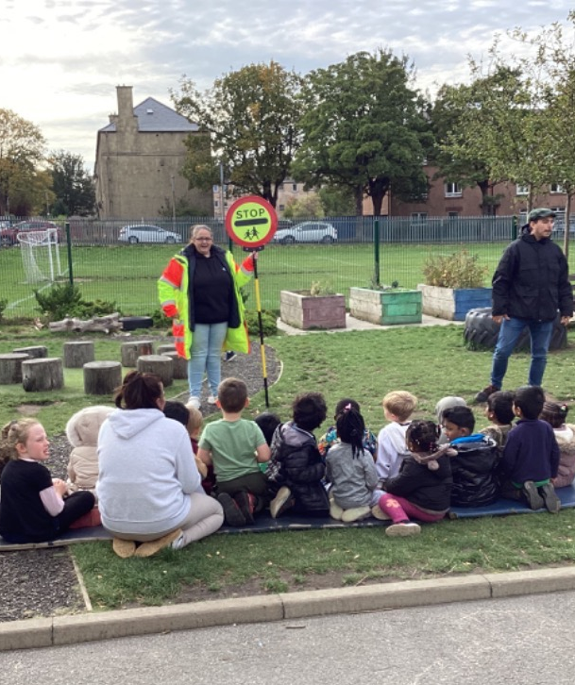
The children really enjoyed meeting one of the people who help us!

Falling leaves and shining lights
This year, Diwali falls on October 21^{st,} which is during the autumn season, so we have been celebrating and investigating both this month. We have been creating beautifully individual Diwali diyas and rangoli and reading all about the festival of lights! We have been out for lovely autumn walks and have created charming autumnal art.

We will be exploring both topics all month. If you would like to come and talk with the children about Diwali, or join in with some autumn artwork, speak to a member of the team!
Books of the month - October
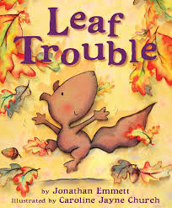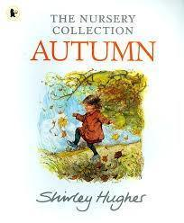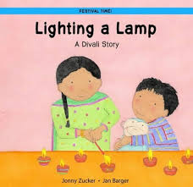
Head over to our nursery Padlet and read along at home!
St Cuthbert's Nursery - Our favourite songs and stories

Dates for the nursery diary
Monday 13 to Friday 17 October - Mid-term break Nursery closed to all term-time children (option 1)
Monday 20 October - Teacher in-service day (nursery closed to all children)
Wednesday 12 November - Individual nursery photographs

Finally

We wish you and your families a restful and relaxing weekend and look forward
to seeing you all on Tuesday

Mr P Brack, Head Teacher and all at St Cuthbert’s School

