 St. Cuthbert’s RC Primary School
Newsletter 13– Friday 7th November
CARES We are: Creative Active Respectful Equal Supported

Good afternoon. Thanks for reading this week’s Newsletter which includes important information relating to our school and nursery. Please ask if you have any questions about its contents.

Upcoming Events at St Cuthbert’s and Dates for your Diary

Key Dates for This Half Term (new info included)

if there are any changes to dates below, this will be flagged up in this section and communicated to parents:

- Wednesday 12th November: Sacramental Registration Meeting, for parents of pupils in P3, P4 and P7, St Cuthbert’s Church 6pm
- Friday 14th November: P6 Class Assembly, School Hall 9.30am
- Friday 21st November: All classes optional dress as a favourite character for Book Week Scotland.
- Friday 5th December: P3 Class Mass, St Cuthbert’s Church 9.30am
- Friday 5th December: Christmas Fayre, St Cuthbert’s Parish Hall time tbc
- Monday 8th December: P4 Choral Showcase, School Hall 9.45-10.15am
- Tuesday 9th December P3-7 Song for Christmas Performance, 2pm School Hall
- Wednesday 10th December: Christmas Dinner and Christmas Jersey Day in school
- Thursday 11th December: P1/2 Nativity, 5pm School Hall
- Christmas Parties will take place w/c 15th December, more details to follow next month.

Parent Council Weekly Update

Our next meeting will be at 11.30am on Friday 14th November in the school library. All parents/carers welcome!
Halloween/All Saints Eve Disco

Thanks to all those who attended. The event raised an amazing £350 for Parent Council Funds!

Christmas Fair Information

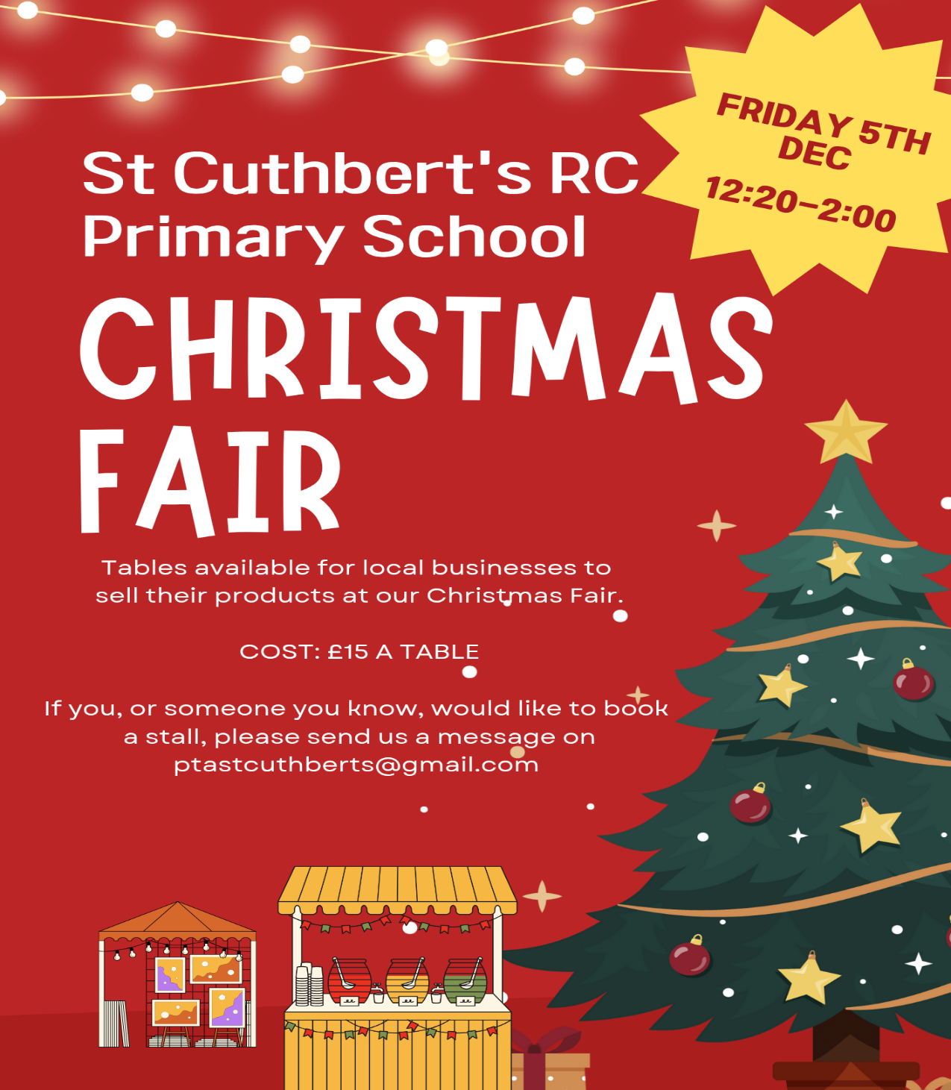
Parent Council Page on School Website

A basic form of the page is now up and running on our website and has been updated again this week. Thanks to Carla for her support!

Should you wish to contact the Parent Council at any time, they can be contacted via e-mail at ptastcuthberts@gmail.com

News & Information

Appeal for Bilingual Readers – Book Week Scotland

Book Week Scotland takes place between 17th and 22nd November. We would very much like it, if any parents carers able to read a story in English and other language (read page first in English then in a second language) could volunteer to read one or more of our classes a story during this week. Please let us know if you are interested in volunteering.

Pantomime Booked for December

Please note that we have managed to book a professional theatre company to perform the pantomime Snow White on Monday 15th December in the school hall.

Gwen Mayor Trust – Successful Application

Congratulations to Miss Donnelly, our EIS Union representative, who made a successful application for a grant of £1000 to develop our P1/2 Outdoor Resources. We will update you with our progress in purchasing items with these funds.

Appeal for Books for our Free Book Dispensary in Main Playground

If anyone has good condition, used books appropriate for primary age children please feel very welcome to add them to our free book box situated in the main playground. If you would prefer to hand them in to the office please also feel free to do so. Thank you!

Active Schools Multisports Club – Space Available for P3 Pupils

There are still 6 spaces available for this club and the organisers have asked us to extend an invite to P3-5 pupils whose parents would like to book them on using the new link below: (even though link doesn’t mention P3, Fiona confirms it is open to P3 pupils).
Multi sports St Cuthberts P4 and P5 Wednesday after school | Edinburgh Sports Unit
Any questions about Active Schools Clubs, please text Fiona Damen on
07769 922 742.

Rag Bag Collection

A Rag Bag Collection has been scheduled for Tuesday 18th November. Please bring any unwanted items in a securely tied plastic bag and place them into the green clothing point container in the front playground. If the container is full, please bring your bags in to the school where they will be kept until they are collected.
All good quality clean Men’s, Women’s and Children’s clothing, belts, bags and paired shoes (tied together please) can be accepted.
The bags will be collected and transported to the Rag Bag factory where they will be sorted and graded for reuse or recycling. The school then receives a cheque from the company which is banked in to our School Fund, thus benefitting all the children.

P6/5 School Football Team Result

Coach Chris reports that our team comprised of pupils from both P5 and P6 classes beat James Gillespies 6-2 on Saturday. A fantastic performance with some really good team goals too!

Open Day for P1 Parents in August 2026 – Wednesday 5th November

Thanks to all of those parents and carers who joined us on this day. We hope that you enjoyed your visit. Thank you for your positive feedback. Please let us know if you have any questions.

Pupil Leadership and Learning at St Cuthbert’s

P3 Learning Discussion

I met with P3 on Monday to discuss their learning, it was great to see the pride they were taking in their work and to hear them describe their weekly learning goals and longer term targets. They were also great at explaining peer and self assessment.

Pupil Rights and Learning Group

Members of the group met with me on Tuesday. We discussed how we use the UNCRC Rights in our Playground and made posters to help articulate these rights in child friendly language. The message of the posters was conveyed to all classes by the group. The posters will be displayed on our school windows to remind pupils of their rights outside. This work also ties in with the Sustainable Development Goal 4. Quality Education.

Health and Wellbeing Group

The Health and Wellbeing Group shared the result of our Healthy eating competition with the school this week. Our winners were P6! The winning class were rewarded with a ‘Fruit Smoothie Afternoon’ making and consuming their own healthy drinks. See picture below. This work linked with Sustainable Development Goal 3. Good Health and Wellbeing. The group will meet again next week.

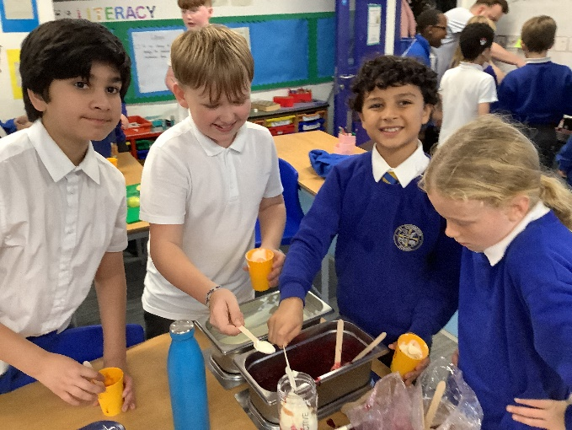

EPSSA Athletics Tournament Feedback

The Team, Ms Armitage and Mrs Pusker had a great time at Meadowbank on Monday. Although they didn’t win the tournament, they did win some individual races and showed great sportsmanship, well done to all involved.

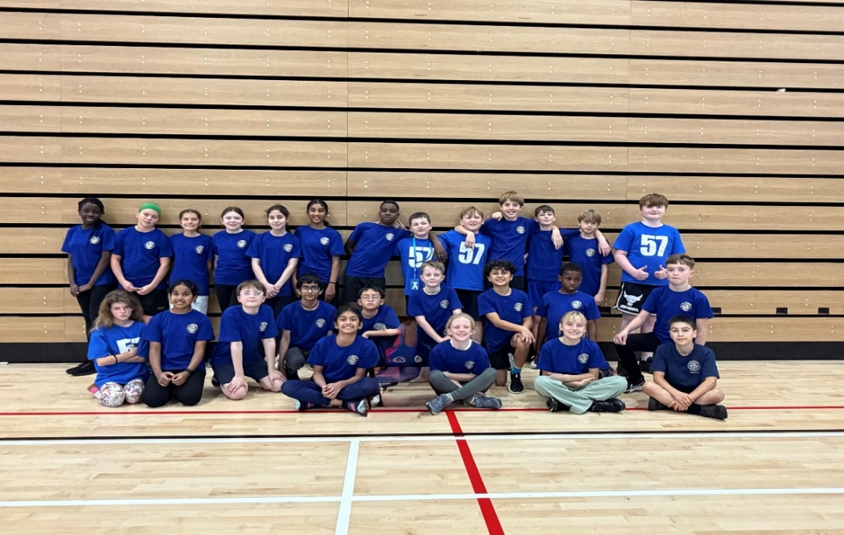

Catholic Education and Parish Update

Catholic Education Week Mass – Tuesday 25th November, 11am at St Mary’s RC Cathedral

Myself and Mrs Peake will take 8 representative pupils to this Mass (the limit prescribed by St Mary’s Cathedral). If your child is a practising Catholic and you would like them to attend, please let us know. If we have more than 8 volunteers, we will draw lots for attendees. Parents and Carers are also welcome to attend.

Sacramental Registration Meeting – Thursday 12th November

Fr Francis has asked that all parents wishing their child to make the sacraments of Reconciliation, First Holy Communion and Confirmation in 2026 attend this information meeting, where they will also be given registration forms for their child’s participation:

- Sacramental Registration Meeting – Wednesday 12th November 6pm, St Cuthbert’s Church.

Nursery Update

This week we have noticed the much darker evenings, so we have been learning about light and dark, and talking about winter approaching. We had great fun making firework paintings and learning about safety on bonfire night.

This week we said goodbye to our temporary Early Years Assistant Julia. She said she will miss all the children and families, but she will keep in touch!
Next Wednesday 12th November Tempest Photography are coming to St Cuthbert’s to take individual photographs of the nursery children. Once the photograph is taken, your child will bring home a Tempest Photography Order Pack for you to view the images and place an order if you wish to do so.

Finally

We wish you and your families a restful and relaxing weekend

Mr P Brack, Head Teacher and all at St Cuthbert’s School

