 St. Cuthbert’s RC Primary School
Newsletter 14– Friday 14th November
CARES We are: Creative Active Respectful Equal Supported

Good afternoon. Thanks for reading this week’s Newsletter which includes important information relating to our school and nursery. Please ask if you have any questions about its contents.

Upcoming Events at St Cuthbert’s and Dates for your Diary

Key Dates for This Half Term (new info included)

if there are any changes to dates below, this will be flagged up in this section and communicated to parents:

- Friday 21st November: All classes optional dress as a favourite character for Book Week Scotland.
- Friday 5th December: P3 Class Mass, St Cuthbert’s Church 9.30am
- Friday 5th December: Christmas Fayre, St Cuthbert’s Parish Hall time 12.20-2pm
- Monday 8th December: P4 Choral Showcase, School Hall 9.45-10.15am
- Tuesday 9th December P3-7 Song for Christmas Performance, 2pm School Hall
- Wednesday 10th December: Christmas Dinner and Christmas Jersey Day in school
- Thursday 11th December: P1/2 Nativity, 5pm School Hall
- Christmas Parties will take place w/c 15th December, more details to follow next month.

Parent Council Weekly Update

Our latest meeting was held this morning. Thanks to all who attended. Minutes will be shared with all parents via email next week.

Christmas Fair Information

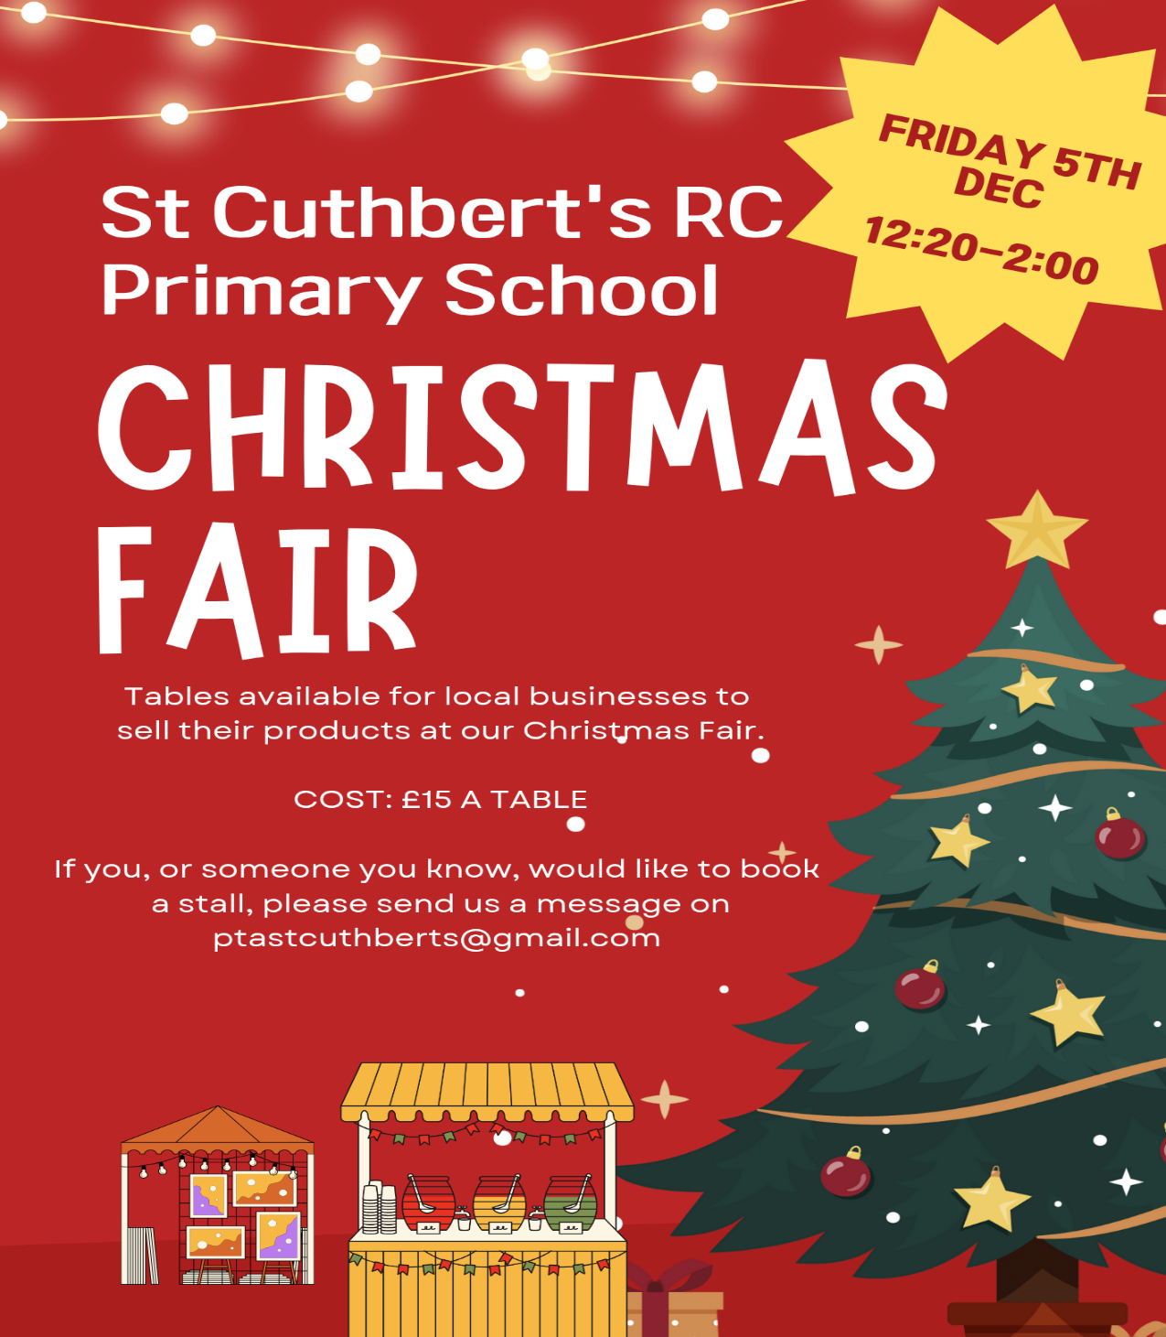
Parent Council Page on School Website

A basic form of the page is now up and running on our website and has been updated again this week. Thanks to Carla for her support!

Contact Us

Should you wish to contact the Parent Council at any time, they can be contacted via e-mail at ptastcuthberts@gmail.com

News & Information

School Lunches Christmas Dinner – Wednesday 10th December

This year our Christmas menu is being offered on Wednesday 10th December. There will only be 2 options offered that day.
Option 1 (in place of Breaded Fish Fingers) will be Festive Roast Turkey, pigs in blankets, roast potatoes, brussel sprouts and carrots. Followed by Christmas ice cream with sponge or seasonal fresh fruit.
Option 2 (in place of Cheesy bean & potato pasty) will be Quorn Fillet Christmas Dinner with roast potatoes, brussel sprouts and carrots. Followed by Christmas ice cream with sponge or seasonal fresh fruit.
There will be NO BAKED POTATO Option. If your child still has a baked potato option selected, they will receive a quorn fillet.
If you wish your child to have a Christmas lunch on that date, please log in to your account and select the option required. Please order no later than Wednesday 3rd December at midnight.

New Administrator at St Cuthbert’s Primary

Mrs Robson’s last day is Wednesday 26th November, we interviewed for a new Administrator this week and have a preferred candidate in mind. Once all checks and paper work are completed, we will share more information.

Appeal for Bilingual Readers – Book Week Scotland

Book Week Scotland takes place between 17th and 22nd November. We would very much like it, if any parents carers able to read a story in English and another language (read page first in English then in a second language) could volunteer to read one or more of our classes a story during this week. Please let us know if you are interested in volunteering. Thanks to those who have done so already.

Pantomime Booked for December

Please note that we have managed to book a professional theatre company to perform the pantomime Sleeping Beauty on Monday 15th December in the school hall.

Gwen Mayor Trust – Successful Application/Purchases Made

Miss Donnelly, our EIS Union representative, made a successful application for a grant of £1000 to develop our P1/2 Outdoor Resources. This week we ordered a mud kitchen and outdoor tables and chairs for our youngest classes.

Appeal for Books for our Free Book Dispensary in Main Playground

If anyone has good condition, used books appropriate for primary age children please feel very welcome to add them to our free book box situated in the main playground. If you would prefer to hand them in to the office please also feel free to do so. Thank you!

Rag Bag Collection

A Rag Bag Collection has been scheduled for Tuesday 18th November. Please bring any unwanted items in a securely tied plastic bag and place them into the green clothing point container in the front playground. If the container is full, please bring your bags in to the school where they will be kept until they are collected.
All good quality clean Men’s, Women’s and Children’s clothing, belts, bags and paired shoes (tied together please) can be accepted.
The bags will be collected and transported to the Rag Bag factory where they will be sorted and graded for reuse or recycling. The school then receives a cheque from the company which is banked in to our School Fund, thus benefitting all the children.

Active School Cricket Club – Additional Week

Please note that Active Schools Cricket Club was cancelled due to weather this week and will now finish for this term on Thursday 20th November.

Pupil Support Officers (PSO’S) in School

This term we have joined by two new members of staff who visit us fortnightly to support the school, pupil and families. They are Anna Mlodzik and Nicola Collins. Please ask if you have any questions about their roles.

Pupil Leadership and Learning at St Cuthbert’s

P2 Learning Discussion

This week I met with pupils from P2 who showed me their Literacy, Numeracy and Interdisciplinary Learning. We talked about their strengths and next steps in learning as well as what they enjoy about learning and what improvements we can make. The discussion was positive and the pupils were open, honest and constructive with their views. Next week I will meet with P4.

Health and Wellbeing Group

Our Health and Wellbeing Group meet this week with Catering Manager Eric Taylor from City of Edinburgh Council and Lynsey Smith, Kitchen Supervisor to discuss School Meals the pupils came up with some positive feedback and interesting suggestions. They also made plans to institute a new weekly healthy eating competition in the school. This work linked with UNCRC Sustainable Development goal 2. No hunger and 3. Good Health and Wellbeing.

Laudato Si Group Charity Appeal – Warm Winter Drive

Members of our Laudato Si Group presented to the school this week re their latest work on UNCRC Sustainable Development Goal 1. No poverty and 12. Responsible Consumption. They are holding a charitable appeal for Advent, asking for used but good condition winter clothing such as hats, scarves, coats, gloves that can be donated and used by those in need. This is being done in support of the charity The Leith Collective which supports families throughout Edinburgh to stay warm during Winter. Donations can be handed in to the school office or pupils can bring them to P7 Classroom. Thank you.

For more information about the charity please see link below:

https://www.scottishhousingnews.com/articles/annual-winter-coat-exchange-launched-to-help-edinburgh-families

P7 Edinburgh College STEM Day

P7 took part in an interactive STEM Challenge in partnership with Edinburgh College on Thursday. They learnt about different types of bridges and built and tested the weightbearing capacities of their own models.

P6 iPads

We have now received our 1:1 P6 iPads. All pupils and parents will be asked to complete a responsible use agreement and support will be received from City of Edinburgh Council to help with the technical support required to make these operational. We hope to have them in daily use within the classroom by end of this month.

P4 BEAR Scotland Trip Next Thursday

P4 will travel to S. Queensferry on Thursday for a STEM Excursion. They will travel there and back by coach. The cost of this trip has been subsidised by Parent Council donations.

Building Resilience

Thanks to Mrs Kelly who lead an Assembly on Monday to re-launch Building Resilience in our school. Building Resilience helps children to develop life-skills to cope with the ups and downs of life. We will be holding an assembly in late January to share work on this theme and look forward to inviting our parents in to hear about this.

Catholic Education and Parish Update

Catholic Education Week Mass – Tuesday 25th November, 11am at St Mary’s RC Cathedral

Thanks for the great response to last week’s appeal. We will confirm attendance with all of those involved next week.

Sacramental Registration Meeting – Wednesday 12th November

Thanks so much to everyone who came to this week’s meeting. There was a great turn out. If you have not registered your child for the Sacraments in 2026 and you wish to, please contact Fr Francis who has spare forms. We will also request spare forms from him for next week if that is easier.

Nursery Update

This week in nursery has been astronomically fun! That’s because the children have been exploring space. We have a space station and a rocket ship, and we’ve been looking at our planet, and the other planets in our solar system. The children have even even been wearing space helmets with coloured visors – to experience the world in a different hue - because they wondered; what does it look like on other planets? At Together-Time, we have been reading Whatever Next by Jill Murphy about a little bear who has an out of this world adventure. Why not get in on all the interplanetary fun and listen to the story at home? https://www.youtube.com/watch?v=6c5cb0u0rPM

The Rights of The Child
We have been creating our Nursery Class Charter this week. This is being made collaboratively with the children and the team. We are supporting the children to develop their personal, social and emotional skills by participating in creating a set of guidelines, which will be displayed in the classroom. By doing this we hope the children gain a sense of ownership and belonging, helping the children to understand what behaviour is expected to keep everyone safe and comfortable. When it is finished, we would love you all to see it!
Nursery has a Padlet dedicated to Children’s Rights, which we will be updating regularly. Please have a look: https://padlet.com/lauramaguire1/the-rights-of-the-child-1m1htop15fqha0mf

Finally

We wish you and your families a restful and relaxing weekend

Mr P Brack, Head Teacher and all at St Cuthbert’s School

