 St. Cuthbert’s RC Primary School
Newsletter 17– Friday 5th December
CARES We are: Creative Active Respectful Equal Supported

Good afternoon. Happy St Nicholas’ Day to all families celebrating this event tomorrow. Thanks for reading this week’s Newsletter which includes important information relating to our school and nursery. Please ask if you have any questions about its contents.

Upcoming Events at St Cuthbert’s and Dates for your Diary

Key Dates for This Half Term

- Monday 8th December: P4 Choral Showcase, School Hall 9.45-10.15am
- Tuesday 9th December P3-7 Song for Christmas Performance, 2pm School Hall – Tickets are sold out for this event.
- Wednesday 10th December: Christmas Dinner and Christmas Jersey Day in school
- Thursday 11th December: P1/2 Nativity, 5pm School Hall – tickets still available contact office.
- Christmas Parties will take place w/c 15th December- see dates and times below, pupils may come to school on this date wearing party clothes if they wish to:
P1 – Monday 15th December at 9.15am
P2 – Monday 15th December at 11am
P3 – Tuesday 16th December at 1.15pm
P4 Tuesday 16th December at 2.15pm
P5 Wednesday 17th December at 1.15pm
P6 Thursday 18th December at 1.30pm
P7 Wednesday 17th December at 2.15pm
Parent Council Weekly Update
Christmas Fair

Our Christmas Fair takes place today, we hope to see as many of you over at the church hall as possible. All profits go to Parent Council funds which are used to support the school with trips, resources etc.

Our Next Meeting

Our next meeting takes place on Friday 23rd January at 11.30am in school library – all welcome.

Contacting Our Parent Council

Should you wish to contact the Parent Council at any time, they can be contacted via e-mail at ptastcuthberts@gmail.com

News & Information

Meals for Return to School on Tuesday 6th January 2026

If you wish your child to receive a lunch on our return after the Christmas holidays, you need to select your options no later than midnight on Wednesday 17th December. The system is then closed, and you will be unable to order, and you will need to supply your child with a packed lunch.
Thank you for your co-operation with this, which greatly helps the kitchen and their ordering for our return in 2026.

Appeal for Lego

If anyone has Lego in their house which they no longer use and which is in good condition we’d be very glad to have it. Any donations can be given to the office before end of term. These donations will be used in our launching the Learning sessions – see below in learning section.

Change of Shoes for P.E

With Winter conditions now fully setting in, it would be great if pupils could bring indoor shoes to school for days when outdoor shoes are icy, wet or muddy. This will also help our pupils take part more safely and enjoyably in P.E. A slip was sent out this week to encourage this practice.
Active Schools Volunteers

After Christmas, we will be advertising our next booking link for Active Schools clubs for that term. Fiona Damen, our Active Schools Coordinator is always on the look out for parents to help with new clubs. If you are interested in running a club, please watch the link below (at 2m 38 seconds) where Chris Evans, one of our parents talks about the positive experience he has had as an active schools volunteer:

Want to become an Active Schools volunteer? Find out more from our volunteers themselves

Pupil Leadership and Learning at St Cuthbert’s

Pupil Rights and Learning Group

I met with the group this week and we revised our school vision, values and aims. The group will take these out to their classes and seek further feedback before we share them with parents and carers after Christmas. Sustainable Development Goal: 4. Quality Education

‘Launching the Learning’ and Metaskills

Mrs Kelly and myself visited Cramond Primary on Wednesday to see their morning starter activities which promote focus and engagement for 10-15 minutes in the mornings before formal learning is launched. They term this ‘Launching the Learning’. We have started a modified version of this in school and will be developing it further after a January in-service training input.

Scottish Ballet Taster Sessions

Thanks very much to the dance teachers from Scottish Ballet who put on two enjoyable taster sessions for P3 and P4 on Thursday. Thanks to Mrs Skelly for organising and to Jessica one of our pupils for helping facilitate the session.

P6 & P7 Trip

P6 had an enjoyable trip to the Museum on Wednesday as part of their project on prehistory. They particularly enjoyed the dinosaur exhibits! Unfortunately, P7’S Trip to the Water of Leith was postponed due to staff absences at the visitor centre. We hope to rearrange this trip in January.

Catholic Education and Parish Update

P3 Class Mass

Well done to P3 and Miss Tulloch for leading today’s Advent Mass. Thanks to Fr Francis, Fr Malachi and to Dorothy for the music too!

Advent Children's Liturgy and Christmas Masses

Each week during Advent the Children's Liturgy will be held at St Cuthbert's Church at 930 Morning Mass. i.e. Sundays 30th November, 7th December, 14th December and 21st December.
At the end of the Liturgy each week the children will be learning a Christmas Carol with percussion and actions that they will sing on Christmas morning Mass at 1000 (not 0930 as in previous years)
The Children's Liturgy team would like to encourage more children to attend the Liturgy during Advent and to participate in the Christmas Carol at the Christmas Morning Mass

Thank you to all those children who already participate in the Children's Liturgy and we really look forward to seeing some more children attending during Advent.

Christmas Masses

- Christmas Eve 24th December – 8pm Mass at both St. Cuthbert’s and Our Lady’s
- (8pm carols, Mass commences at 8.30pm)
- Christmas Day 25th December – 10am Mass at both St. Cuthbert’s and Our Lady’s
- New Years Day 1st January – 9.30am Mass at St. Cuthbert’s and 11.30 Mass at Our Lady’s

Nursery Update

The children have been working on their small motor muscles and their eye-hand coordination this week; they have been busy writing letters to Santa, folding them and placing them in envelopes (really tricky!), making and decorating salt-dough ornaments, designing their own Christmas cards, as well as exploring lots of different crafting tools and techniques.
The nursery has been alive with the sound of music! We have been practicing our Christmas carols for our annual Carol Concert next Friday. Please come along and join in. details below.

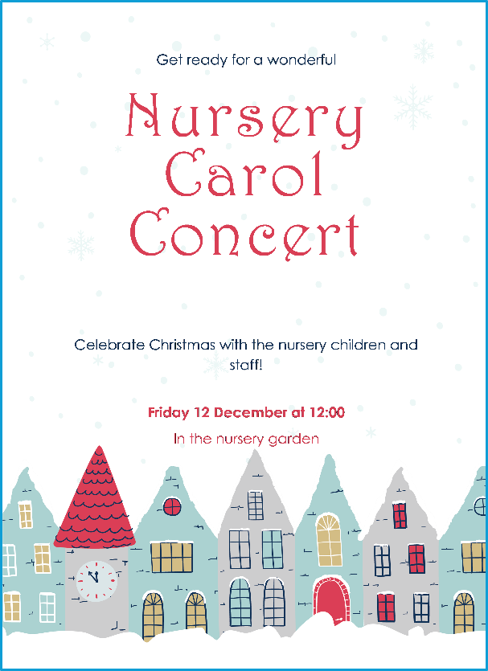

Finally

We wish you and your families a restful and relaxing weekend

Mr P Brack, Head Teacher and all at St Cuthbert’s School

