 St. Cuthbert’s RC Primary School
Newsletter 18– Friday 12th December
CARES We are: Creative Active Respectful Equal Supported

Good afternoon. Thanks for reading this week’s Newsletter which includes important information relating to our school, parish church activities and nursery. Please ask if you have any questions about its contents.

Upcoming Events at St Cuthbert’s and Dates for your Diary

Key Dates for This Half Term

- Christmas Parties will take place w/c 15th December- see dates and times below, pupils may come to school on this date wearing party clothes if they wish to:
P1 – Monday 15th December at 9.15am
P2 – Monday 15th December at 11am
P3 – Tuesday 16th December at 1.15pm
P4 Tuesday 16th December at 2.15pm
P5 Wednesday 17th December at 1.15pm
P6 Thursday 18th December at 1.30pm
P7 Wednesday 17th December at 2.15pm

Term End and Return Dates
Please note that the school term ends next Friday 19th December at the normal times of 12.20pm for P1-2 and 12.30pm for P3-7.
School resumes for staff on Monday 5th January and for pupils on Tuesday 6th January at the usual time of 8.55am.

Parent Council Weekly Update
Christmas Fair Proceeds
Huge thanks to all who helped organise and run the fair as well as to those who attended. This year’s Fair raised £757 for Parent Council Funds and this will be used to help fund a new sound system in partnership with the school.

Our Next Meeting

Our next meeting takes place on Friday 23rd January at 11.30am in school library – all welcome.

Contacting Our Parent Council

Should you wish to contact the Parent Council at any time, they can be contacted via e-mail at ptastcuthberts@gmail.com

News & Information

Song for Christmas and Nativity Performances

Thank you for coming out in such huge numbers for both performances and for being such an appreciative audience. We hoped you enjoyed viewing these events as much as our pupils enjoyed performing them. Donations to school funds including the raffles totalled £ 218.21. Thank you.

School Advent Charity – The Leith Collective

Huge thanks to all those who made donations to help families in our local area stay warm this winter. Our school’s donations were dropped off on Wednesday. See pictures below:

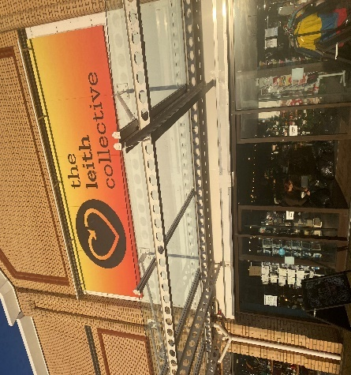

Attendance and Lateness Updates

We have received our attendance statistics for November from City of Edinburgh Council. Our percentage of pupils attending below 85% was 4.6% which is very encouraging. Unfortunately attendance below 90% was a much higher 23.2%. We understand that it is flu season but please try to keep absences to a minimum. We have also noted an increase in a small number of pupils arriving late on more than 2 occasions each week. Again, please try wherever possible to have your child arrive on time for start of school.

Meals for Return to School on Tuesday 6th January 2026

If you wish your child to receive a lunch on our return after the Christmas holidays, you need to select your options no later than midnight on Wednesday 17th December. The system is then closed, and you will be unable to order, and you will need to supply your child with a packed lunch.
Thank you for your co-operation with this, which greatly helps the kitchen and their ordering for our return in 2026.

Appeal for Lego

If anyone has Lego in their house which they no longer use and which is in good condition we’d be very glad to have it. Any donations can be given to the office before end of term. These donations will be used in our launching the Learning sessions – see below in learning section. Thanks to those who donated this week.

Change of Shoes for P.E

With Winter conditions now fully setting in, it would be great if pupils could bring indoor shoes to school for days when outdoor shoes are icy, wet or muddy. This will also help our pupils take part more safely and enjoyably in P.E. A slip was sent out this week to encourage this practice.

Active Schools Volunteers

After Christmas, we will be advertising our next booking link for Active Schools clubs for that term. Fiona Damen, our Active Schools Coordinator is always on the look out for parents to help with new clubs. If you are interested in running a club, please watch the link below (at 2m 38 seconds) where Chris Evans, one of our parents talks about the positive experience he has had as an active schools volunteer:

Want to become an Active Schools volunteer? Find out more from our volunteers themselves

Pupil Leadership and Learning at St Cuthbert’s

Laudato Si Group Charity

Please see text and pictures above. Sustainable Development Goals 1. No poverty and 12. Responsible Consumption.

HWB Group

Will meet next week to plan our healthy eating competition for next term and discuss how to promote indoor shoes for P.E.

P7 Visit to St Augustine’s

P7 had a busy day on Tuesday, taking part in a cross Learning Community Drama workshop at St Augustine’s High School before taking part in a Song for Christmas in the afternoon. This visit was part of their ongoing secondary school transition programme.

Catholic Education and Parish Update

Christmas Singalong Friday 19th December

Pupils, staff, Fr Francis and our parish musicians will take part in a Christmas Sinaglong comprised of Carols and secular Christmas on Friday 19th December to round off the term in a fun and spiritual way.

Advent Children's Liturgy, Parish Carol Service and Christmas Masses

We still have two Children's Liturgy sessions at St Cuthbert's Church on the Sundays leading up to Christmas. i.e. 14th December and 21st December. It would be lovely to see more children attending over the next couple of weeks
At the end of the Liturgy each week the children will be learning a Christmas Carol with percussion and actions that they will sing on Christmas morning Mass at 1000 (not 0930 as in previous years)
After Christmas the Liturgy for children will continue as before once every fortnight. We will send dates after Christmas. If your child is shy about coming into the Liturgy room it is perfectly ok for an adult to accompany them to begin with.

Christmas Carols Service Sunday 14th December

This Sunday at 2pm there will be a Carol Service in St Cuthbert's Church. Please come along and enjoy singing some of your favourite Christmas Carols!
During the service the children will be invited to sing 'Away in a Manger' with actions. There will be people leading this and they can copy the actions. Again we encourage as many children as possible to come along and join in.
Thank you
Dorothy Johnstone (Church/School Liturgy Co-ordinator)

Christmas Masses

- Christmas Eve 24th December – 8pm Mass at both St. Cuthbert’s and Our Lady’s
- (8pm carols, Mass commences at 8.30pm)
- Christmas Day 25th December – 10am Mass at both St. Cuthbert’s and Our Lady’s
- New Years Day 1st January – 9.30am Mass at St. Cuthbert’s and 11.30 Mass at Our Lady’s

Nursery Update

A huge thank you to all those braved the December weather to attend the nursery Carol Concert. The children put in lots of time and effort to learn the songs and it worth it – didn’t they do well!?
Only one more week until the end of term, and only one more week until our nursery Christmas party – and our very, very special visitor makes an appearance! We can’t wait.

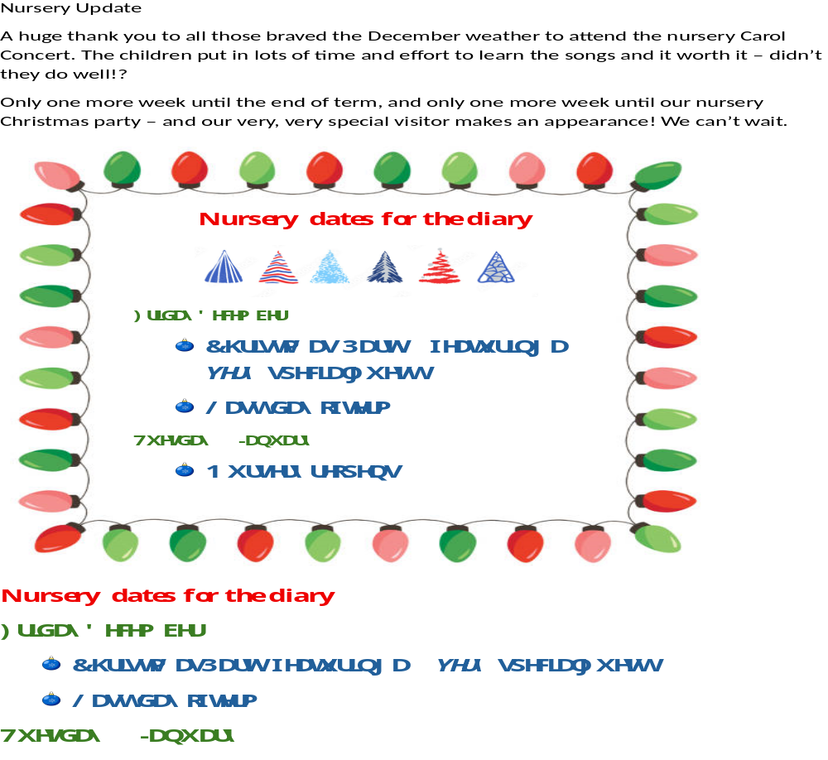

Finally

We wish you and your families a restful and relaxing weekend

Mr P Brack, Head Teacher and all at St Cuthbert’s School

