 Newsletter 20 – Friday 9th January 2026
CARES We are: Creative Active Respectful Equal Supported

Good afternoon and Happy New Year to all of our families. We hope that you all had a great Christmas Holiday. Thanks for reading this week’s Newsletter and for all of your support and engagement with the school last term. Thank you also for the many kind cards and gifts for our staff and myself.

Upcoming Events at St Cuthbert’s and Dates for your Diary

This Term’s Dates for your Diary
These are currently with staff for their consideration and final version will be shared next week.

Parent Council - Our Next Meeting

Our next meeting takes place on Friday 23rd January at 11.30am in school library – New members are always welcome.

Contacting Our Parent Council

Should you wish to contact the Parent Council at any time, they can be contacted via e-mail at ptastcuthberts@gmail.com

News & Information

Uniform This Term

Our uniform expectations are always rightly relaxed in the run up to Christmas, now that we are back to school however, it would be great to see uniform being worn consistently again. As always, we appreciate your support with this.
Punctuality & Absence Reminder

Our absence figures for December were as follows. Only 5.6% of pupils attended for less than 85% of the month, a rather higher figure of 20.6% attended for between 85% and 90%. 79.4% of pupils attended for over 90% of the month.

Please see visual below that shows the impact of both lateness and absence on learning. Thanks for your continuing support in ensuring that your children are in school and on time
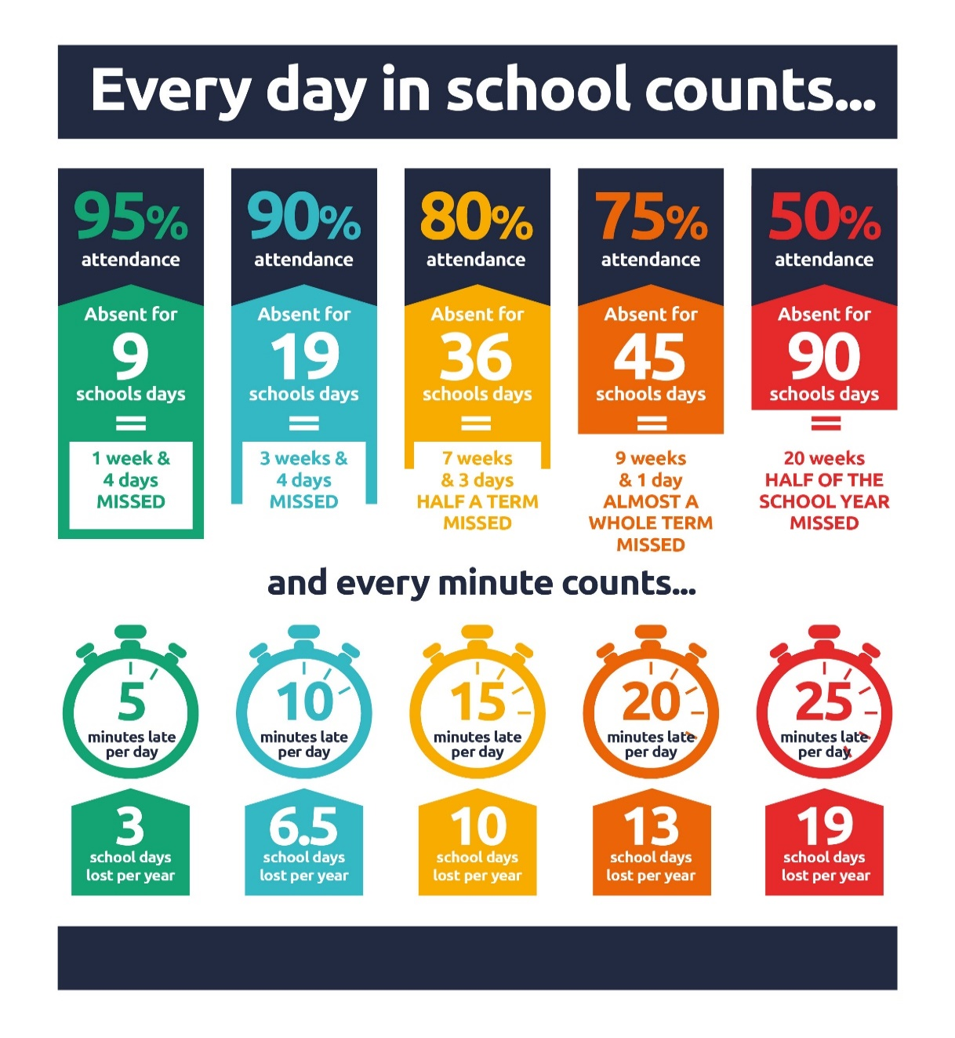
Online Safety Parent and Carer Event – Wester Hailes Education Centre Wednesday 14th January

Please see link below to register for this event which runs from 6-8pm on the above date.

Free Online Safety Event for Parents and Carers

Keeping your Child Safe Online: Porn, Nudes and Online Sexual Harm Online event - Jan 27 from 7pm to 8pm

City of Edinburgh Council have asked that we distribute the important message and link below:

The Lucy Faithful Foundation are delivering an online one-hour session on online sexual harm. This is for parents/carers and aimed at sharing practical strategies to keep children safe online. Similar sessions delivered this time last year were very popular. Please see attached for more information.

https://www.eventbrite.com/e/keeping-your-child-safe-online-porn-nudes-and-online-sexual-harm-tickets-1979712974800?aff=ebdsoporgprofile&keep_tld=1

P4/5 Multisports Club – Resumes Next Week

The Multisports Club for P4/5 pupils who signed up for this club last term will recommence on Wednesday 14th January from 3.20-4.20pm. The club will continue to Wednesday 4th February 2026. A reminder will also be emailed to parents/carers on Monday.

P7 Hoodies

A link will be provided later this month for those P7 parents wishing to order a Leaver’s Hoodie. These will arrive in plenty of time for school camp in March. Please note that these hoodies, once ordered can be worn during school camp and during the final term only in line with the school’s uniform guidance. We have found from past experience that this approach best supports pupil behaviour and engagement. Please ask if you have any questions.

P4-7 Choir Starts Next Monday

Choir Club will start on Monday 12th January. Timings are 3.20-4pm each week. Thanks to all those who returned the slip contained in letter sent before Christmas. If you return the form and have not heard from us by Friday 9th January, this means that your child has been accepted for choir and may attend on Mondays.

Booking Lunches in Advance for Convenience

If it helps, you are now able to book lunches up to and including the 2nd of April 2026. When booking you may come across a red line that says, “no bookings available this week”. Just continue to the next week and you will be able to continue booking. You don’t need to worry about remembering what your child’s lunch is as they are informed of their choice on the day. Please contact the school office if you need any help with this.

Appeal for Lego/ Building Bricks or Blocks - Christmas Clearout

If anyone has Lego in their house after Christmas which their children no longer use and which is in good condition we’d be very glad to have it. Any donations can be given to the office. These donations will be used in our ‘Launching the Learning’ sessions – see below in learning section.

Pupil Leadership and Learning at St Cuthbert’s

Pupil Rights and Learning Group

The group met with me on Tuesday and we discussed the school vision, values and aims that we had created before Christmas. They then presented these to other classes and requested their feedback. We are happy with the result, please see appendix 1 below and let me know if you have any feedback from a parental perspective. Sustainable Development Goal 4: Quality Education.

HWB Group

The group met with me on Wednesday to discuss how to promote healthy eating in school. We came up with the idea of a weekly competition to be rewarded with extra fruit for the class from the Dinner Hall on a Thursday afternoon and 5 minutes extra play time on a Thursday lunchtime. Sustainable Development Goal 3: Good Health and Wellbeing.

Staff Inservice Training

During the in-service day on Monday, staff took part in training related to Launching Learning at the start of the school day, we also learnt about how to create skills based Learning Intentions and Success Criteria and had an input from our Educational Psychologist on Promoting Positive Behaviours and Relationships.

P7 Water of Leith Trip

P7 will visit the Water of Leith Centre next Wednesday. An information letter was sent out yesterday.

Catholic Education and Parish Update

New Year Service

Due to Fr Francis being away at the moment, we had a non Eucharistic New Year Liturgy of the Word at school on Friday. Thanks to those pupils who lead the service, to Mrs Peake for organising it and to Dorothy for the music

Nursery Update

This week we have been settling back into nursery and investigating the changes in weather exploring ice, frost, and snow.
We are looking forward to welcoming our new children and families to nursery next week and reading our focus story owl babies to help everyone settle in.

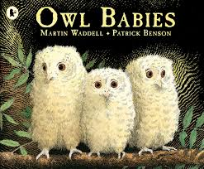

Finally

We wish you and your families a restful and relaxing weekend.

Mr P Brack, Head Teacher and all at St Cuthbert’s School

