 Newsletter 21 – Friday 16th January 2026
CARES We are: Creative Active Respectful Equal Supported

Good Afternoon. Thanks for reading this week’s Newsletter. Please contact us if you have any questions about its contents.

Upcoming Events at St Cuthbert’s and Dates for your Diary

This Term’s Dates for your Diary
- Friday 23rd January – Termly Overviews of Learning Shared with Parents/carers via email.
- Friday 23rd January – Scottish Performance P1-7, 9.30am School Hall – communication sent out this week re securing a place to attend.
- Friday 6th February – Parent Council Meeting, 11am School Library
- Friday 6th February – P2 Class Mass, 9.30am St Cuthbert’s Church
- Friday 6th February – Parent Council Meeting, 11am School Library
- Thursday 12th February – Parent Curriculum Morning, 9.15am, School Hall then classrooms – more info to follow.
- Friday 13th February – P3 Class Assembly, 9.30am School Hall
- Friday 27th February – P1 Class Assembly
- Friday 6th March – P1 Class Mass, 9.30am, St Cuthbert’s Church
- Thursday 12th March – P3 Reconciliations, 6pm St Cuthbert’s Church
- Tuesday 17th March – Wear Green for St Patrick’s Day
- Friday 20th March – P4 Class Assembly, 9.30am St Cuthbert’s Church
- Monday 30th March – Parent Consultations 5-7.30am
- Wednesday 1st March – Parent Consultations 4-6.30am

Parent Council - Change of Date for Next Meeting

Our next meeting date has been rearranged and now takes place on Friday 6th February at 11.30am in school library – New members are always welcome. Please ignore previously set meeting date of 23rd January.

Contacting Our Parent Council
Should you wish to contact the Parent Council at any time, they can be contacted via e-mail at ptastcuthberts@gmail.com
News & Information

Scottish Cultural Performance

A communication was sent out on Wednesday re this performance which is held annually around the time of Rabbie Burns day to honour Scottish song and poetry. Please contact the office re admission to this event. For health and safety capacity reasons please only come if your place has been confirmed. It should be a great morning!

Active Schools Clubs This Term – Booking Opens Next Week

Booking information for this term’s Active Schools Club will be shared with parents/carers next week. Please note that Stage Club, Choir, P6 Football and P4/5 Multisports are already up and running for this term.

Punctuality & Absence Reminder

Please see visual below that shows the impact of both lateness and absence on learning. In accordance with City of Edinburgh Council Attendance Policy, we are continuing to monitor both absence and lates. Whilst we understand that there can be emergencies every now and then that lead to lateness, we have noticed recently that many of the same pupils are repeatedly late. We have tried to engage with families via calls and informal discussions but if this continues, we will need to send out formal letters due to the disruption to teaching and learning this is causing.
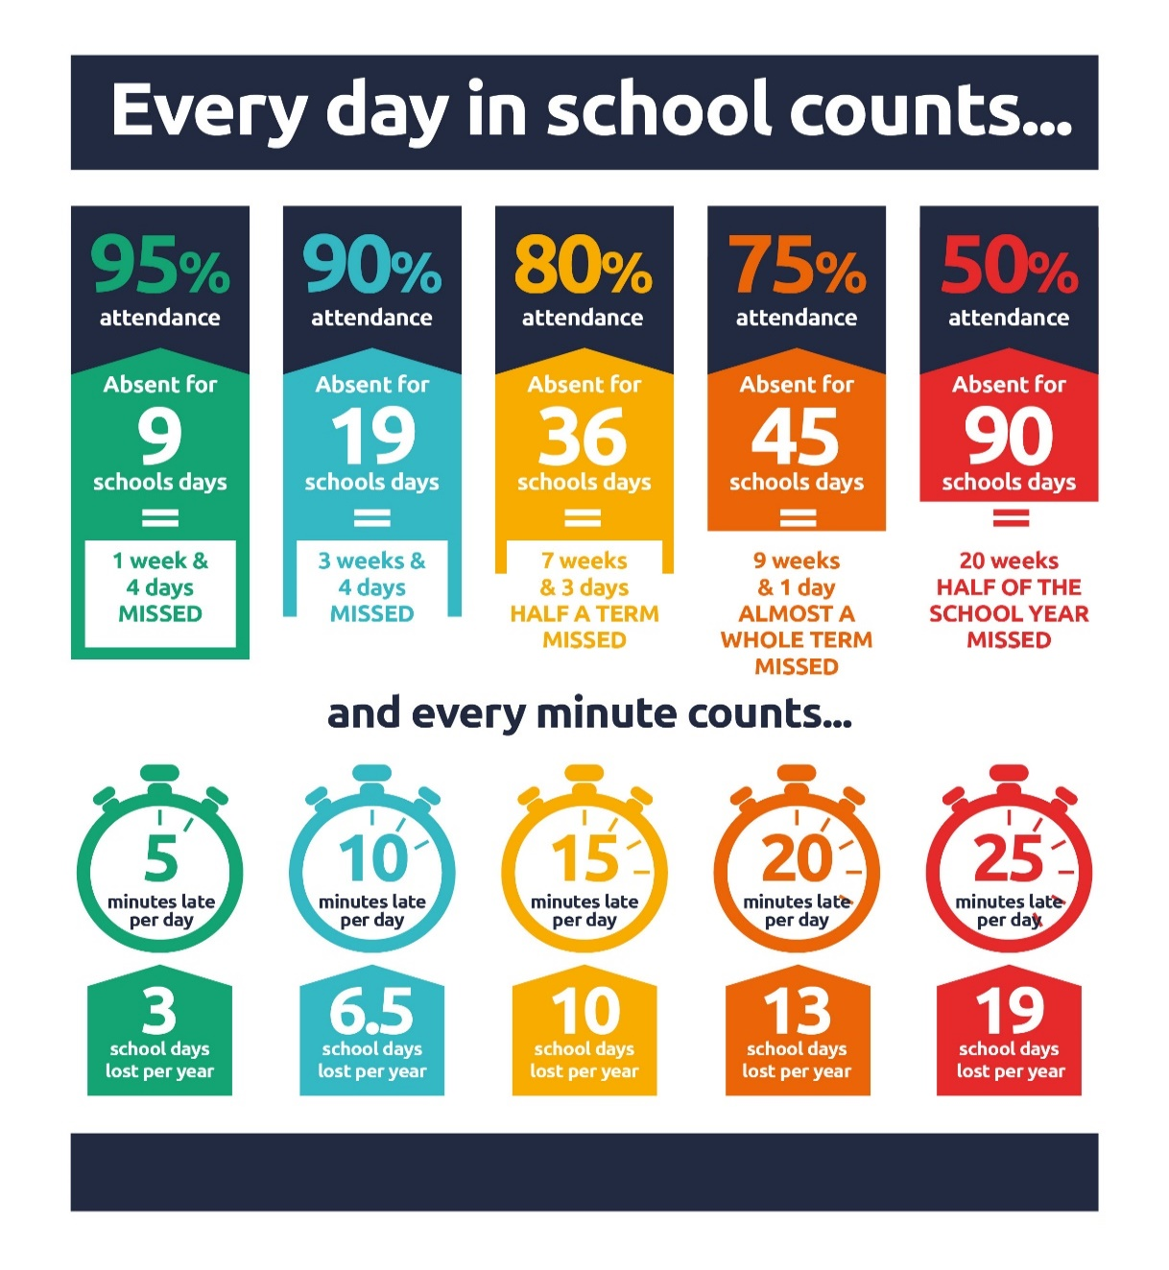
Keeping your Child Safe Online: Porn, Nudes and Online Sexual Harm Online event - Jan 27 from 7pm to 8pm

City of Edinburgh Council have asked that we distribute the important message and link below:

The Lucy Faithful Foundation are delivering an online one-hour session on online sexual harm. This is for parents/carers and aimed at sharing practical strategies to keep children safe online. Similar sessions delivered this time last year were very popular. Please see attached for more information.

https://www.eventbrite.com/e/keeping-your-child-safe-online-porn-nudes-and-online-sexual-harm-tickets-1979712974800?aff=ebdsoporgprofile&keep_tld=1

P7 Hoodies

A link will be provided later this month for those P7 parents wishing to order a Leaver’s Hoodie. These will arrive in plenty of time for school camp in March. Please note that these hoodies, once ordered can be worn during school camp and during the final term only in line with the school’s uniform guidance. We have found from past experience that this approach best supports pupil behaviour and engagement. Please ask if you have any questions.

Pupil Leadership and Learning at St Cuthbert’s

Youth Music Initiative P1 & 2 from Next Week

Both classes will take part in lessons designed to teach skills in singing, rhythm and tempo for 4 weeks starting next Tuesday.

Ukelele Lessons P4 & P5 from Next Week

From next Monday (P5) and Tuesday (P4) both classes will start weekly instrumental tuition for a 5 week block

HWB Group

This week the group’s ‘healthy eating’ challenge competition started and all classes took part really well, particular thanks to Phoebe, Igor, Oliwia and Rohan for helping facilitate the competition so successfully. Winners were P3. Sustainable Development Goal 3: Good Health and Wellbeing.
P7 Water of Leith Trip

P7 represented the school very well at this Jacobite themed learning event. They really enjoyed learning how important Scottish history had taken place in our local neighbourhood.

Catholic Education and Parish Update

Class Masses This Term

Please see list of class Masses in Dates for your Diary Section above.

P3 Reconciliation Preparation Plans

Home Workbooks will be sent home with a covering letter today. In school preparation will begin on Monday and continue until March. Fr Peter Kelly will support this preparation in our school.

Mini Vinis – Society of St Vincent De Paul

We were visited by Aongus from Our Lady’s Currie Parish this week. He gave us advice re how to set up a pupil version of the St Vincent De Paul Society in our school. Mrs Peake will be attending the Archdiocesan R.E Coordinators Meeting on 28th January and will get more advice about the remit of this group and how we select members. More information to follow.

Nursery Update

We have had such a busy and heart-warming week! We are absolutely delighted to welcome some new faces to our nursery family. Our "veteran" pupils have been such superstars, showing their new friends the ropes—from exploring our fantastic toy collection to teaching them the "who, what, and where" of our handwashing and bathroom routines. We are so proud of how kind and supportive everyone has been!
Looking ahead, we’re getting ready to party! To prepare for Burns Night next week, the children have been immersed in all things Scotland. We’ve been tapping our toes to traditional Scottish songs, getting cozy with classic stories, and getting creative with blue and white paint to make Saltires to decorate our room.
It’s going to be a "braw" celebration!

Finally

We wish you and your families a restful and relaxing weekend.

Mr P Brack, Head Teacher and all at St Cuthbert’s School

