 Newsletter 22 – Friday 23rd January 2026
CARES We are: Creative Active Respectful Equal Supported

Good Afternoon. Thanks for reading this week’s Newsletter. Please contact us if you have any questions about its contents.

Upcoming Events at St Cuthbert’s and Dates for your Diary

This Term’s Dates for your Diary
- Friday 6th February – Parent Council Meeting, 11.30am School Library
- Friday 6th February – P2 Class Mass, 9.30am St Cuthbert’s Church
- Friday 6th February – Parent Council Meeting, 11am School Library
- Thursday 12th February – Parent Curriculum Morning, 9.15am, School Hall then classrooms – more info to follow.
- Friday 13th February – P3 Class Assembly, 9.30am School Hall
- Friday 27th February – P1 Class Assembly
- Friday 6th March – P1 Class Mass, 9.30am, St Cuthbert’s Church
- Thursday 12th March – P3 Reconciliations, 6pm St Cuthbert’s Church
- Tuesday 17th March – Wear Green for St Patrick’s Day
- Friday 20th March – P4 Class Assembly, 9.30am St Cuthbert’s Church
- Monday 30th March – Parent Consultations 5-7.30am
- Wednesday 1st March – Parent Consultations 4-6.30am

Parent Council - Change of Date for Next Meeting

Our next meeting date has been rearranged and now takes place on Friday 6th February at 11.30am in school library – New members are always welcome. Please ignore previously set meeting date of 23rd January.

Contacting Our Parent Council
Should you wish to contact the Parent Council at any time, they can be contacted via e-mail at ptastcuthberts@gmail.com

News & Information

Scottish Performance

Thanks for those who came to support our Scottish Performance today. We really appreciate the ongoing support you give to all school events. We hope you enjoyed the performances today! Thanks to the pupils and staff for their hard work.

Termly Overviews of Learning

There were emailed out today. We hope you find them helpful, please ask at the office if you have any questions, wish to give us any feedback or require a paper copy.

Late Arrivals at School

Please note that City of Edinburgh Council ask us to carefully monitor lateness and absence. Therefore, if you are late please bring your child to the office so that this can be recorded. We have definitely seen an improvement in punctuality this week. Thank you for your cooperation.

Active Schools Clubs This Term – Bookings Now Open

An email was sent out yesterday with a link to bookings for this term’s Active Schools Clubs, please contact our Active Schools coordinator Fiona Damen on
07769 922(text is best) if you have any questions about this terms clubs.
Please note that Stage Club, Choir, P6 Football and P4/5 Multisports are already up and running for this term.

Indoor Shoes for P.E.

Please note that for safety reasons and for the protection of our hall floor that pupils are required where possible to bring in a change of shoes/indoor shoes for P.E. Please ask if you have any questions about this.

City of Edinburgh Council Consultation on the Use of Mobile Phones in School

THE City of Edinburgh Council are keen to hear the views of parents and carers on the this subject. Please see link below to share your views. Deadline for responses is 2nd March.

Mobile Phones in Schools - Parent/Carer survey - City of Edinburgh Council - Citizen Space

Stage Club Show at Churchill Theatre

Our Stage Club will be performing at the Churchill Theatre on Sunday 8th March from 12-1pm. Tickets have already been purchased by parents and carers of performers. If anyone else is interested in coming along to support the perfomers please see link below for more details.

https://fienta.com/a-little-nonsense-st-c-stage-club

Keeping your Child Safe Online: Porn, Nudes and Online Sexual Harm Online event - Jan 27 from 7pm to 8pm

City of Edinburgh Council have asked that we distribute the important message and link below:

The Lucy Faithful Foundation are delivering an online one-hour session on online sexual harm. This is for parents/carers and aimed at sharing practical strategies to keep children safe online. Similar sessions delivered this time last year were very popular. Please see attached for more information.

https://www.eventbrite.com/e/keeping-your-child-safe-online-porn-nudes-and-online-sexual-harm-tickets-1979712974800?aff=ebdsoporgprofile&keep_tld=1

P7 Hoodies

A link will be provided next week for those P7 parents wishing to order a Leaver’s Hoodie (not obligato. These will arrive in plenty of time for school camp in March. Please note that these hoodies, once ordered can be worn during school camp and during the final term only in line with the school’s uniform guidance. We have found from past experience that this approach best supports pupil behaviour and engagement. Please ask if you have any questions.

Pupil Leadership and Learning at St Cuthbert’s

Youth Music Initiative P1 & 2 and Ukelele Lessons P4 & P5

These began this week and the teacher feedback that the P1 and P2 singers and P4 and P5 ukelele players were all extremely engaged and enthusiastic.

Laudato Si Group

Our Laudato Si group met with Ms Pusker this week and they discussed a new Sustainability Project ‘The Big School Birdwatch’. This activity is about counting the number of birds in registered schools’ grounds. The Big Schools Birdwatch is the largest citizen science project for schools, taking place January to February each year. We’ll update you on your progress with this work next week. Sustainable Development Goal 15: Life on Land.

Mrs Skelly has also asked us to thank Siddhu and Dominik for their hard work keeping our school grounds litter free. Here they are at work this week!

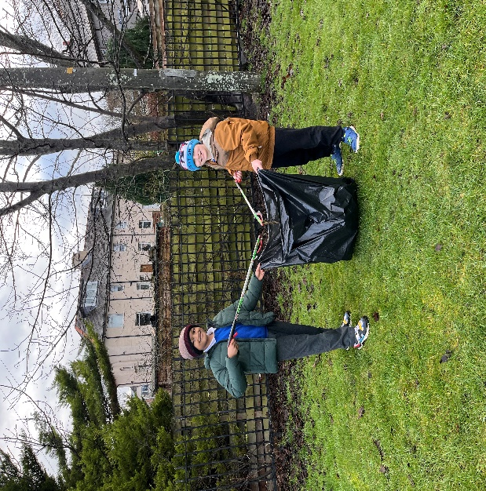

HWB Group

Continued with the second week of their Healthy Eating challenge, which is having a positive effect on our eating habits across the school. Sustainable Development Goal 4. Good Health and Wellbeing.

Digital Leaders

All classes have nominated representatives to share work done in class on the ‘camera app’ at a sharing Assembly on 30.1.26.

Writing Moderation Training

This week our staff devoted time after school to professional discussion of how we most accurately assess pupil’s formal written work. We had a good team discussion and clarified our understanding.

P7 National Standardised Assessments

P7 began work on these online standardised assessments in Numeracy, Reading, Grammar, Spelling and Punctuation this week. These are a snapshot of learning and are used along with day to day assessments by teachers to make professional judgements of pupil progress by the end of the year. Similar tests will be done by P4 before Easter and P1 after Easter. Please ask if you have any questions or wish any further information.

Orienteering Compasses

As part of our focus on Outdoor Learning this year, we have just this week received an order for a class set of compasses, we look forward to seeing them used throughout the school.

Catholic Education and Parish Update

Class Masses This Term

Please see list of class Masses in Dates for your Diary Section above.

P3 Reconciliation Preparation Begun This Week

Home Workbooks were sent home last week and in class preparation began in class this week. P3 have already done the first three units of preparation and created a wall display on the Sacrament of Reconciliations.

Thanks also to Fr Peter Kelly for visiting the children as part of our Sacramental Work this week.

Nursery Update

What an action-packed week we’ve had! From Burns to Badgers, the fun (and learning) didn’t stop. We kicked things off by transforming our art corner into a "fun science" lab this week! We’ve been busy experimenting with paint, mixing vibrant new colours and adding all sorts of different things to see what happens. It’s been a big, exciting, and beautifully messy science experiment that has everyone's creativity flowing.
The excitement continued as we dove into the mysterious world of nocturnal animals. We’ve been investigating exactly what creatures like frogs, owls, wolves, and foxes get up to (and what they eat!) while we’re all fast asleep. It’s been wonderful to see the children becoming little experts; so many of them already knew so much and were absolutely beaming as they shared their knowledge with their friends.
And we finished the week by celebrating our national bard Rabbie Burns, and the room was ringing with the sound of lively ceilidh music as the children showed off their best dance moves. We even held a special tasting session with some vegetarian haggis—it was so much fun to see the "varying levels of delight" on everyone's faces as they tried something new!
It has truly been a week to remember!

Finally

We wish you and your families a restful and relaxing weekend.

Mr P Brack, Head Teacher and all at St Cuthbert’s School

