 Newsletter 25 – Friday 13th February 2026
CARES We are: Creative Active Respectful Equal Supported

Good Afternoon. Thanks for reading this week’s Newsletter. Please contact us if you have any questions about its contents.

Upcoming Events at St Cuthbert’s and Dates for your Diary

This Term’s Dates for your Diary (see Rearranged Date for Curriculum Morning)
- Thursday 26th February – Parent Curriculum Morning, 9.15am, School Hall then classrooms – all welcome.
- Friday 27th February – P1 Class Assembly
- Friday 6th March – P1 Class Mass, 9.30am, St Cuthbert’s Church
- Thursday 12th March – P3 Reconciliations, 6pm St Cuthbert’s Church
- Tuesday 17th March – Wear Green for St Patrick’s Day
- Friday 20th March – P4 Class Assembly, 9.30am School Hall
- Monday 30th March – Parent Consultations 5-7.30am
- Wednesday 1st April – Parent Consultations 4-6.30am

Parent Council – Minutes

Minutes from our latest meeting last week were shared. Thanks to all those who attended.

Contacting Our Parent Council

Should you wish to contact the Parent Council at any time, they can be contacted via e-mail at ptastcuthberts@gmail.com

Volunteers Wanted

See information below re an exciting event planned for later this year. This can only go ahead with support from our parents/carers. Please contact email address given if you are able to help.


Easy Fundraising

Earn cashback with Easy Fundraising when you shop online with participating retailers. They will donate part of what you spend to our School Funds.
Scan the QR code below to help us raise funds today.



News & Information

Traffic Survey on Hutchison Avenue and Medway

We are aware of the increased traffic being diverted through this street due to Gorgie Road closure. We have spoken to the police about this and they are continuing to monitor the situation. We have also forwarded on our concerns and those expressed by the Parent Council, to City of Edinburgh Council’s School Traffic Crossing Team. They have agreed to conduct a survey of affected roads to see if any further crossing support can be allocated. This will take place week commencing 23rd February. I’ll keep you updated.

P7 Camp Information and Documents for Return

Primary 7 received their camp information packs on Thursday with all the necessary forms. Please read the cover letter attached in pack carefully. All forms should be returned in the envelope provided by Friday 27th February. There will be a drop-in session after school on Thursday 26th February, for any families who have further questions or require support filling in the forms.

Group Call Communications Coming Soon

Please note that the school is moving from Parent Pay to GroupCall Messaging from after February Holiday, once Admin and School Leadership have been trained. This new system allows us to send and receive both texts and emails. Amongst other things parents/carers it allows to receive information in their home language and translate replies into English.

P7 Hoodies

The link for ordering hoodies was sent out on Tuesday this week. https://stcuthbertsleavers2026.superlogoshop.co.uk/

Please also note that whilst we are sharing the link we are not responsible for any fault with orders which need to be taken up with the company concerned. All orders made will however be delivered to school and passed on to pupils by staff in P7.

The link is live until 6th March (company said link will probably still be available over weekend to 9th March) and hoodies will arrive by weeke ending 20th March in time for school camp.

Ragbag Collection on 18th March

Please note that the next uplift for our Ragbag Clothes Container is on the above date. Thanks for your donations which also benefit our school funds via a commission percentage which we receive. Our most recent collection raised £39.20.

Pupil Leadership and Learning at St Cuthbert’s

Internet Safety Day and Visit from Community Police Officer

All classes marked internet safety day on Tuesday. Our P6 and P7 classes will be visited by our Community Police Officer on 25th February for a talk on responsible used of the internet and online safety.

Digital Leaders App of the Month and Promo Video

Following on from last month’s focus on the camera app, Mr Crowley and our pupil Digital Leaders have nominated a new app of the month, ‘iMovies’. Please see their introductory video below:

https://clickv.ie/w/XjJB

P1 and P7 Digital Learning

Our City of Edinburgh Council, Digital Link person Andrew was in school this week working on Digital Learning with our P1 and P7 classes.

P1 Outdoor Learning

P1 took part in Outdoor Learning with Margon from the Green Team this week, they learnt how to build animal dens and were also taught some outdoor games.

Pupil Rights and Learning Group

Representatives from the group took part in classroom visits this week alongside myself to observe teaching and learning in P5, P6 and P7. They gave great feedback that will help both myself and the teachers. Sustainable Development Goal 4: Quality Education.

P7 Transition Visit to St Augustine’s

The class visited St Augustine’s for a theatre show on Tuesday as the next step in their Transition process.

P6/7 Cross Country Event Saughton Park

We had 22 P6 and P7 pupils attend this event on Monday and their behaviour and performance levels did us proud. Thanks to the parents and carers who came along to support us. All participants received a certificate and below we can see our 3 medallists. Huge congratulations to all of our team!

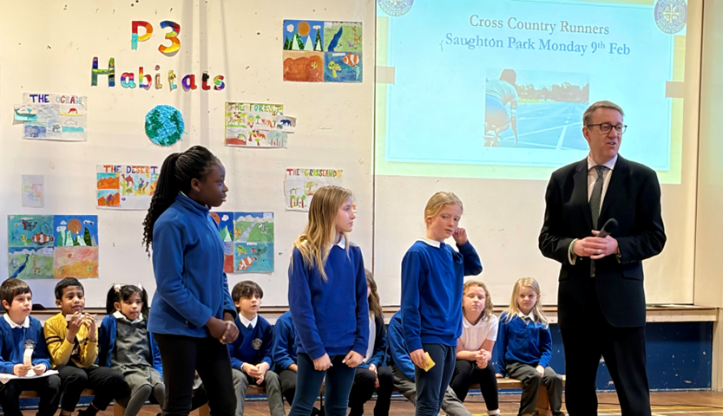

Catholic Education and Parish Update

P7 Transition Mass

This will take place on Tuesday 24th February at St Mary’s Cathedral, York Place, Edinburgh. Pupils from all P7 classes in Edinburghs’ Catholic schools will attend Mass celebrated by Archbishop Cushley. All parents/carers are welcome to attend. Please ensure that all pupils are in school uniform on this date.

Fr Peter Kelly Fortnightly Visits to School

Fr Peter visited P3 this week as part of our ongoing preparation for the sacrament of Reconciliation in March .

Nursery News

Love is in the Air (and Under the Rocks!)
Hello everyone! It has been a bee-utiful week here at the nursery. We’ve been busy as a hive with all sorts of heart-warming activities and creepy-critter discoveries. Here is a little peek at what your little love bugs have been up to!

Love Bugs & Heartfelt Art
We were really feeling the love this week! The children have been getting creative with some un-beet-able artwork.
- Love Bug Paintings: We’ve been painting colourful "Love Bugs," counting out their spots, and learning all about symmetry.
- Card Making: Our writing area has been buzzing with mark-making as the children created Valentine’s Day cards.
- Fine Motor Fun: We discovered that putting a card into an envelope is actually quite difficult! It gave our fine motor skills a serious workout, but we stuck with it.

It’s a Bug’s Life
Speaking of bugs... it’s been beetles, spiders, and ants—oh my! We’ve been crawling with curiosity as we learn about:
- Where these tiny friends live (habitats).
- What they like to snack on.
- All the "legs-tra" special things they do!

A Roaring Good Time in the Garden
The weather might be a bit damp, but we aren't letting it dampen our spirits. The garden has been very wet and muddy, which we decided was the perfect habitat for a Dinosaur Land! Our prehistoric pals have been having a stomping good time in the sludge.

Health & Wellbeing: The Underwear Rule
This term, the nursery class will be discussing the NSPCC Underwear Rule (PANTS). This is a vital part of our Health & Wellbeing curriculum, ensuring our children stay safe and happy. For more information, go to your child’s online Learning Journal or watch the video below.
https://www.nspcc.org.uk/advice-for-families/pants-underwear-rule/

Finally

We wish you and your families a restful and relaxing weekend.

Mr P Brack, Head Teacher and all at St Cuthbert’s School



