 Newsletter 26 – Friday 27th February 2026
CARES We are: Creative Active Respectful Equal Supported

Good Afternoon. Thanks for reading this week’s Newsletter. Please contact us if you have any questions about its contents.

Upcoming Events at St Cuthbert’s and Dates for your Diary

This Term’s Dates for your Diary (Please note Change of Date for P1 Mass)
- Thursday 5th March – World Book Day – pupils can dress up as a character from their favourite book and will receive a free book.
- Friday 11th March – P1 Class Mass, 9.30am, St Cuthbert’s Church
- Thursday 12th March – P3 Reconciliations, 6pm St Cuthbert’s Church
- Tuesday 17th March – Wear Green for St Patrick’s Day
- Friday 20th March – P4 Class Assembly, 9.30am School Hall
- Friday 20th March – P7 Parents Open Morning for Families of Pupils attending St Augustine’s in August 2026. Nurture Room 11am-12pm
- Monday 30th March – Parent Consultations 5-7.30am
- Wednesday 1st April – Parent Consultations 4-6.30am

Contacting Our Parent Council

Should you wish to contact the Parent Council at any time, they can be contacted via e-mail at ptastcuthberts@gmail.com

Volunteers Wanted

See information below re an exciting event planned for later this year. This can only go ahead with support from our parents/carers. Please contact email address given if you are able to help.


Easy Fundraising

Earn cashback with Easy Fundraising when you shop online with participating retailers. They will donate part of what you spend to our School Funds.
Scan the QR code below to help us raise funds today.



News & Information

Traffic Survey Completed on Hutchison Avenue and Medway – Results Shared

City of Edinburgh Council’s Traffic Patrol Team carried out a survey at our request at the junction of Hutchison Road / Hutchison Crossway on 24th February. The Team say that unfortunately the total counted still falls short of the criteria required to establish a School Crossing Patrol site at this location. See quote below:

‘During the duration of the hour-long survey our officer observed that whilst traffic was heavier than the previous count there were adequate gaps to allow a safe crossing and that no excessive speeding was witnessed’

Drop in Morning for Parents of P7 Pupils Attending St Augustine’s Next Year – Friday 20th March

A chance to speak to Mrs McCallum, Transition Teacher at St Augustine’s if you have any questions about your child’s transition to S1 at this High School in August 2026. This will be held

Our School Website

The website received 445 visitors in January, up 115 on December. Thanks to all who continue to access our website and use it for information purposes.
Please feel free to give us your feedback on its contents any time.

Group Call Communications

This system is now being used, we hope that you are finding it helpful.

P3, P4, P6 and P7 Football

All of the above classes will have teams involved in football competitions over the course of this term. Thanks to all those involved in supporting this. It is very much appreciated.

P7 Hoodies – See closing date below

The link for ordering hoodies was sent out before the Holidays

https://stcuthbertsleavers2026.superlogoshop.co.uk/

Please also note that whilst we are sharing the link we are not responsible for any fault with orders which need to be taken up with the company concerned. All orders made will however be delivered to school and passed on to pupils by staff in P7.

The link is live until 6th March (company said link will probably still be available over weekend to 9th March) and hoodies will arrive by week ending 20th March in time for school camp.

Ragbag Collection Date Changed to 1st April

Please note change of date for this event from 18th March to Wednesday 1st April.

Pupil Leadership and Learning at St Cuthbert’s

Curriculum Morning

Thanks to those who attended this event on Thursday morning. As always with our parents/carers it was an amazing turnout. I hope that you found your visit useful and enjoyable - we appreciated your feedback. If you didn’t get a chance to complete our online survey about this event, please use the QR code below to do so:



P3 Published Authors

In Term 1 Primary 3 entered a 'Monster Mayhem' drawing competition as part of the young writers competitions. P3 used their imagination and creativity skills to draw a monster of their choice and name them using an alliteration, linking to their class learning.
These drawings were so great that they all got published into the Monster Mayhem book.
A special well done to Ellis in P3 who's picture was chosen as their favourite and now features on the front cover! Ellis was gifted a £10 national book token and is now a finalist with a chance of winning the overall prize - An awesome den making set!
Well done to all P3 learners on using their skills of creativity and focus to create their monsters.

See a copy of the book’s front cover below:

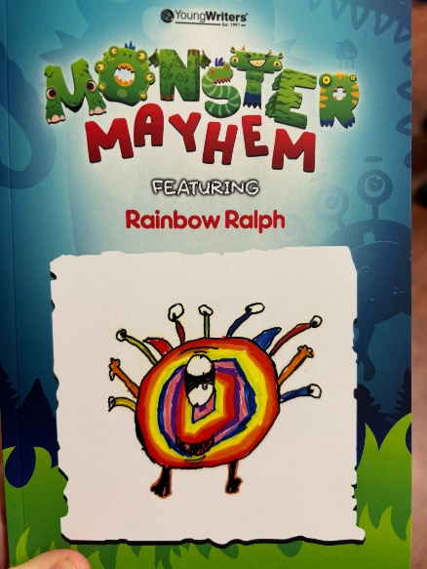

World Book Day

On the subject of books, World Book Day will be celebrated next Thursday. Look out for pictures of our learning on the Class Blog pages of our school website.

Internet Safety Talk from Community Police Officer

PC Walter Millar came in to speak to our P6 and P7 pupils on this topic on Wednesday afternoon. Staff and pupils found his visit informative and helpful.

Health and Wellbeing Group

The Health and Wellbeing Group worked with our PSA Team to communicate news of our new Playground equipment to all of our classes. This equipment is now in use across the school. Sustainable Development Goal 3. Good Health and Wellbeing.

Sports Leaders from St Augustine’s Working with P3 and Miss Armitage

This six week block began on Wednesday and will be a god experience for our pupils and also the Leaders themselves.

P6 Transition: Literacy Task

P6 pupils were joined by two senior pupils from St Augustine’s on Thursday to undertake a transition project based on literacy.

P7 Sports Leaders Programme

Fiona Damen, our Active Schools Coordinator began work with our P7 pupils on Thursday afternoon on a programme of training designed to develop their leadership skills. This is our second year of the programme and it culminates in our senior pupils working with younger classes to teach them playground games as a way of demonstrating their newly acquired skills.

Catholic Education and Parish Update

P7 Transition Mass

P7 represented our school at Mass on Tuesday alongside their peers from across all of Edinburgh’s Catholic schools. Mass was celebrated by the Archbishop and the pupils represented the school very well. Thanks to Jack and Lila for carrying our banner at the Mass.

Fr Peter Kelly Fortnightly Visits to School

Fr Peter visited P3 again this week as part of our ongoing preparation for the sacrament of Reconciliation in March.

CHILDREN’S LITURGY AT ST CUTHBERT’S CHURCH DURING LENT

The Children’s Liturgy will be on every Sunday during Lent. Please encourage your child/children to come along and listen to the readings at their level and participate in prayers and hymns.
If your child is shy and doesn’t feel confident to come in to the Liturgy Room, it is perfectly acceptable for an adult to join them for the first couple of weeks.
Children should be of school age to attend.
We look forward to seeing more children at the Children’s Liturgy especially during this very important time leading up to Easter Sunday.
Thankyou in advance for encouraging your children to participate.
Dorothy Johnstone. (School/Church Liturgy Coordinator)

Nursery News

Finally

We wish you and your families a restful and relaxing weekend.

Mr P Brack, Head Teacher and all at St Cuthbert’s School

