 Newsletter 28 – Friday 13th March 2026
CARES We are: Creative Active Respectful Equal Supported

Good Afternoon. Thanks for reading this week’s Newsletter. Please contact us if you have any questions about its contents.

Upcoming Events at St Cuthbert’s and Dates for your Diary

This Term’s Remaining Dates for your Diary
- Tuesday 17th March – Wear Green for St Patrick’s Day
- Friday 20th March – P4 Class Assembly, 9.30am School Hall
- Friday 20th March – P7 Parents Open Morning for Families of Pupils attending St Augustine’s in August 2026. Nurture Room 11am-12pm
- Monday 30th March – Parent Consultations 5-7.30pm
- Wednesday 1st April – Parent Consultations 4-6.30pm

Contacting Our Parent Council

Should you wish to contact the Parent Council at any time, they can be contacted via e-mail at ptastcuthberts@gmail.com

Volunteers Wanted

See information below re an exciting event planned for later this year. This can only go ahead with support from our parents/carers. Please contact email address given if you are able to help.


Easy Fundraising

Earn cashback with Easy Fundraising when you shop online with participating retailers. They will donate part of what you spend to our School Funds.
Scan the QR code below to help us raise funds today.



News & Information

Parent Consultation Booking

Invites were sent out on Monday with a link for booking. Please ensure that you select option for translator if required. Please contact the office if you have any questions or require any help with this process.

Attendance and Lateness Update

Our latest attendance figures were shared by City of Edinburgh Council this week. For the month of March 4.5% of our pupils recorded absence of less than 85%, whilst 17.6% recorded absence at below 90%. These figures compare favourably with other schools in our Learning Community but still have room for improvement. Our main issue in terms of attendance is lateness. School begins at 8.55am for all classes everyday. Please try to ensure your child is on time. See below re impact of absence and lateness on learning:

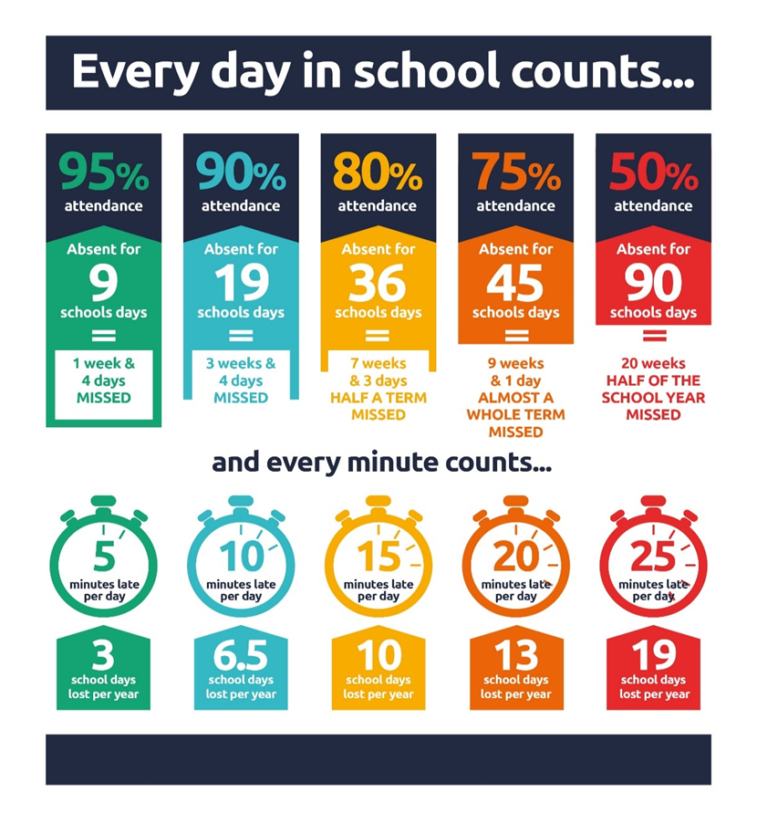
School Camp Update and Outstanding Payments – Arrangements for Monday 23rd March

On the day of departure for camp, pupils should arrive at school at 8.45am. They should enter via main doors and put cases/luggage in hall. They should then proceed to class, where leaders will be waiting for them. Parents and Carers are very welcome to wait in playground and then see bus off at approximately 9.15am. If you have not paid last instalment please do so as soon as possible.

Drop in Morning at St Cuthbert’s for Parents of P7 Pupils Attending St Augustine’s Next Year – Friday 20th March 11am-12pm

A chance to speak to Mrs McCallum, Transition Teacher at St Augustine’s if you have any questions about your child’s transition to S1 at this High School in August 2026. This will be held in our Nurture room at St Cuthbert’s.

P7 information Morning at St Augustine's High School: 9am on 26th March

All parents/carers of pupils attending St Augustine’s from August invited. Get assistance with uniform, travel to St Augustine's, and see some of the school.

Ragbag Collection Date Changed to 1st April

Please note change of date for this event from 18th March to Wednesday 1st April. The company doing the collecting have asked that last donations be made by Tuesday 31st March.

Stage Club Show – Churchill Theatre Edinburgh

Well done to all of our pupils who took part in Sunday’s performance at the Churchill Theatre. There was also a great turnout of parents and staff to support the pupils. Stage Club are hoping to run clubs at our school again after Easter and in the next school year. More details to follow in the coming weeks.

Pupil Leadership and Learning at St Cuthbert’s

Pupil Rights and Learning Group

The Pupil Rights and Learning Group carried out their teaching and learning survey this week. This information, along with the views we received from parents/carers at the recent Curriculum morning has been really informative and helps us to understand the progress we are making with our school improvement and where we need to get better.

Sustainable Development Goals 3: Health and Wellbeing and 4: Quality Education

Digital Club

Our Digital Club led by Primary 7 pupils began this week, unfortunately there were some connectivity issues with the iPads but this will be resolved for next week. If your child wanted to join the club but did not get a space, they will get a space when the club runs again later in Term 3. Contact Mr Crowley if you require further info.

Catholic Education and Parish Update

P3 First Reconciliations – Thursday 12th March at St Cuthbert’s Church

Congratulations to all of our pupils who made their First Reconciliations. Thanks to Miss Tulloch, Fr Peter, Fr Francis and Fr Malachy for preparing the pupils and to Dorothy and the choir for the lovely music.

P1 Mass

Thanks to Fr Francis, Mrs Igoe, Mrs Bryce, Dorothy, our P7 readers and all those parents and carers who supported us at today’s Mass. Well done P1!

Confirmations Preparation

Mr Crowley started work with our P7 Confirmation Candidates on our programme of preparation for Confirmation. Which will be celebrated on Friday 8th May at St Cuthbert’s Church.

Fr Peter Kelly Fortnightly Visits to School

Fr Peter will visit P4 as part of our ongoing preparation for the sacrament of Reconciliation on 12th March.

CHILDREN’S LITURGY AT ST CUTHBERT’S CHURCH DURING LENT

The Children’s Liturgy will be on every Sunday during Lent. Please encourage your child/children to come along and listen to the readings at their level and participate in prayers and hymns.
If your child is shy and doesn’t feel confident to come in to the Liturgy Room, it is perfectly acceptable for an adult to join them for the first couple of weeks.
Children should be of school age to attend.
We look forward to seeing more children at the Children’s Liturgy especially during this very important time leading up to Easter Sunday.
Thankyou in advance for encouraging your children to participate.
Dorothy Johnstone. (School/Church Liturgy Coordinator)

Ramadan – Prayer Room

Mrs Sheikh has been supervising a short prayer time for our Muslim pupils on Mondays and Wednesdays in our Nurture Room. Thanks to all those involved.

Nursery News

Heartfelt Creations
Our little artists have been working hard making beautiful cards for the important people in their lives. This has been a fantastic way for them to practice their mark-making and refine those all-important fine motor skills.

Bug Fever!
We are still "mad about mini-beasts" here! The children have been fully immersed in the world of tiny creatures—counting them, drawing them, and enjoying bug-themed board games and puzzles.

Spring is in the Air
Despite the unpredictable weather, we’ve been making the most of the outdoors. The children have been exploring the garden daily and taking trips into the local community to spot the very first signs of spring.

A Quick Reminder
Since we love to get outside rain or shine, please ensure your child has a spare change of clothes on their peg. This helps us keep everyone warm and dry if they happen to get a little damp during their adventures!

Finally

We wish you and your families a restful and relaxing weekend.

Mr P Brack, Head Teacher and all at St Cuthbert’s School

