 Newsletter 31 – Friday 15th May 2026
CARES We are: Creative Active Respectful Equal Supported

Dear all

Thanks for reading this week’s Newsletter. Please read the Building Update section as it contains important information for all of us.

Please see below our regular list of news and events, as always please ask if you have any questions (admin@st-cuthberts.edin.sch.uk or 0131 443 2621)

Upcoming Events at St Cuthbert’s and Dates for your Diary

This Term’s Remaining Dates for your Diary
- Monday 18th May – Public Holiday for both staff and pupils – all return on Tuesday 19th May,
- Tuesday 19th May Parent Consultations, 4-6.30pm in St Cuthbert’s Church Hall
- Friday 22nd May – Parent Consultations 1-3.30pm in St Cuthbert’s Church Hall
- Monday 25th May – Wear traditional/national costume or bright colours for Africa Day.
- Friday 29th May – Sports Day for all Classes at St Augustine’s 9.45-11.45am approximately.
- Wednesday 10th June – P1 Induction Meeting, 1.30-2.30pm, St Cuthbert’s Church Hall
- Thursday 11th June – P7 Leavers’ Mass, St Cuthbert’s Church, 2pm
- Sunday 14th June – First Holy Communions, 9.30am St Cuthbert’s Church
- Tuesday 16th to Thursday 18th June 2026 P7 Transition Visits to High Schools across Edinburgh.
- Friday 19th June – End of Session Reports to be issued in paper form
- Tuesday 23rd June - Leavers’ Assembly, 2pm in Church Hall
- Friday 26th June – Final Day of Term: P7 Leavers’ Parade 12.10pm

Parent Council Update

Our next meeting is on Friday 5th June at 11.30am in Nursery Office Building

Please see below a helpful information graphic about our Parent Council and the work it does to support our school:

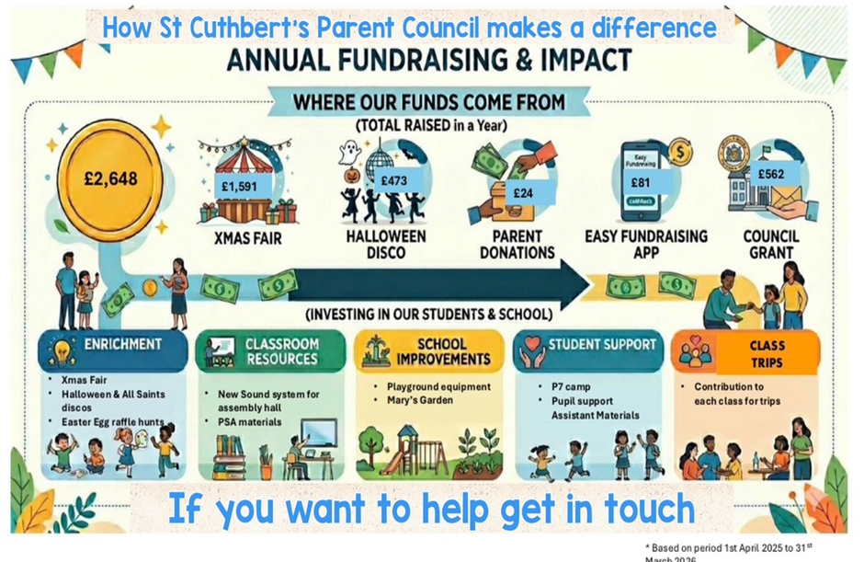

World Cup Summer Fair

The Parent Council are delighted to let everyone know that we are planning to go ahead with the World Cup fair on Friday 12th June after school in the church hall from 1230pm. We are looking for helpers for the bake sale, tattoos/face paint, second hand toy stall, and a stall to swap old football strips, football boots and possibly football cards. If you can help please let someone on the parent council know by sending an email or word of mouth (we really do need as many volunteers as possible in order to have the above stalls). Can we also appeal for bakers, donations for the raffle, second hand toys, and any old football strips/boots that you can swap?Without volunteers we won’t be able to run the fair 🙏 Will be lovely to have the school community all together in one place again!

Contacting Our Parent Council

Should you wish to contact the Parent Council at any time, they can be contacted via e-mail at ptastcuthberts@gmail.com

News & Information

Weekly Building Update from City of Edinburgh Council Facilities Management

Within the last week, to check for deflection on the roof support structure, further surveys have been conducted on the first-floor ceiling and roof structure. This has revealed evidence of deflection on level two of the building, between the ceiling and roof. Whilst the report has been received this morning for review and to agree next steps, any final design/remediation will now be required for both floors of the building. The engineers have advised that inspections of the ceiling/roof structure in other school buildings on site will be carried out as a precautionary step.

Proposals for a final design solution for the two-storey block are due to be with us by 1 June, and this will enable the full specification of the works to progress to the tendering process. An accurate timeframe will be confirmed once tendering is concluded and a works programme agreed. This is now likely to extend beyond the initial August indication due to the wider structural issue now confirmed. Options for the new school year will be reviewed as soon as possible.

Interscholastics – May 25th

Ms Armitage will take a team of P6 and P7 pupils to Meadowbank to represent the school on the above date.

Monthly Attendance Update

Attendance below 85% in April was very good with a percentage figure of 5.1%, we still hope to improve this though. Unfortunately, Attendance between 85 and 90% remains very high at 31.5% of pupils. Please continue to try to avoid absence wherever possible. Thanks for your cooperation.

Lunches at St Peter’s

Ms McVey in the office sent out further information yesterday which aimed to clarify how these work and how to ensure that what you select, aligns with what St Peter’s are able to offer. I hope this email helped explain things but please contact the office with any further questions or requests.

Pupil Leadership and Learning at St Cuthbert’s

Gold Sports Award

We have just submitted our reaccreditation forms for the extension of our Gold Sports Award up to 2029. Please see a link to a film we have made to accompany our submission. Thanks to the pupils, parents/carers and staff who took part in the video for their positive contributions. Thanks to Mr Crowley for his hard work preparing our submission:

https://clickv.ie/w/OSOC

Digital Schools Award and Forthcoming Pupil Surveys

This week we have surveying our pupils on our improvement goal of developing Digital Learning. We look forward to sharing our pupil’s views with you in summary fashion next week.

Over the next two weeks we will also be surveying pupils on their health and wellbeing and on their views on how far we have met our school improvement objectives this year. Again, we will look forward to sharing their views.

Catholic Education and Parish Update

Sacrament of Confirmation

Congratulations to all of our candidates who represented the school so well last Friday night.



Mass for Ascension Day

Our P3 and P4 Churches attended Mass at St Peter’s Church on Thursday and P5-7 at St Augustine’s school. We are grateful to our host schools for their help is us attending this Holyday of Obligation.

Nursery News

Little Crawlers & Fast Runners!

Hello everyone! We have had such an uplifting week at the nursery. Here is a little peek at what your little ones have been up to:

Our 10 Tiny Guests
The excitement is buzzing! We now have 10 baby caterpillars in our care. The children have been absolutely fascinated, watching them closely and asking some very clever questions. It’s like The Very Hungry Caterpillar by Eric Carle has hopped right off the pages and into our classroom!

Safety & Sharing in the Garden
We’ve been very impressed with how the children are learning to risk assess their own play! While using the climbing frame, we have been practicing great communication. You'll hear lots of lovely phrases like "waiting," "you are next," and "my turn now" as we learn to navigate the equipment safely and fairly.

Important Date: Nursery Sports Day!
We’ve also been making the most of the sunshine by practising our racing skills. From speedy sprints to steady hops, everyone is getting into the competitive spirit as we prepare for the big day!
Mark your calendars for Tuesday 26th May. It’s going to be a fantastic day of fun and games! For all the specific details regarding Sports Day, please check your email inbox and your child's Learning Journal. You can also find updates on the Nursery Notice Boards.

Finally

We wish you and your families a restful and relaxing holiday weekend.

Mr P Brack, Head Teacher and all at St Cuthbert’s School

