 Newsletter 32 – Friday 22nd May 2026
CARES We are: Creative Active Respectful Equal Supported

Dear all

Thanks for reading this week’s Newsletter. Happy Eid Al Adha to our Muslim families too.

Please see below our regular list of news and events, as always please ask if you have any questions (admin@st-cuthberts.edin.sch.uk or 0131 443 2621)

Upcoming Events at St Cuthbert’s and Dates for your Diary

This Term’s Remaining Dates for your Diary
- Monday 25th May – Wear traditional/national costume or bright colours for Africa Day.
- Friday 29th May – Sports Day for all Classes at St Augustine’s 9.45-11.45am approximately.
- Wednesday 10th June – P1 Induction Meeting, 1.30-2.30pm, St Cuthbert’s Church Hall
- Thursday 11th June – P7 Leavers’ Mass, St Cuthbert’s Church, 2pm
- Sunday 14th June – First Holy Communions, 9.30am St Cuthbert’s Church
- Tuesday 16th to Thursday 18th June 2026 P7 Transition Visits to High Schools across Edinburgh.
- Friday 19th June – End of Session Reports to be issued in paper form
- Tuesday 23rd June - Leavers’ Assembly, 2pm in Church Hall
- Friday 26th June – Final Day of Term: P7 Leavers’ Parade 12.10pm

Parent Council Update

Our next meeting is on Friday 5th June at 11.30am in Nursery Office Building

Please see below a helpful information graphic about our Parent Council and the work it does to support our school:
World Cup Summer Fair

The Parent Council are delighted to let everyone know that we are planning to go ahead with the World Cup fair on Friday 12th June after school in the church hall from 1230pm. We are looking for helpers for the bake sale, tattoos/face paint, second hand toy stall, and a stall to swap old football strips, football boots and possibly football cards. If you can help please let someone on the parent council know by sending an email or word of mouth (we really do need as many volunteers as possible in order to have the above stalls). Can we also appeal for bakers, donations for the raffle, second hand toys, and any old football strips/boots that you can swap?Without volunteers we won’t be able to run the fair 🙏 Will be lovely to have the school community all together in one place again!

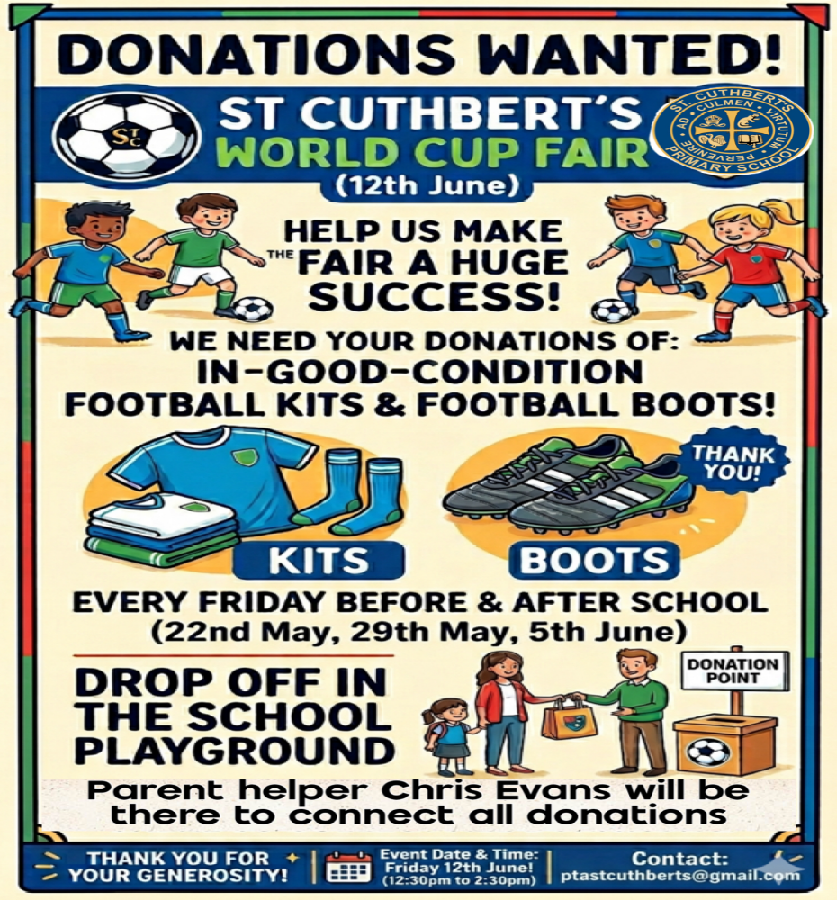
Contacting Our Parent Council

Should you wish to contact the Parent Council at any time, they can be contacted via e-mail at ptastcuthberts@gmail.com

News & Information

Africa Day – Monday 25th May

Marks the anniversary of the foundation of the African Union in Adis Adabba in 1963. The day celebrates African unity, freedom from colonialism and progress. Children can wear any bright colours or clothing associated with Africa on this day.

Gold Sports Award

We have just submitted our reaccreditation forms for the extension of our Gold Sports Award up to 2029. Please see a link to a film we have made to accompany our submission. Thanks to the pupils, parents/carers and staff who took part in the video for their positive contributions. Thanks to Mr Crowley for his hard work preparing our submission:

https://clickv.ie/w/OSOC

Sports Day – Friday 29th May

Planning for this event has been taking place this week. Please note that more information will come out in a letter on Monday. In the event of bad weather the event will be moved to the following Friday. We will notify you by 8am on the Friday.

Playground and Buses at the start and end of Each Day

Please continue to leave space for classes to line up both in the morning and in the afternoon when we return. We are legally obliged to dismiss the pupils from our school grounds and leaving space for teachers will help speed the process up. For the same reasons, we would be grateful if you could wait in the playground rather than outside buses.

Please note that we are aware that the P5/5 bus has been leaving later than the other buses at times, we have followed this up with City of Edinburgh Council’s Transport and Operational Teams and hope to see some improvement soon.

Weekly Building Update from City of Edinburgh Council Facilities Management

The structural engineers have carried out initial inspections of the ceiling/roof structure in other school buildings on site as a precautionary step. This has confirmed a similar block and beam structure as per the two-storey building, intrusive surveys will be conducted on these single storey buildings, this process will commence next week. For clarity, the Nursery building which continues to be open and operate as normal, is a modern building and is unrelated to the ongoing checks and surveys.

Options for the new school year are currently being reviewed and we hope to have more information to share with you on Tuesday 26th May.

Interscholastics – Monday May 25th

Ms Armitage will take a team of P6 and P7 pupils to Meadowbank to represent the school on the above date. We wish them good luck and look forward to hearing how they get on.

Fair Trade Uniform Option
We are pleased to partner with the Fairtrade school uniform company, Koolskools, who provide quality Fairtrade uniform at affordable prices. All Koolskools-manufactured uniform is made with Fairtrade cotton and recycled polyester. You can buy the Fairtrade/ECO uniform online at:
https://www.koolskools4u.co.uk/product-category/st-cuthberts-rc-primary/
They have asked us to make parents/carers aware of 10% discount windows - from 29 May to 8 June, and from 3 to 12 July 2026. More information will follow next week.

Pupil Leadership and Learning at St Cuthbert’s

Promoting Positive Behaviour

This week we have reintroduced our House Points Challenge and have also brought in a Pupil Effort Award for each class where winners will meet as a group with myself and Mr Crowley for juice and a biscuit as a reward for their hard work. We are fortunate to have well behaved and engaged pupils in our school but hope this will encourage all pupils to keep up their excellent efforts despite the challenging situation they find themselves in.

Parent Carer Survey – May 26

Thanks to all those who have completed this week’s survey, seeking parents views on the life and progress of the school. If you haven’t had the chance to do so and would like to complete it, please see link below:

St Cuthbert's RC PS Parent Feedback May 2026 – Fill in form

Digital Schools Award and Forthcoming Pupil Surveys

This week we have surveying our pupils on our improvement goal of developing Digital Learning. We look forward to sharing our pupil’s views with you in summary fashion next week.

Over the next two weeks we will also be surveying pupils on their health and wellbeing and on their views on how far we have met our school improvement objectives this year. Again, we will look forward to sharing their views.

Sharing Stories Project – P5 and P6

Our P5 and P6 Classes are working with staff and peers at St Augustine’s to produce their own books on the theme of anti – discrimination (UNCRC Right 2). A letter will go out on Monday with more information.

Catholic Education and Parish Update

Rosary for the Intentions of the School and its Community – Monday 25th May 8.30am

This will take place on Monday 25th May at 8.30am in the Mary Garden. Fr Malachy will be present to lead the decade to be recited in Latin, the universal language of the church. Please bring flowers or herbs for Mary’s Garden during Mary’s Month!

Sacrament of First Holy Communion – Sunday 14th June 9.30am

We look forward to this celebration at St Cuthbert’s Church and the children have been working really hard with Mrs Peake to prepare. Dress code for the day is entirely up to the choice of parents. One row per child will be reserved for families. Fr Francis asks that all pupils be seated by 9am on the day.

Nursery News

Our Caterpillar Diary
We have had a wonderful week of discovery in the nursery as we closely watched our tiny guests. The children noticed that our caterpillars are getting fatter and fatter every single day! We have been using magnifying glasses to look at them in great detail, examining their tiny legs and patterns.
The Next Big Step
The children learned a very exciting fact this week. We now know that when the caterpillars climb up to the top of the pot, they are getting ready to form their chrysalis! We are keeping a very close watch on them as they prepare for this magical transformation.
Creativity in the Art Corner
In our art corner, we bring our learning to life. The children made long, colourful 3D caterpillars using a variety of fun materials. These amazing creations are now "crawling" all along our nursery ceiling, making our room look incredibly bright and cheerful.
Nursery Sports Day Schedule
The big day is this Tuesday! Please see the exact timings for each colour group below:
- 🟠 09:30 – Orange Team (George)
- 🟢 10:30 – Green Team (Laura)
- 🔵 13:00 – Blue Team (Aimee & Beccy)
- 🔴 14:00 – Red Team (Louise)
Remember to dress your child in comfortable clothing and footwear they can run in.
We will see you at the designated time on the school field!

Finally

We wish you and your families a restful and relaxing weekend.

Mr P Brack, Head Teacher and all at St Cuthbert’s School

