 Newsletter 34 – Friday 5th June 2026
CARES We are: Creative Active Respectful Equal Supported

Dear all

Thanks for reading this week’s Newsletter.

Please see below our regular list of news and events, as always please ask if you have any questions (admin@st-cuthberts.edin.sch.uk or 0131 443 2621)

Upcoming Events at St Cuthbert’s and Dates for your Diary

This Term’s Remaining Dates for your Diary
- Wednesday 10th June – P1 Induction Meeting, 1.30-2.30pm, St Cuthbert’s Church Hall
- Thursday 11th June – P7 Leavers’ Mass, St Cuthbert’s Church, 2pm
- Sunday 14th June – First Holy Communions, 9.30am St Cuthbert’s Church
- Tuesday 16th to Thursday 18th June 2026 P7 Transition Visits to High Schools across Edinburgh.
- Tuesday 16th June – Learning Community Dance Showcase
- Friday 19th June – End of Session Reports to be issued in paper form
- Tuesday 23rd June - Leavers’ Assembly, 2pm in Church Hall
- Friday 26th June – Final Day of Term: P7 Leavers’ Parade 12.10pm

Parent Council Update

Our next meeting is on Friday 5th June at 11.30am in Nursery Office Building. Minutes of the meeting will be shared next week.

World Cup Summer Fair

The Parent Council are delighted to let everyone know that we are planning to go ahead with the World Cup fair on Friday 12th June after school in the church hall from 1230pm. We are looking for helpers for the bake sale, tattoos/face paint, second hand toy stall, and a stall to swap old football strips, football boots and possibly football cards. If you can help please let someone on the parent council know by sending an email or word of mouth (we really do need as many volunteers as possible in order to have the above stalls). Can we also appeal for bakers, donations for the raffle, second hand toys, and any old football strips/boots that you can swap? Without volunteers we won’t be able to run the fair 🙏 Will be lovely to have the school community all together in one place again!



Contacting Our Parent Council

Should you wish to contact the Parent Council at any time, they can be contacted via e-mail at ptastcuthberts@gmail.com

News & Information

Important Answers to Recent Questions Raised re Building

Please note before reading the update below, that if, as is likely, we continue to be decanted next term that free buses will be provided to and from school as they have since March and that this will not change until we return to our own buildings. Please also note that the Council’s focus is solely on repairing our existing building and there are no plans at all to demolish it!

Weekly Building Update from City of Edinburgh Council Facilities Management

As indicated last week we had two key actions to deliver this week and we are pleased to confirm both actions have been achieved.
Structural engineers have submitted the design package for the two storey block, and this is now with our Term Service Contractor for costing and programme of works.

Secondly, Surveys were carried out within three areas of the single storey block ( 2 x Classrooms plus Corridor area). Structural engineers are currently reviewing and analysing the data from these locations. Once this assessment is complete, we'll be in a better position to compare the findings across the different areas of the building. Report expected by the 12th June.
Following receipt of the above information we are targeting the 19th June as when we will have a clear timeline regarding pupils returning to St Cuthberts PS.

Thanks

Sandy Rintoul, Technical Operations, Facilities Management

Possible Contingency Plans for August

As above, once we have more clarity re the survey done on our single building, a plan will be shared for next year. At the moment the options being considered are as follows:

  - If one storey building survey is positive, P1 and P2 will return to St Cuthbert’s in August.
  - If not, P1-5 will be located at St Peter’s and P6 and P7 will be based at Canaan Lane Primary, which is very close to St Peter’s and would enable us to be together as a school for Assemblies and Masses. This will depend on space being available in Canaan Lane.
  - If this can’t be agreed P1-5 would still attend St Peter’s and P6 and P7 would continue at St Augustine’s.

Nothing will however be confirmed until 19th June – as above!

Removal of Former ESB Hut

Mrs Rendall, our Business Manager will met with City of Edinburgh Council staff next week to discuss this. Definitely, a positive piece of news!

Staffing for Next Year

We are waiting on one more post to be confirmed and hope to share this next Friday.

Homework

For month of June will be issued on Monday via email (some classes may also provide paper copies).

P7 Leavers’ Trip to Go Ape at Dalkeith Country Park

Thanks so much to the Parent Council, our P7 parents – particularly Sean and Gillian - and pupils for raising the funds to allow the class to take part in this trip and to travel there and back via coach – a real treat!



School and Evening News Photos

Mrs Pennycook in the office is still liaising with Tempest Photography re links for P5-7 photos. She also informed P7 Parents that souvenir issue including our classes’ photo went on sale yesterday. If parents have any questions about this, they can contact the evening News on 0131 777 0755 or reception@scotsman.com

Attendance Update – May 26

Please note that percentage of pupils attending school for 85% or less of the month was 6.2%, whilst those attending between 85 and 90% of the time was 21.2%, over 1 in 5 pupils. We understand how challenging our current circumstances are but please continue to help your child attend school, wherever possible.

Fair Trade Uniform Option - Koolskools
We are pleased to partner with the Fairtrade school uniform company, Koolskools, who provide quality Fairtrade uniform at affordable prices. All Koolskools-manufactured uniform is made with Fairtrade cotton and recycled polyester. You can buy the Fairtrade/ECO uniform online at:
https://www.koolskools4u.co.uk/product-category/st-cuthberts-rc-primary/
They have asked us to make parents/carers aware of 10% discount windows - from 29 May to 8 June, and from 3 to 12 July 2026. More information will follow next week.

Additional Uniform Option – Borders Embroidery (BE Uniforms)

Borders Embroidery has been our long term partner for school uniform. It used to have a shop in Dundee Terrace but is now based online. Items can be accessed at:

https://www.border-embroideries.co.uk/

City of Edinburgh Council Education Service Survey

The Children, Education and Communities service in the Council has developed a survey for parents and carers to help consider how they shape and improve their service. Please see link to survey - Parent and Carer Survey 2026 – Fill in form. We would be delighted if you would take the time to fill out this survey and submit it by 28 June 2026. Survey information will shortly be available on our website.

Kind regards,

Donna Murray

Pupil Leadership and Learning at St Cuthbert’s

P5 & P6 Sharing Stories Project

Our pupils completed these stories this week and they have all been sent to Melanie Balfour at the St Augustine’s, English Department. A letter with more information will be sent out to parents/carers this week. Please return this.

Pupil Learning Survey

The headline results were as follows:

- 90% or more of pupils in 5 of our 7 classes felt that our new approach to teaching of writing had helped them improve their skills this year.
- 90% or more of our pupils in 6 of 7 classes felt that they had the chance to set and evaluate meaningful short and long term learning targets this year.
- 85% or more of pupils in 6 out of 7 classes and 90% or more in 4 classes felt that they had regular opportunities for Digital Learning in class
- 90% or more of pupils in 5 classes feel that they have regular opportunities for Outdoor Learning
- 70% or more of pupils in 6 out of 7 classes feel that they have a choice in which Social Studies Topics their class studies

P7 Trip to Napier University – Hub for Success Project

P7 visited Napier’s Sighthill Campus on Wednesday, this was the culmination of their work with the Hub for Success Project that promotes interest in and aspiration to further education for all children and supports access to further education for care experienced pupils.

P7 Transition Information – St Augustine’s

This week, we shared a letter from Mrs McCallum at St Augustine’s re Transition arrangements for 16th to 18th June 3 Day Visit. We hope you find it helpful. Please contact us with any questions and we will pass on to Mrs McCallum.

Catholic Education and Parish Update

Continuing Rosary for the Intentions of the School and its Community – Now on a Friday at 8.40am

Anyone who would like to join us is very welcome to come and pray a decade of the rosary in English for our quickest possible return to our school building. Rosary will be held in the Mary Garden at 8.40am on Friday. See below some of the pupils who joined us along with their parents/carers this week. The decade takes no more than 10 minutes and it would be great, as St Teresa of Calcutta said to storm heaven for the cause of our school!

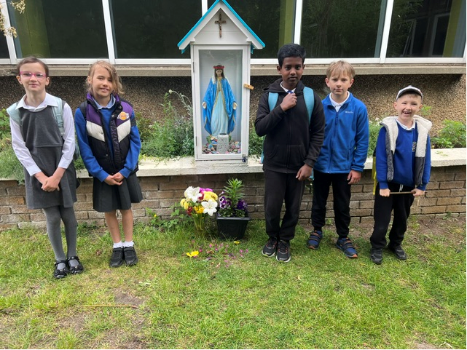

Minnie Vinnies Mass – St Patrick’s Church, Wednesday 3rd June 10am

Well done to the 6 pupils from P3-6 who represented our Minnie Vinnie group at Mass with the Archbishop on Wednesday. The hope is that over the coming year, our group will work in partnership with the Society of St Vincent de Paul at Our Lady’s Currie and St Cuthbert’s to support our parish and local community.

Here is a link to a short film of the day, the Society of St Vincent dePaul gave us to share:

https://www.instagram.com/reel/DZKq18uNLVL/?utm_source=ig_web_copy_link&igsh=MzRlODBiNWFlZA==

Please also see a phot of the day below too:

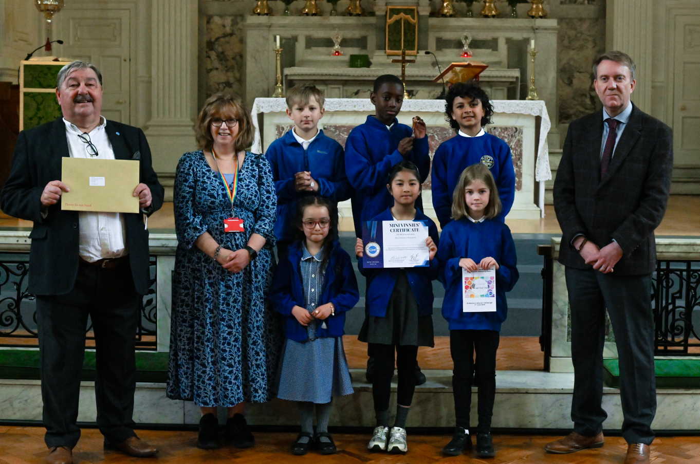

Sacrament of First Holy Communion – Sunday 14th June 9.30am

We look forward to this celebration at St Cuthbert’s Church and the children have been working really hard with Mrs Peake to prepare. Dress code for the day is entirely up to the choice of parents. One row per child will be reserved for families. Fr Francis asks that all pupils be seated by 9am on the day.

Nursery News

We have had such an incredibly exciting and busy time lately, filled with wonderful learning adventures both inside the nursery and out in our garden.
Beautiful Butterflies
This week, we said goodbye to our nursery butterflies as we released them into the garden. It was a magical moment for the children, and it has sparked so much wonderful creativity. Our quiet areas have been buzzing with children doing beautiful drawings and paintings of our fluttery friends.

We're Going on a Bear Hunt!
Our Book of the Month, We're Going on a Bear Hunt by Michael Rosen, has been a Huge hit. The children have fully embraced the story, leading to lots of brilliant bear-related play. Out in the garden, they have been marching through the "long wavy grass" during our garden bear hunts, and they even helped build their very own special bear cave outside. Inside the nursery, the excitement continues with a fantastic small world zoo setup, allowing for all kinds of mini animal adventures.

Dates for the Diary
For our families with children moving on to Primary 1 in August, we have some very important and exciting transition events coming up very soon:
- St Cuthbert's P1 Induction Day
  - When: Next Wednesday
  - Time: 1:30 pm – 2:30 pm
  - Where: St Cuthbert’s Church Hall

- Annual Transition Picnic
- When: Next Thursday
- Time: 12:30 pm
- Where: Get set up in the school field. A lovely chance to celebrate together before the big move!

- Nursery Graduation
  - When: Friday 26th June
  - Time: 12:30 pm
  - Details: Nursery Garden. Come and watch our amazing big girls and boys graduate.

It is such an exciting time of year, and we cannot wait to share these special milestones with you all. Thank you for your continued support!

Finally

We wish you and your families a restful and relaxing weekend.

Mr P Brack, Head Teacher and all at St Cuthbert’s School

