 Newsletter 36 – Friday 19th June 2026
CARES We are: Creative Active Respectful Equal Supported

Dear all

Thanks for reading this week’s Newsletter, the second last of the term.

Please see below our regular list of news and events, as always please ask if you have any questions (admin@st-cuthberts.edin.sch.uk or 0131 443 2621)

Upcoming Events at St Cuthbert’s and Dates for your Diary

This Term’s Remaining Dates for your Diary including Details for Final Day
- Friday 19th June – End of Session Reports to be issued in paper form
- Tuesday 23rd June - Leavers’ Assembly, 2pm in Church Hall
- Wednesday 24th June – Sending home of pupil jotters and folders - all pupils work apart from P1-6 writing jotters will be sent home on this day. It should fit in school bags but please give your child an additional carrier bag if you think that would be helpful.
- Friday 26th June – Final Day of Term: P7 Leavers’ Parade 12.10pm. All classes will return to school for 12pm. P1-6 will be lined up outside perimeter of playground. P7 will process with piper from the front door out of main gates and back through P1 gate, finishing back at main entrances. P1/2 pupils can be collected from their lines at 12.20pm and P3-7 from their lines at 12.30pm.

Parent Council Update

World Cup Summer Fair Update

Thanks to all those who came along to last week’s enjoyable event. The excellent total of £751 was raised at this event, all of which will be used to enhance the school experience of our pupils.

Contacting Our Parent Council

Should you wish to contact the Parent Council at any time, they can be contacted via e-mail at ptastcuthberts@gmail.com

News & Information

Weekly Building Update from City of Edinburgh Council Facilities Management

Project works required for the two-storey block have been approved and will
start to be mobilised on site from 1st July. It is anticipated that the works will be completed within three to four months, this includes all the required redecoration and new flooring. Progress updates will be provided.

The design solution for the single-storey block (two classrooms and the corridor) is in progress, corrective works are required. Once confirmed and approved these works will commence without delay, at that stage an overall timeframe can be provided for re-occupancy of the school, every effort is being made to ensure this happens as soon as is practicably possible.

As a reminder, the current arrangements to decant the P1-P4 children to St Peter’s Primary School will remain in place for the start of the new term. There will be a change for P5-7 children as they will no longer be placed at St Augustine’s High School. Instead, P5 children will be allocated to St Peter’s Primary School and P6 & 7 will be allocated to vacant classrooms within Canaan Lane Primary school which is next door to St Peter’s. This arrangement will provide opportunities for the St Cuthbert’s children to come together in shared spaces within the host schools.

Mark Stenhouse, Manager, City of Edinburgh Council Facilities Management

First Holy Communions

Congratulations to our First Communicants who did so well on Sunday. We hope you and your families had a great day. Thanks so much to Fr Francis, our parish music group, our parents and carers and Mrs Peake for their support. See picture below. Thanks to Amaka for her help with this!

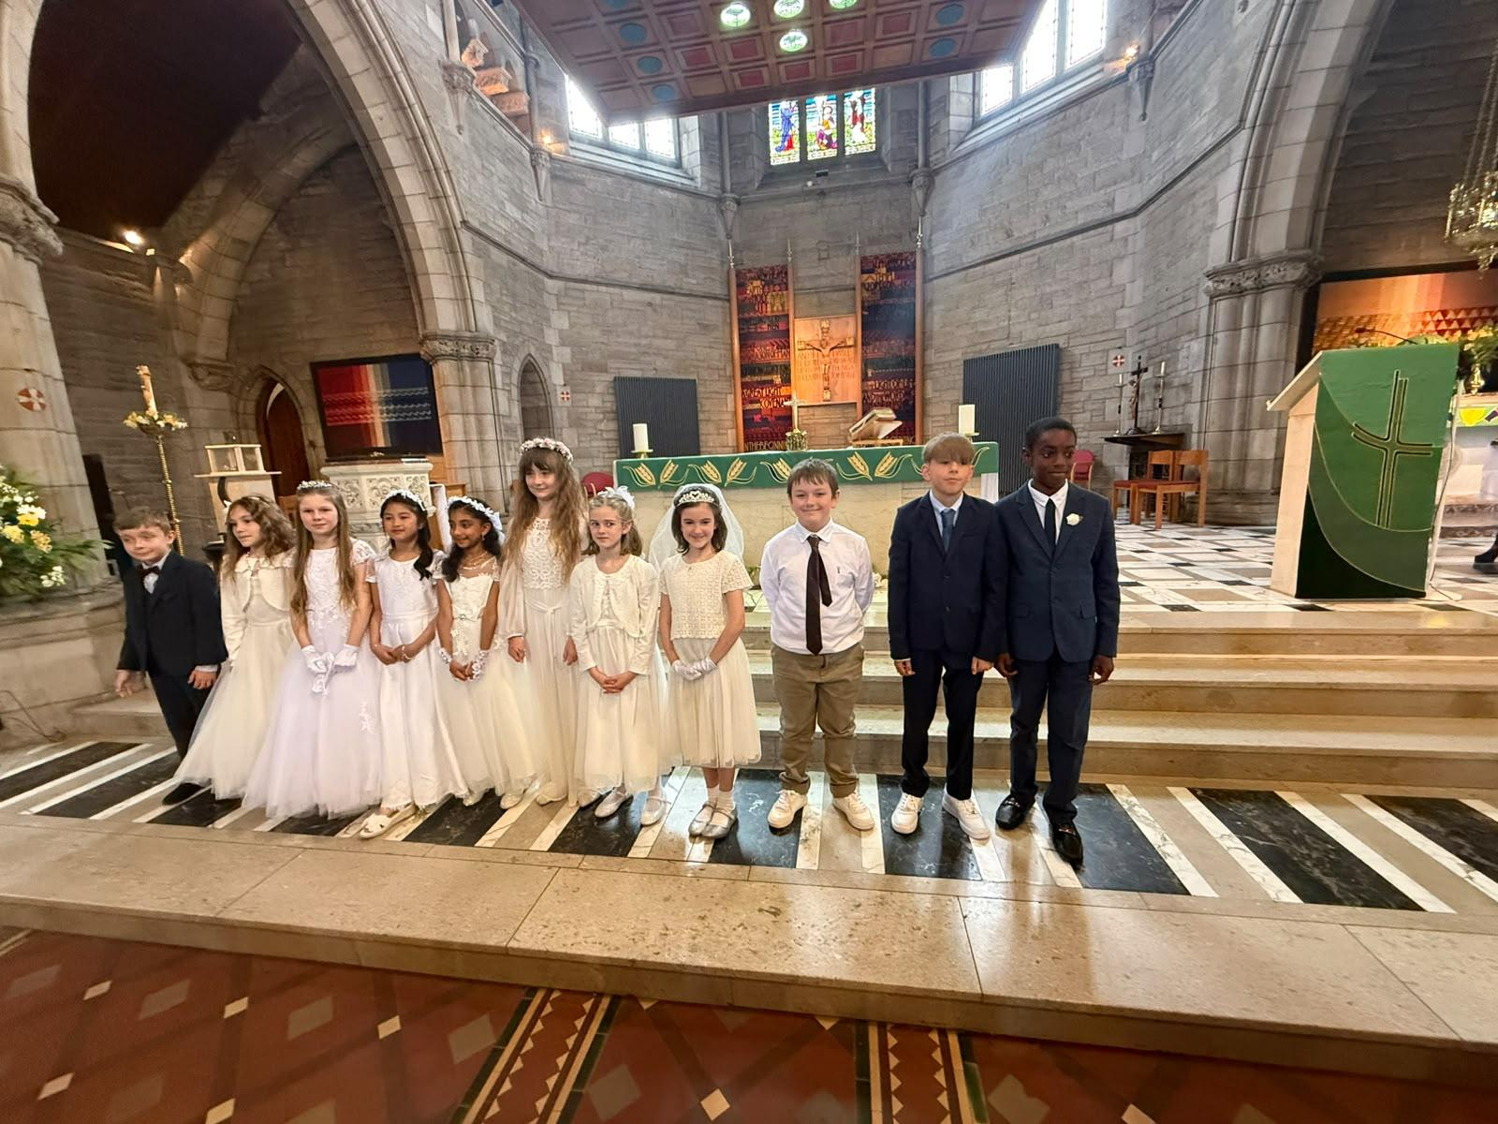

Staffing and Transition - Update

All pupils met their new teacher this week on Monday and Tuesday and Mrs Igoe visited next year’s P1s in Nursery on Wednesday. A staffing update was also sent out on Wednesday. Please ask if you have any questions.

Pupil Support Officer

Nicola Collins, Pupil Support Officer who worked with us fortnightly this year will join us weekly on a Wednesday from next term and adds to a very strong staff team for next year.

End of Session Reports Issued Today

These were issued today. Please fill in the parent and pupil feedback sheet if you have time to do so and hand back to the office, myself, Mr Crowley or your child’s class teacher. We are always keen to hear your views.

Learning Community Dance Showcase at St Augustine’s

Thanks to all of our performers who took part in Tuesday night’s event. Thanks also to Miss Tulloch who managed to prepare the children really well despite our changed circumstances.

P7 Leavers’ Party

Thanks to the parents/carers who organised this event so professionally. The children had a great time.

Website Update

In May our website had 2,439 views from 520 separate visitors. Thanks for supporting our website.

Pupil Leadership and Learning at St Cuthbert’s

P7 Transition Week

The annual three day visit was completed on Thursday. We hope the children found it helpful. Please contact your child’s Secondary School with any questions.

P1 Transition Communication

As promised at our recent P1 Induction Meeting, we will send out an email to all parents of carers of next year’s P1 class with a link to a video of the journey to St Peter’s and what the school and class looks like. There will also be the option of a short transition visit on the second in-service day.

P3 Theatre Trip and Outdoor Afternoon

P3 had a great time on Thursday visiting the Playhouse Theatre in the morning for a puppet show themed around Bluey, the children’s cartoon. In the afternoon they made a visit to Bruntsfield Links. A lot of walking but they all had a great time!

Effort Champions

This week’s effort champions are Thanks to all of them for their hard work and positive examples this week.

Catholic Education and Parish Update

Thank You to Fr Francis and the Parish

The school would like to put on record, its sincere thanks for all of the help we have received from Fr Francis and the parish this year and particularly since the decant. It has been a great demonstration of the power of the link between Catholic schools and parishes. We are so grateful.

Continuing Rosary for the Intentions of the School and its Community – Now on a Friday at 8.40am

Thanks to all those who took part again this morning. Let’s keep asking Our Lady to intercede for the quickest possible return to our own school buildings. Please see a photo from last week of those who took part:

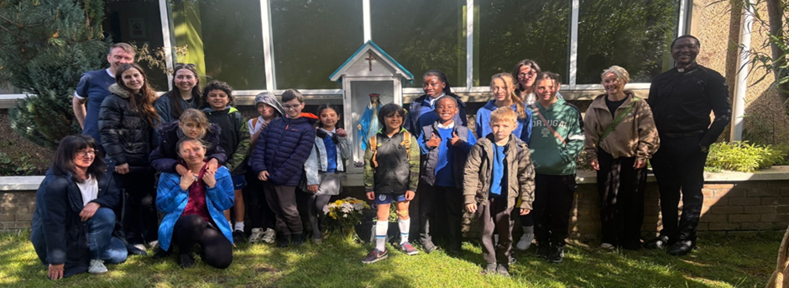

Sacrament of First Holy Communion – Sunday 14th June 9.30am

See above comments and photo in News Section.

Nursery News

Faye will return to Nursery from 10th August and Rachel’s last day as Acting SEYO will be Friday 7th August 2026. Thanks to Rachel for all of her work, she has been great! We also look forward to Faye’s return with all the skills and experience she has to offer.

Exploring in the Sunshine!
We have been loving our recent community walks! A particular favourite for the children has been Saughton Park. There is so much wonderful open space for everyone to run around, play games, and explore. The children have also turned into fantastic little nature detectives, collecting lots of interesting leaves, twigs, and natural treasures along the way!
A Fond Farewell to Beccy
This week, we said a bittersweet goodbye to our Early Years Officer, Beccy. She has left the nursery to embark on an exciting new career journey with the NHS! While we will all miss her dearly, we are so incredibly proud of her and will be keeping in touch to hear all about her new adventures. We wish you all the very best, Beccy!

Big Steps Ahead: Nursery Graduation!
For our oldest children, the countdown to starting primary school has officially begun! Graduation is just around the corner, and we are so proud of everything our school leavers have achieved.

Our special Graduation Ceremony will take place next Friday at 12:30 PM. Families of our graduating children are most welcome to join us to celebrate this wonderful milestone. We cannot wait to see you there!
Have a fantastic weekend, everyone!

Finally

We wish you and your families a restful and relaxing weekend.

Mr P Brack, Head Teacher and all at St Cuthbert’s School

