 Newsletter 3 – 28th August 2026
CARES We are: Creative Active Respectful Equal Supported

Dear all

Thanks for reading this week’s Newsletter which contains lots of important information for parents and carers. We would also like to reassure our Nepalese families that our thoughts and prayers are with them at this time.

Please see below our regular list of news and events, as always please ask if you have any questions (admin@st-cuthberts.edin.sch.uk or 0131 443 2621)

Contacting Us This Term

We are still in the process of setting up a new phone land-line for the duration of our stay in St Peter’s and Canaan Lane. Until such times as this is operational please continue to contact admin@st-cuthberts.edin.sch.uk or call mobile via 07889997680
Collecting Pupils from Canaan Lane
Please come to St Peter’s School Office if you wish to collect a P6 or P7 pupil from Canaan Lane or drop them off after an appointment etc. Thank you.

Parent Council Update

First Meeting of the Term Today

Thanks to those who attended today. Minutes will be shared next week. Next meeting takes place online on 9th October 2026 at 11.15am on Team. Please contact the Parent Council to receive a link to the meeting.

Contacting Our Parent Council

Should you wish to contact the Parent Council at any time, they can be contacted via e-mail at ptastcuthberts@gmail.com

Parent Council Church Rep – Vacancy

Sylwia, our highly committed Parent Council Church Rep has completed her 3 year term and would be happy for someone to step up and take her place. Please contact school if you wish to put your name forward. Thank you.

News & Information

Key Dates for This Term (until October Break)

- Monday 31st August: P1-5 Meet the Teacher, 1.20-2.20pm St Peter’s Primary
- Friday 4th September – Termly Overviews from August to Christmas to be shared electronically.
- Monday 7th September: P6-7 Meet the Teacher, 1.20-2.20pm Canaan Lane, please come to St Peter’s Office initially.
- Thursday 10th September, P5 Class Mass, 2pm St Cuthbert’s Church
- Week Commencing 5th October – Parent Consultations, days to be confirmed next week, St Cuthbert’s Church Hall.

Meet the Teacher and the See the Classroom – Monday 31st August (P1-5 St Peter’s) and Monday 7th September (P6&P7, Canaan Lane)

If you would like to see your child’s new classroom and meet their teacher, there is a drop-in session available from 1.20-2.20pm on the above dates. Please come to St Peter’s Office for all classes/both schools, where Mr Brack or Mr Crowley will direct you to the correct location. Please do not go directly to Canaan Lane.

Fortnightly Building Update from City of Edinburgh Council Facilities Management

All works continue to be on schedule. Notification of Construction has been received and is displayed within the school. The final draft of PCI has been received 27th August. All steel work on order with expected delivery week commencing 7th September. Site cabins and storage containers are scheduled for 1st September with mobilisation of the cabin electricity supply scheduled also. Works will also commence for the removal and storage of furniture w/c 1st September. The work has been split into 2 phases. Phase 1 being the 2 storey and phase 2 the remainder of the school. All updates at present refer to phase 1. We are still engaging with the consultant on the design for phase 2. The hope is that both phases will run concurrently.

Mark Stenhouse/Sandy Rintoul, Managers, City of Edinburgh Council Facilities Management

Confirmation of Sacramental Dates

Reconciliations – Thursday 18th March, 6pm St Cuthbert’s Church

First Holy Communions – Sunday 30th May, 9.30am St Cuthbert’s Church

Confirmations – Friday 21st May, 7pm St Cuthbert’s Church

Homework Survey

We’ll be sending out a Microsoft Form to capture parental views re homework next week. The plan is for homework to start on week commencing 14th September.

Website Help Appeal

If anyone is able to help us with the school website this year, we’d very much welcome your support. Please email or call school mobile. Thank you.

Message for P7 Parents from St Thomas of Aquins High School

P6 and 7 primary school parents within the catchment area of St Thomas of Aquin’s are invited to experience a morning at St Thomas of Aquin’s RC High School in September and October 2026:
Up to 80 P6 and 7 Primary school parents are invited to visit St Thomas of Aquin’s on each of the following dates: Friday 18th of September, Friday 25th of September and Friday 2rd of October from 11.30-1.00pm to experience our school at work. Each Friday morning will involve meeting the HT in the staffroom for an initial coffee/tea, a tour of the school by the S6 Leadership Team and then a Qand A session for 20 minutes in a classroom. Why Fridays and why during the school day? Parents will get a direct experience of our school community and be able to feel and see our school in action.
If you are a P6 or P7 parent within our catchment area then please email St Thomas of Aquin’s Admin@st-thomasaquins.edin.sch.uk and please give the following information: Name of parent, Name of pupil and Primary school, Date of visit:

Pupil Learning and Leadership at St Cuthbert’s
,
Edinburgh Schools Football Representative Team Trials

Good luck to those attending September’s trials.

Book Bus

The Mobile Library Book Bus came to St Peter’s on Thursday to allow our pupils to borrow books as they would normally do back at St Cuthbert's.

Assembly and Effort Champions

Congratulations to all of this week’s champions who will celebrate their success with Mr Crowley on Monday. We look forward to celebrating more success next Friday.

P6 iPad Allocation – Up and Running Next Week

Andrew McArthur from City of Edinburgh Council Digital Team will support setup of these iPads on Tuesday 1st September. Thanks to all for returning the responsible use forms.

School Improvement Plan – Parent Version

This will be shared via website by end of next week.

Staff Training This Week – Forward Planning

This week, our staff met after school to discuss a consistent, school wide forward planning approach for the year’s learning across the 8 areas of the curriculum. It was a great session and we thank Fr Francis for the use of the meeting room in the parish house.

Meta-Skills in Learning at st Cuthbert’s

Next Friday P7 will lead an Assembly on Skills Scotland Meta skills. These are life skills that are developed via everyday learning activities and the idea is that we introduce these into ever lesson alongside Learning Intentions and Success Criteria.

Catholic Education and Parish Update

Class Masses This Year

The plan is for each class to lead a Mass over the course of the year. The idea is that this year, these will be attended by the class and their parents only to maximise the classes’ leadership and the prayerfulness of the occasion. We need to meet with the clergy at both St Peter’s and St Cuthbert’s to establish the best way to do this. We will keep you informed. I am hoping to meet Fr Francis on Monday to finalise these plans.

Parish Bulletin Challenge

P7 created illustrations for the parish bulletin this week. This was as part of a Literacy, summarising lesson using this week’s Gospel as a text.

Mary Garden Rosary for Swift Return of School to our own St Cuthbert’s Building – Every Friday at 8.30am All Welcome!

Thanks to those who attended today despite the weather! All welcome next week.

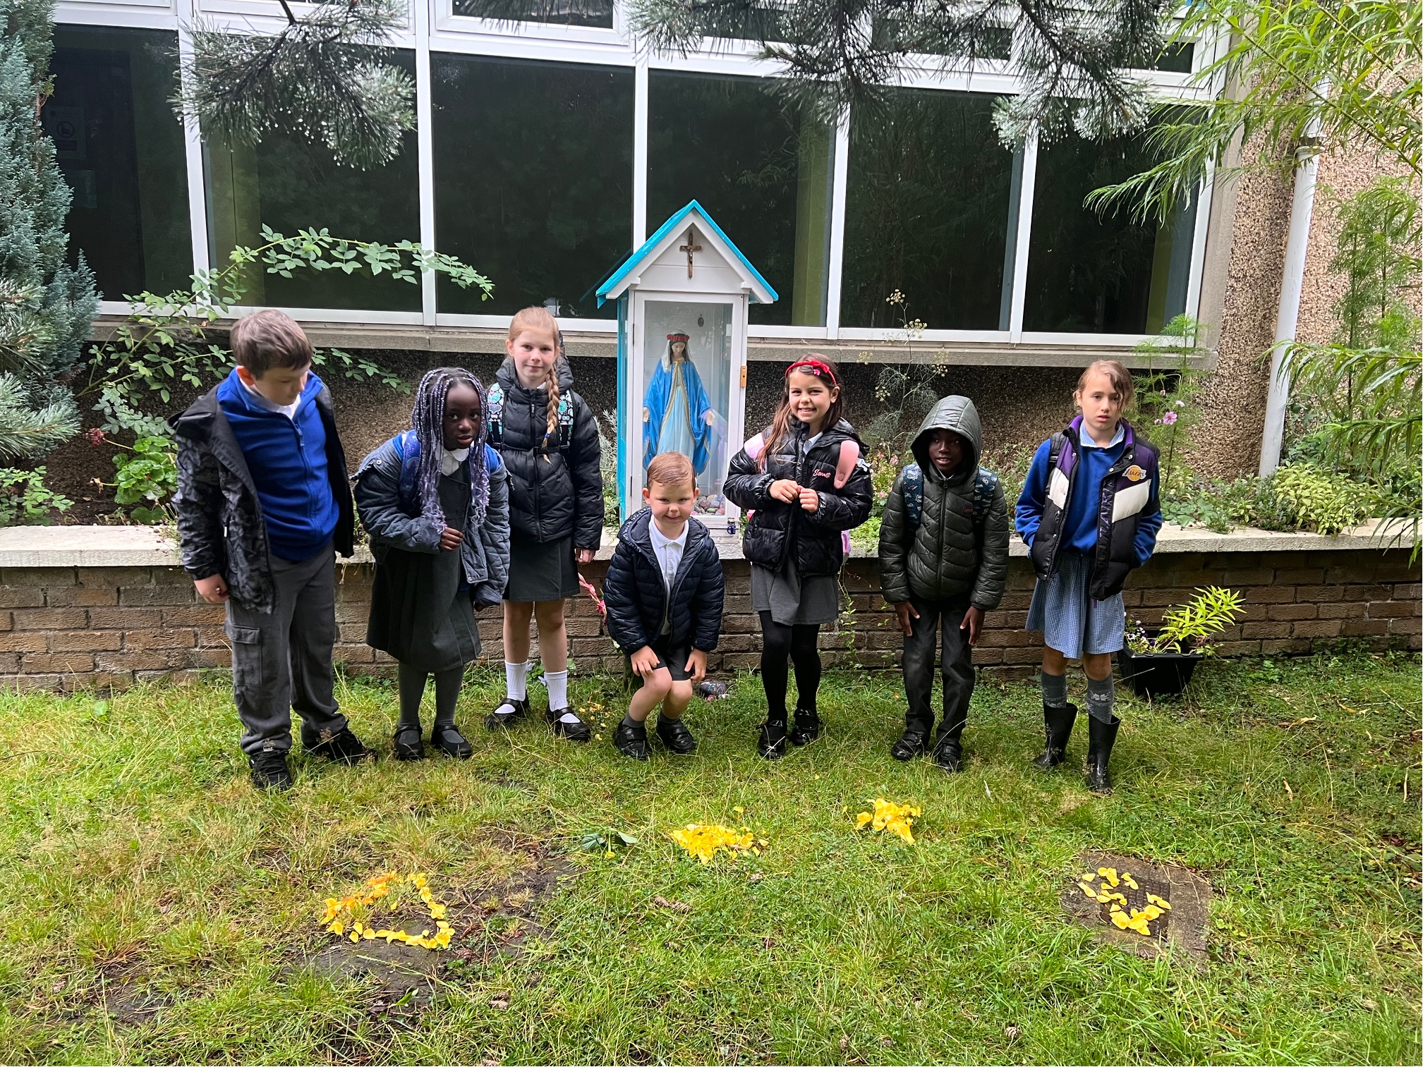
Nursery News

We have had an incredibly busy, creative, and muddy week at nursery! The children have shown fantastic teamwork, amazing imagination, and a wonderful drive to learn new skills. Here is a look at what we have been up to:

Knights, Castles, and Fairytales!
The children have completely immersed themselves in the world of castles, knights, kings, and queens! We have been reading classic fairytales together, which has sparked so much wonder and storytelling.
Using lots of recyclable materials, the children even worked together to build their very own grand castle. It has been fantastic to see their creativity and engineering skills come to life!

Winter Garden Prep!
We have also been super busy getting our nursery garden ready for the colder weather. This meant pulling on our wellies, grabbing our spades, and doing some serious digging! It is a dirty job, but the children absolutely love working hard outside.

Welcoming New Friends
We are absolutely delighted to continue welcoming new children to our nursery family. Our returning children have been so kind and caring, helping our new friends settle in and show them how the nursery works.

Growing Our Independence
We are super proud of how hard all the children are working on mastering our daily nursery routines. They are becoming so independent! We are currently focusing on:
- Hanging up our own jackets
- Navigating toilet routines confidently
- Putting on our wellies for outdoor play
- Washing our own plates after eating
- Helping ourselves to our daily snacks

A Friendly Reminder About Messy Play
Nursery life is full of wonderfully messy adventures—whether we are digging, painting, sand baking, running, or jumping! To help us keep your children comfortable, please remember:
- Wear play clothes: Please dress your children in outfits you do not mind getting a bit dirty.
- Pack a full change: Keep a complete set of spare clothes (socks, pants, tops, and trousers) on your child's peg in case they need to get changed after a big adventure.

Thank you so much for your continued support at home. Have a wonderful weekend!

Finally

We wish you and your families a restful and relaxing weekend.

Mr P Brack, Head Teacher and all at St Cuthbert’s School

