 Newsletter 5: 11th September 2026
CARES We are: Creative Active Respectful Equal Supported

Dear Parents and Carers

Thanks for reading this week’s Newsletter, which includes important information for parents and carers.

Monday Holiday – Edinburgh September Weekend

Please be reminded that Monday 14th September is a holiday across all Edinburgh Schools. School resumes at the normal time on Tuesday 15th September.

Contacting Us This Term – School Landline Now Working Again

Our school phone land-line is operational again, and parents can now call as they did previously on 0131 443 2621 and select the appropriate option. You can also continue to contact us using admin@st-cuthberts.edin.sch.uk

Parent Council Update

Contacting Our Parent Council

Should you wish to contact the Parent Council at any time, they can be contacted via e-mail at ptastcuthberts@gmail.com

Our Next Parent Council Meeting

Our next meeting will be online via MS Teams and is due to be held on Friday 9th October at 11.15am on Teams. Please contact the Parent Council if you would like to take part in this meeting and they will provide you with a link to join the meeting.

Parent Council Church Rep – Vacancy

Sylwia, our highly committed Parent Council Church Rep has completed her 3 year term and would be happy for someone to step up and take her place. Please contact school if you wish to put your name forward. Thank you.

News & Information

Key Dates for This Term (until October Break)

- Tuesday 29th September – P7 Only Parent Consultations, 4-6pm Nursery Building
- Thursday 1st October – P1-6 Parent Consultations 1, 4-6.30pm St Cuthbert’s Church Hall
- Tuesday 6th October – P7 Only Parent Consultations, 4-6pm Nursery Building
- Thursday 8th October – P1-6 Parent Consultations 2, 4-6.30pm St Cuthbert’s Church Hall

Active Schools Clubs Information

Plans for these are well advanced and we hope to share these too. The idea is for most clubs to start week commencing 28th September 2026.

P1 Evening News Photo

This took place on Thursday 10th September at St Peter’s. Mrs Pennycook in the Office has shared details re how to order a souvenir copy of the paper including the photo.

Flu Immunisations

These took place on Thursday 10th September for P1-7. Thanks to all those who returned their forms so promptly. Please let us know if you have any questions about the immunisations.
Fortnightly Building Update from City of Edinburgh Council Facilities Management

To provide clarification on the project phases. Phase one being the two-storey building and phase two the remainder of the school. Investigation commenced initially into the two-storey building, which has been progressed without delay, the other parts of the school were investigated later. As such the two-storey building will be completed first, see the latest update below. Phase two design is expected to be completed early next week, once the specification is agreed and costed, it will progress ASAP. It is planned in the next update to share the overall programme timeframe, with expected completion of the entire project and handover back to the school.

Phase one update - steelwork was delivered to the supplier premises on 28th August, where fabrication of the steelwork commenced on 7th September (8-day programme). In preparation for the steelwork arriving on site, scaffolding is programmed to be erected 14th/15th with delivery of the steel on 17th. Cranage & lifting follows on 21st/22nd and steel erection starts on 23rd of this month. Stakeholder communications will be key during this phase, including traffic management protocols. There will be major deliveries/plant on site to facilitate the offloading of the steelwork, but this is planned between 0930 and 1430 when school pupils are not on campus.

Mark Stenhouse/Sandy Rintoul, Managers, City of Edinburgh Council Facilities Management

Parent Homework Survey

Thanks to those who responded to the survey. We have also surveyed our pupils and staff. We will use all of this information to formulate a plan for homework this year, whilst we remain outside of our own school building. This will be communicated to all stakeholders next week.

Pupil Learning and Leadership at St Cuthbert’s
,

Maths Week Scotland – Monday 21st to Friday 25th September

We have a range of learning activities planned for this week, whose theme this year is ‘Maths Matter – Why Maths Count’. This will also include a Maths Week Sumdog Challenge. Look out for more details on our website nearer the time.

Class Blog Posts Return from Friday 18th September

As above, all classes will resume their class blogs on the above date. Apologies for the delay with this, we have being trying to work out how to set these pages up for the new year on our website.

Climate Week – 28th September to 4th October

All classes will be taking part in learning a range of activities linked to this Learning for Sustainability goal.

Transition Teacher Working with P7 Pupils from 30th September

Mrs McCallum, our Transition Teacher from St Augustine's High School will be starting with us again soon on Wednesday afternoons. Her focus this year will be supporting the teaching of reading as well as getting to know our pupils and supporting them as part of their transition to secondary school.

Rights Respecting School – Article of the Month, Article 42

Both school and Nursery are currently focusing on this article which asks that everyone (in our school community) is aware of children’s rights. We discussed this at Assembly today. Thanks to P7 for their help with this work.

P6 Outdoor Learning Festival Trip – Tuesday 8th September

P6 had a great time at Holyrood Park on Tuesday.

More Trips to Come

Look out for letters and information re more upcoming trips:

- P3 visiting Swanston Farm
- P4 visiting Craigmillar Castle
- P7 visiting Edinburgh Castle

P7 House Captains – Voting to Happen on Monday 21st September

On the above date, all pupils will get the chance to hear speeches from our House Captains and then vote for their representatives.
Building Resilience – HWB Learning

This term, our classes will be working on Building Resilience Unit 2: Keep Connected. Children will explore the importance of positive relationships and learn how staying connected to friends, family and trusted adults helps them feel supported and confident. We will be encouraging pupils to recognise the people who help them, practise healthy communication, and understand how strong connections contribute to their overall wellbeing.

School Improvement Plan – Parent Version

This has now been uploaded to the website. Please ask if you have any questions.

Wider Achievement

Congratulations to Joshua and Alan who took part in trials for the all Edinburgh Primary Select representative team at Meggetland on Wednesday.

Thanks to all of those who celebrated their wider achievement at Assembly today too.

Catholic Education and Parish Update

Class Masses This Year – P5 First Class Mass

Thanks to those who attended on Thursday. Big thanks also to Dorothy for the music and to Fr Francis for saying Mass. P5 did a great job.

Confirmation of Sacramental Dates for School Year 2627

Reconciliations – Thursday 18th March, 6pm St Cuthbert’s Church

First Holy Communions – Sunday 30th May, 9.30am St Cuthbert’s Church

Confirmations – Friday 21st May, 7pm St Cuthbert’s Church

Mary Garden Rosary for Swift Return of School to our own St Cuthbert’s Building – Every Friday at 8.30am All Welcome!

Thanks to those who attended today. Remember that all are welcome to pray for the repair of our building.
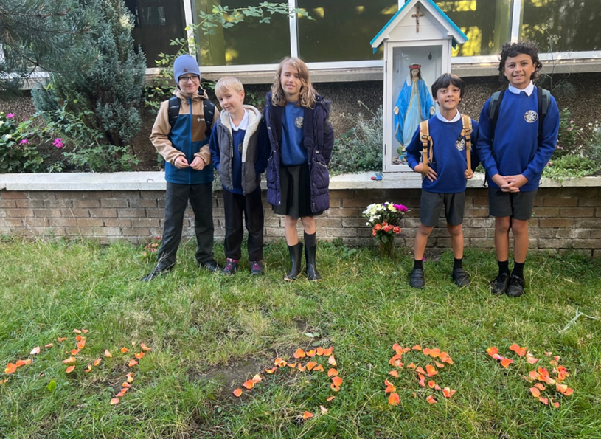

Nursery News

We have had another wonderful, busy week at St Cuthbert's Nursery! The children have been exploring new skills, tasting delicious food, and sharing beautiful memories of their home lives.
Superstar Safety: Our Fire Drill Champions!
We were so incredibly proud of the children this week because they practiced their very first fire drill of the term, and they did an absolutely fantastic job. Afterwards, we sat down together to talk about what to do in an emergency and even listened closely to the sound of the alarm. Now, everyone knows exactly what it sounds like and what to do. The children learned that as soon as they hear that sound, they need to quickly line up at the gate and walk sensibly across the school field to stay safe. They were all so calm and mature throughout the whole experience!

Kitchen Magic: Courgette Fritter Frenzy!
Meanwhile, George’s cooking club is truly going from strength to strength. This week, we had a wonderful visit from one of our nursery mummies who came in to make some delicious courgette flower fritters with the children. The mouth-watering smells drifted through the nursery all day, making everyone very hungry! The children got to try them for their snack, and the reports coming back have been brilliant—they absolutely loved them. If you would like to come and cook with the children, or if you have any other skills you could share with us, please speak to one of the team or drop us an email! We would absolutely love to have you involved.

Branching Out: The St Cuthbert’s Family Tree

Lastly, we have noticed such a lovely interest in families lately, which was sparked by all the wonderful parents sending in family photographs. These have now become a beautiful, permanent part of our St Cuthbert's Family Tree display. The children have been absolutely fascinated by it, and they love going over to point out their loved ones and share proud stories about their families with their friends and teachers.
If you would like to send a family photograph, there is still plenty of time! You can share your picture with us by uploading it on Learning Journals, emailing it to stcu-nurmail@st-cuthberts.edin.sch.uk , or simply handing a physical copy to any member of the nursery staff.
Thank you so much to everyone who has contributed so far!

Finally

We wish you and your families a restful and relaxing holiday weekend.

Mr P Brack, Head Teacher and all at St Cuthbert’s School

