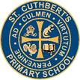 Newsletter 6: 18th September 2026
CARES We are: Creative Active Respectful Equal Supported

Dear Parents and Carers

Thanks for reading this week’s Newsletter, which includes important information for parents and carers.

Contacting Us This Term – School Landline Now Working Again

Our school phone land-line is operational again, and parents can now call as they did previously on 0131 443 2621 and select the appropriate option. You can also continue to contact us using admin@st-cuthberts.edin.sch.uk

Parent Council Update

Contacting Our Parent Council

Should you wish to contact the Parent Council at any time, they can be contacted via e-mail at ptastcuthberts@gmail.com

Our Next Parent Council Meeting

Our next meeting will be online via MS Teams and is due to be held on Friday 9th October at 11.15am on Teams. Please contact the Parent Council if you would like to take part in this meeting and they will provide you with a link to join the meeting.

News & Information

Key Dates for This Term (until October Break)

- Tuesday 29th September – P7 Only Parent Consultations, 4-6pm Nursery Building
- Thursday 1st October – P1-6 Parent Consultations 1, 4-6.30pm St Cuthbert’s Church Hall
- Tuesday 6th October – P7 Only Parent Consultations, 4-6pm Nursery Building
- Thursday 8th October – P1-6 Parent Consultations 2, 4-6.30pm St Cuthbert’s Church Hall

Information was sent out re Parents' Evenings’ on Wednesday and Thursday of this week. Please contact the office with any questions. We have had some feedback re issues with link for P7 Consultations, we will ensure that this issue is addressed on Monday. Apologies for any confusion.

Active Schools Clubs Information – Booking Now Open

Booking form was shared this week. It’s great that despite our current challenges that we have managed to get some clubs organised. Thanks to our parent volunteers, Mr Crowley and Fiona, our Active Schools Coordinator for their hard work organising this and thanks to all who have signed up so far. There are still spaces. Please contact us with any questions.

Homework and Weekly Website Blogs

A communication was sent out re Homework this week. This will resume on Friday 25th September and will be issued electronically every Friday for completion by the following Thursday.

We have had some issues updating our website at the start of this year, but thanks to Carla, one of our parents, we now have it fully updated and class posts will resume on the Class Updates page of the website from this Friday. Please note posts may appear any time between 1pm and 5pm.

Open Day for Prospective Parents of P1 Pupils in August 2027 – Tuesday 4th November
The school is in discussion with City of Edinburgh Council re best way to organise this operationally. We hope to share more information next week.
School Christmas Cards

As we have done these last few years, we will be asking pupils to design their own Christmas Cards again this year. The children received this information on Wednesday and we also want to share the following information:
- Friday 25 September – Artwork will be sent home to parents
- Thursday 1 October – Artwork needs to be returned to school so that we can send it off to Cauliflower Christmas Cards, who produce the cards.

Violin Teacher
Mrs Egan hopes to return this week. Please ask children to bring their instruments on their usual day.
Effort Champions
Congratulations to this week’s winners: Cora, Dike, Gaja, Anto, Luca, Zosha, Maggie and Joshua
Online sessions on How to Keep Children and Young People Safe Online
In partnership with Police Scotland's Cybercrime Harm Prevention team, Parenting Across Scotland is hosting two online sessions for parents and carers to learn about the risks of the online world, and how to keep children and young people safe. The webinars, which will take place on 23 September, will include presentations from Police Scotland and Education Scotland.
Find out more

Pupil Learning and Leadership at St Cuthbert’s
,

Class Trips

P4 had a great time at historic Craigmillar Castle on Thursday, Mrs Kelly asked me to thank all of our parent volunteers who supported our staff and pupils with the trip.

Look out for letters and information re more upcoming trips:

- P3 visiting Swanston Farm on 28th September
- P4 visiting Oriam for a Multisports Festival next week
- P7 visiting National War Museum on 5th October

P7 House Captains – Voting to Happen on Monday 21st September

On Monday afternoon, all pupils will get the chance to hear speeches from our House Captains and then vote for their representatives

P5 & P4 Swimming Update

We have been in discussion with City of Edinburgh Council re funding for buses to take our pupils from St Peter’s to Forrester High School in February and May 2027 and hope to have more news to share soon.

Maths Week Scotland – Monday 21st to Friday 25th September

We have a range of learning activities planned for this week, whose theme this year is ‘Maths Matter – Why Maths Count’. This will also include a Maths Week Sumdog Challenge. Look out for more details on our website nearer the time.

Climate Week – 28th September to 4th October

All classes will be taking part in learning a range of activities linked to this Learning for Sustainability goal.

Transition Teacher Working with P7 Pupils from 30th September

Mrs McCallum, our Transition Teacher from St Augustine's High School will be starting with us again soon on Wednesday afternoons. Her focus this year will be supporting the teaching of reading as well as getting to know our pupils and supporting them as part of their transition to secondary school.

Rights Respecting School – Article of the Month, Article 42

Both school and Nursery are currently focusing on this article which asks that everyone (in our school community) is aware of children’s rights. We discussed this at Assembly today. Thanks to P7 for their help with this work.

Wider Achievement on a Friday at Assembly

Thanks to all of those who celebrated their wider achievement at Assembly today. We had a high number of volunteers today which was great! If your child has any medals, trophies, musical instruments they play or books they have read, please encourage them to celebrate this achievement by bringing them into Assembly on a Friday, where they will have the chance to show the school and describe their achievement.

Catholic Education and Parish Update

Confirmation of Sacramental Dates for School Year 2627

Reconciliations – Thursday 18th March, 6pm St Cuthbert’s Church

First Holy Communions – Sunday 30th May, 9.30am St Cuthbert’s Church

Confirmations – Friday 21st May, 7pm St Cuthbert’s Church

Mary Garden Rosary for Swift Return of School to our own St Cuthbert’s Building – Every Friday at 8.30am All Welcome!

Thanks to those who attended today. Remember that all are welcome to attend and pray for the repair of our building.

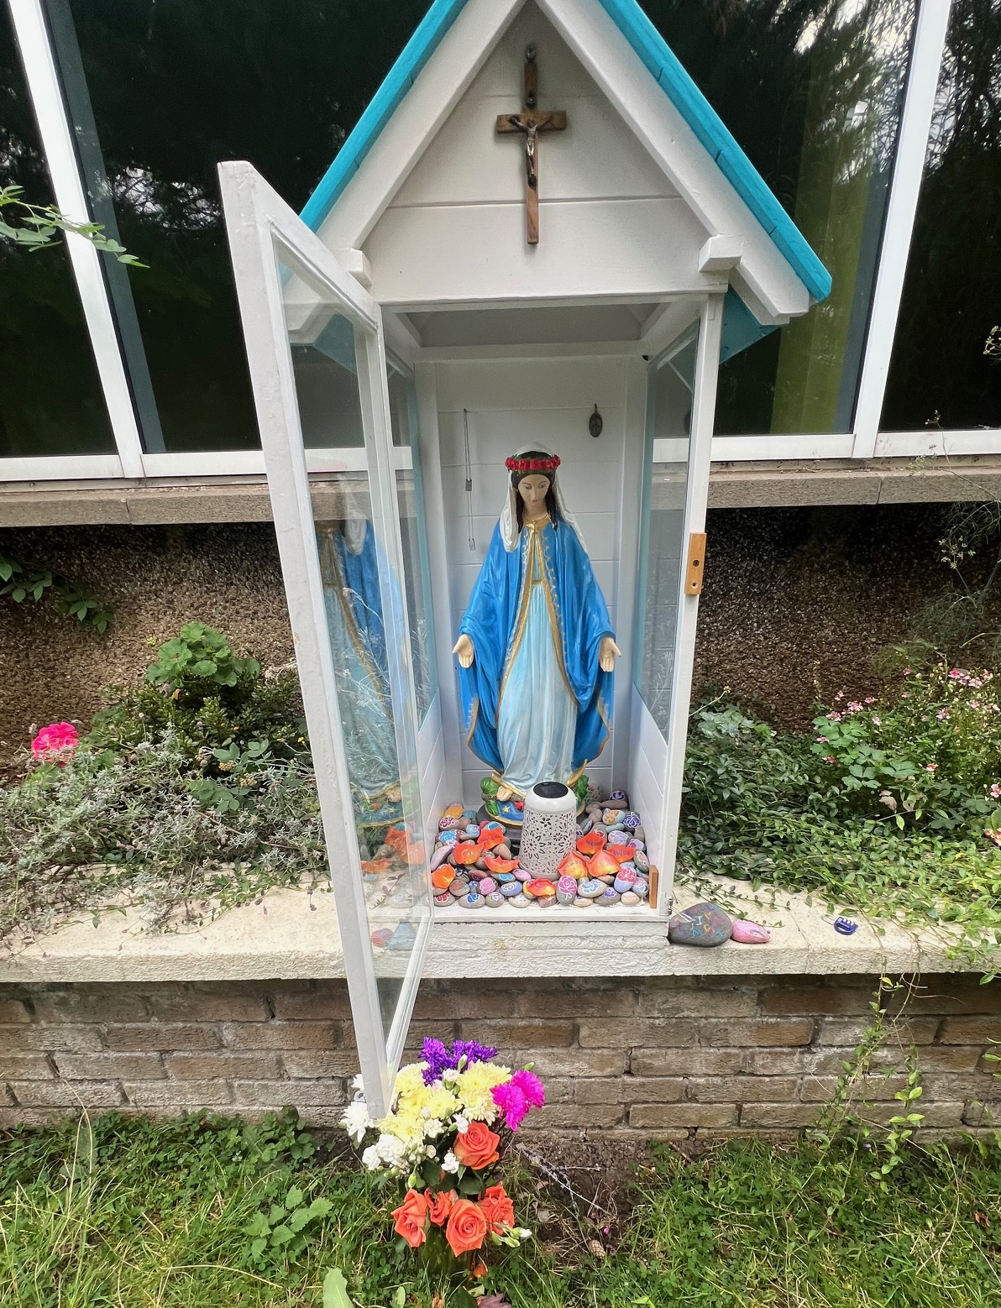

Nursery News

Updates will resume next week.

Finally

We wish you and your families a restful and relaxing holiday weekend.

Mr P Brack, Head Teacher and all at St Cuthbert’s School

