 Newsletter 8: 2nd October 2026
CARES We are: Creative Active Respectful Equal Supported

Dear Parents and Carers

Thanks for reading this week’s Newsletter, which includes important information for parents and carers, particularly in relation to Homework and progress with building repairs. Happy Nigerian Independence Day, to our Nigerian Community too!!



News & Information

Key Dates for This Term (until October Break)

- Tuesday 6th October – P7 Only Parent Consultations, 4-6pm Nursery Building
- Thursday 8th October – P1-6 Parent Consultations 2, 4-6.30pm St Cuthbert’s Church Hall

An email was sent out this week re translators, please contact us if you need a translator for Parents Consultations’ taking place next Tuesday (P7) and Thursday (P1-6).

If you want to consult with Mrs Peake, our Support for Learning Teacher and were not able to visit on Thursday 1st October, please email Admin@st-cuthberts.edin.sch.uk to make a separate appointment.

Building Update from City of Edinburgh Council Facilities Management

These will resume next Friday, 9th October. In the meantime, the school and parent representatives have passed on views re the need for February completion deadline to be met, regardless of any weather or other issues that arise and have requested some additional staffing support to help with learning recovery to compensate for lost learning time occasioned by travel. In response, City of Edinburgh Council have agreed to support funding of a Teacher to support learning recovery on Mondays and Fridays after the October Holiday. They have also passed on our request re Overtime and Weekend working, which Facilities Management have agreed to look at in terms of feasibility and likely impact.

Active Schools Clubs Information – Most Clubs Started This Week, More to Come!

Most clubs started this week. We have some spaces available in Gaelic Football, P4/5 football, Karate and Mini-kickers.

Please also look out for a link to booking for cricket club which will be shared next week. We are also planning a Lunch Time club for Multisports later in the month. Look out for a booking link either just before or after October break.

Homework Update

Thanks for bearing with us, as we move to a new way of doing homework. Please keep feeding back any issues you are experiencing. We will be refining and standardising our Class Teams and guidance for Homework as part of our training and development work on Inservice Day. Please note that as many of our reading books are trapped in St Cuthbert’s building that we are having to be creative with the reading elements of homework. Please ask if you have any questions.

Drop in Open Day for Prospective Parents of P1 Pupils in August 2027 – Tuesday 4th November – St Cuthbert’s Church Hall 9.30am to 2.30pm
Please feel very welcome to come along and meet our Class Teacher, Administrator and Head Teacher to learn more about St Cuthbert’s school and ask any questions you have before applying for a place at our school. You can come at any time between 9.30am and 2.30pm.
School Christmas Cards

As we have done these last few years, we will be asking pupils to design their own Christmas Cards again this year. The children received this information on Wednesday and we also want to share the following information:
- Thursday 1 October – Artwork was to be returned to school so that we can send it off to Cauliflower Christmas Cards, who produce the cards. If you haven’t managed to meet the deadline but can get artwork returned by Monday 5th October, we will do our best to help it be accepted. We can’t accept any entries after this.

Violin Teacher Update

Mrs Egan is likely to be absent over the coming weeks. The Music Department within City of Edinburgh Council are working hard to source a replacement. We will keep you posted as to progress with this. In the meantime, Cello continues as usual.
Effort Champions
Congratulations to this week’s winners: Arvid, Anabel, Aayansh, Ada, Gabi, Weronika and Ayvan. Thanks to all of them for their hard work this week!

Pupil Learning and Leadership at St Cuthbert’s
,
P6 Learning Discussion

I met with pupils from P6 on Tuesday and we discussed all aspects of their learning, including reviewing their jotters and classwork. It was an instructive meeting, helping to produce productive areas of focus going forward. The pupils involved were all articulate and engaged with the life of the school. Thanks to all involved.

In-Service Day – Training Focus

On Monday 19th October, we will focus on:

- Training Staff in use of Teams and Kanva
- Awareness of Sustainable Development Goals
- Journalling to improve Writing skills
- The Building Resilience HWB Programme
- Discussion as to most impactful use of new Pupil Support Officer and Recovery Teacher.

Pupil Support Officer After October Holiday.

Samm Hamilton will join us as a replacement for Nicola Collins from after the October break. She will be with us weekly on alternate Mondays and Fridays starting Friday 30th October. We look forward to working with her.

P3 Class Trip to Swanston Farm

Well done P3, who had a great time at Swanston Farm – a trip that they will always remember! They were also really patient waiting for a number 4 bus that could take all of their class too! Huge thanks to Miss Tulloch, Mrs Skelly and our Parent Helpers for making this day happen.

P2 & P3 Visiting Churchill Theatre for ‘The Buttons Show’

Primary 2 and Primary 3 will be visiting the Church Hill Theatre to see "The buttons show" on Wednesday x November. The show is a fun-filled Scottish pantomime adventure featuring magic, storytelling and lots of singalongs, encouraging children to join in and become part of the performance.
This opportunity will allow learners to develop their creativity and experience the joy of live performance. #Article 31 – The right to relax, play and take part in cultural and artistic activities."

Other Upcoming Trips Scheduled

- P6 visiting Astley Ainslie grounds for Outdoor Leaning with the Green Team on Tuesday 6th October.
- P7 visiting National War Museum on 5th October

Fire Service – Firework Safety Visit to P7

The Fire Service visited us at Canaan Lane yesterday to give a talk on Fire Safety as Bonfire Night approaches. The class were also given the chance to view apparatus used by Fire Service personnel.

Climate Week – 28th September to 4th October

All classes took part in learning a range of activities linked to this Learning for Sustainability work. Sustainable Development Goal 13: Climate Action

Transition Teacher Now Working with P7 Pupils

Mrs McCallum, our Transition Teacher from St Augustine’s High School started with us on Wednesday. She will focus on teaching Reading skills but will also spend time getting to know our pupils. She will then support our transition planning and process after Christmas as we build towards the childrens’ departure for Secondary.

Wider Achievement on a Friday at Assembly

Thanks to all those who shared their Wider Achievement at Assembly today. Remember pupils can bring in trophies, medals, books, art and craftwork, musical instruments or any other achievements from outside of school hours.

Catholic Education and Parish Update

Confirmation of Sacramental Dates for School Year 2627

Reconciliations – Thursday 18th March, 6pm St Cuthbert’s Church

First Holy Communions – Sunday 30th May, 9.30am St Cuthbert’s Church

Confirmations – Monday 31st May, 7pm St Cuthbert’s Church. This has been rearranged as original date set by Archdiocese conflicted with return date from school camp. It is very close to Communions date but is the only other date that they can manage.

Children’s Liturgy Update: St Cuthbert’s Parish Church

See below.

Children's Liturgy at St Cuthbert's Church

We have had fewer children attending Mass recently at St Cuthbert's Church and would like to enourage parents to bring their children along especially on the weeks when we run the Children's Liturgy. Below are the Liturgy dates for the coming weeks.

October/November

Sunday October 4th
Sunday 18th October
Sunday 1st November
Sunday 15th November,

Advent- every week

Sunday 29th November
Sunday 6th December
Sunday 13th December
Sunday 20th December

If your child is shy about coming into the Liturgy room it is perfectly ok for an adult to accompany them to begin with. Children attending should be of school age
Many thanks to all those who do atttend the Liturgy on a regular basis and we look forward to seeing more children returning over the coming weeks.

Dorothy Johnstone
School/Church Liturgical Coordinator

Class Masses

Dates for the remainder of the Year have been shared with Fr Francis and we will share these with parents/carers via Newsletter next term.

Mary Garden Rosary for Swift Return of School to our own St Cuthbert’s Building – Every Friday at 8.30am All Welcome!

Thanks to those who attended today. Remember that all are welcome to attend and pray for the repair of our building. See this week’s photo from Sylwia, our rosary leader below:

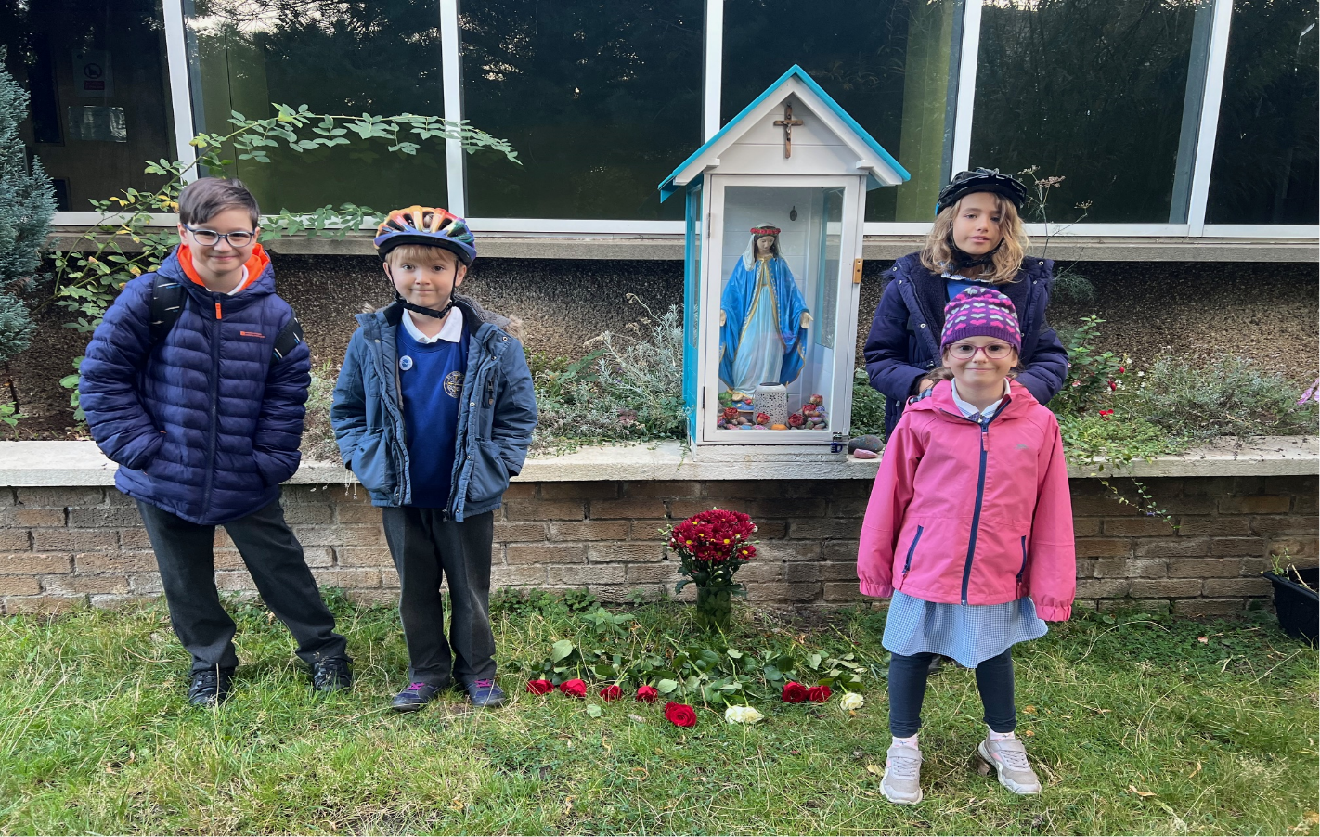

Nursery News

Autumn Sensory Fun

Autumn is officially upon us, and we have had a fantastic, action-packed week at nursery! The children have been diving into the new season by exploring beautiful autumn sensory materials on our tuff tray.

Jet-Setting Back to Our Summer Adventures

The summer holidays must still be on everyone's minds! This week, we became world travellers by making our own passports. The children looked closely at their reflections to draw wonderful self-portraits for their passport pictures and loved sharing stories about their summer adventures.

Snap, Crackle, and Pop Playdough

We have had some lovely sensory experiences creating all different sorts of playdough with unexpected ingredients. Rice Krispie playdough was a massive hit—there was lots of Snap, Crackle, and Pop! in the room!

Zooming Around with Our Dream Machines

Out in the garden, the children have been motorbike crazy! We used blocks and loose parts to build our own custom motorbikes and loved racing them around the garden.

Nursery Parent Consultation Evening

Wednesday 7th October 2026 | 3:30pm – 5:30pm
This evening is a wonderful opportunity to meet with your child’s Key Worker, discuss their progress report, and strengthen our partnership to support your child’s learning both here and at home.
Quick Tips for Your 10-Minute Slot
- Plan Ahead: Time flies! Write down any questions in advance. You can even ask your child if there is anything they want you to bring up.
- Keep Big Issues Separate: If you have a larger concern, please don't wait for Parents Evening. Speak to a team member at drop-off/pick-up so we can give it dedicated time.
- Follow Up Anytime: If you run out of time, don't worry! We can always chat at the door or book a follow-up meeting.
How to Book Your Appointment
If you haven’t secured your slot yet, please speak with a member of the team as soon as possible. Appointments are allocated on a first-come, first-served basis.

Packing for Puddles: Autumn Clothing Reminder

As the weather turns crisp and we continue our outdoor adventures, please ensure your child comes to nursery with appropriate clothing for the season.
What Your Child Needs to Bring:
- Warm Outdoor Wear: A cosy, waterproof coat and sturdy shoes or wellies for puddle-jumping.
- A Full Change of Clothes: A complete set of spare clothes (including socks and underwear) kept in your child's bag. Sensory play and autumn mud can get messy, and we want to ensure everyone stays warm and dry!
Please Label Everything

Please remember to label all items with your child's name so they don't get mixed up. Thank you for your continued support!

Finally

We wish you and your families a restful and relaxing weekend.

Mr P Brack, Head Teacher and all at St Cuthbert’s School

