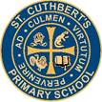 Newsletter 9: 9th October 2026
CARES We are: Creative Active Respectful Equal Supported

Dear Parents and Carers

Thanks for reading this week’s Newsletter, the last of this first term. Thank you for your support during this period.

News & Information

Key Dates for Next Term

We will give teachers the chance to feedback on proposed dates over the first week of next term and then share with you in second Newsletter of term on Friday 30th October 2026.

Building Update from City of Edinburgh Council Facilities Management

The project remains on schedule for completion by the end February 2027, note this includes the re-occupation plan to have all the classroom furniture and teaching materials/equipment in place. The Property team will work on the detail of the plan in the coming weeks with the Head Teacher and the wider Education team.

The team are confident that the project completion target will be met. The one risk factor we have over winter is severe weather, if we did have this worst-case scenario, every available option would be considered to avoid any delay.

Parent/Carers Consultations and Feedback Survey

Thanks so much to all parents who have attended Parents’ Consultations over the last two weeks. We hope you found the meetings informative and helped you support your child’s learning.

See below, link to Parent Carer Survey for Term 1:

St Cuthbert's Parent Feedback Survey – Fill in form
Nursery Entrance Gate

Please ensure that if you are using this that gate, including hasp at top is closed and bolt drawn over when you leave playground.
Parent Council Information

Meeting Today

Thanks to all those who attended meeting today. Minutes will be shared in the first week of next term.

Halloween Disco

A flyer with information was shared with families on Monday – see a copy of the flyer below and a letter from Parent Council went home with all pupils on Thursday. Please note that £4 suggested payment can be made by bith cash and card. Please contact Parent Council with any further questions:

Contact details are: ptastcuthberts@gmail.com

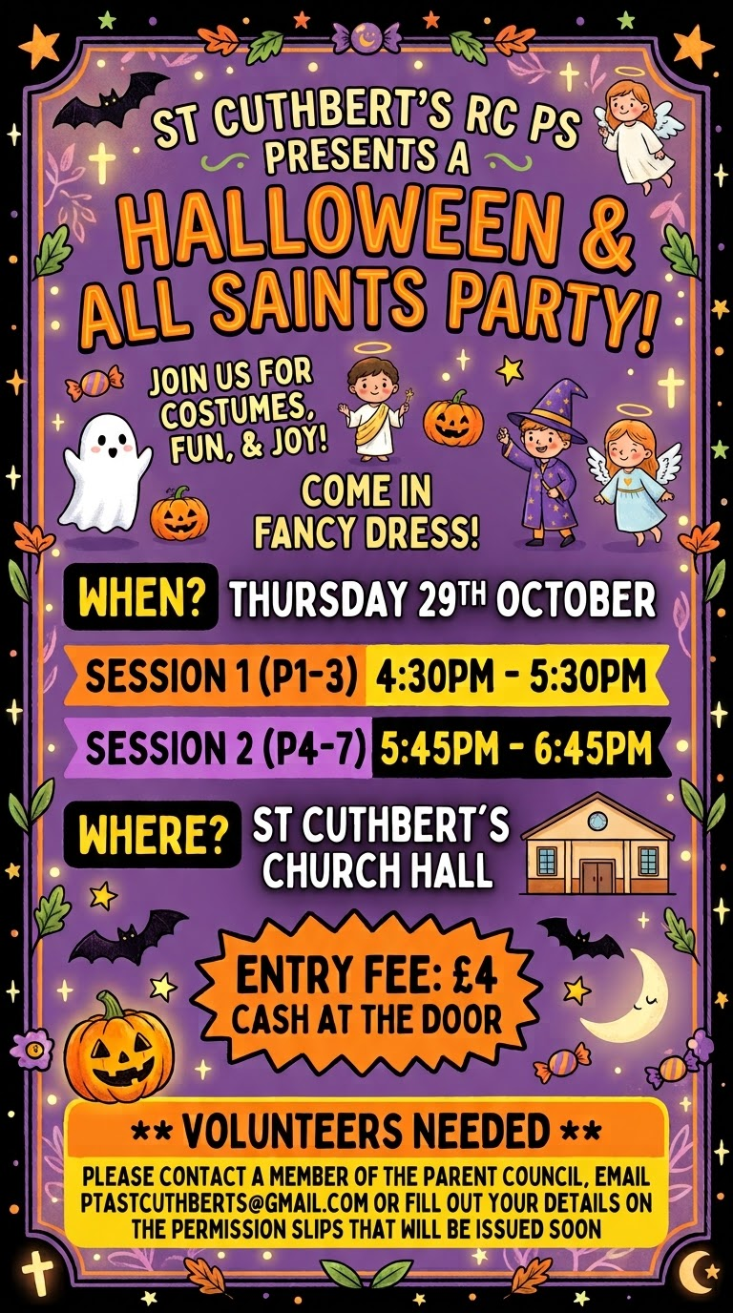
Active Schools Clubs Information – More Clubs to Come after October Break

Most clubs started this week. We have some spaces available in Gaelic Football, P4/5 football, Karate and Mini-kickers.

Links were also shared this week for new Cricket and Multisports Clubs

Homework Update and 'Drop in' Support Session

No homework this week as we have holidays coming up. Thanks to those who have contacted us with issues re logins etc, please continue to do so. Our staff team will discuss our processes re Homework on the Inservice Day on Monday 19th October and continue to streamline the process. Hopefully after the holidays, things will be a lot clearer. We will also provide a 'how to' hand out and a drop-in support session in our Nursery Building on Thursday 22nd October from 3.30-4pm.

Drop in Open Day for Prospective Parents of P1 Pupils in August 2027 – Tuesday 4th November – St Cuthbert’s Church Hall 9.30am to 2.30pm
Please feel very welcome to come along and meet our Class Teacher, Administrator and Head Teacher to learn more about St Cuthbert’s school and ask any questions you have before applying for a place at our school. You can come at any time between 9.30am and 2.30pm to ask questions and find out more about our school and how P1 works.
School Christmas Cards

Thanks to all those who have purchased their child’s Christmas Card designs, we expect the cards to arrive by late November for distribution to families. We’ll keep you posted.

Instrumental Teacher Update

Mrs Egan is likely to continue to be absent over the coming weeks. The Music Department within City of Edinburgh Council are working hard to source a replacement. We will keep you posted as to progress with this. In the meantime, Cello continues as usual.
On a positive note, Cello is continuing weekly with Mr McVinnie and his P6 and P7 students. He is currently working with groups of P5 pupils to help him create a new group for that class. We will keep you informed as to our progress.
Effort Champions
Will resume next term
Diwali and Christmas Celebrations
Plans are currently being worked on to ensure Diwali is celebrated this year as we usually do. More information to follow after the break.
Christmas celebration details will also be shared after the holidays.
Breakfast Club
It has been great to see an increase in our Breakfast Club numbers this term. Please note however that in order for your child to attend Breakast Club that you must book before the Wednesday of the preceding week (in the same way that you do for Parent Pay meals). Please ask if you have any questions.

Pupil Learning and Leadership at St Cuthbert’s
,
In-Service Day – Training Focus

On Monday 19th October, we will focus on:

- Training Staff in use of Teams and Canva
- Awareness of Sustainable Development Goals and the 4 ‘Cs’ of Learning for Sustainability
- Journalling to improve Writing skills
- The Building Resilience HWB Programme
- Pupil Voice and Leadership at St Cuthbert’s
- Discussion as to most impactful use of new Pupil Support Officer and Recovery Teacher.

House Captains

All of our House and vice Captains received their new badges today. They have made a great start in their new roles.

Sharing Assembly

Every month we have a curricular sharing Assembly, this week saw P2 and P3 sharing information re their leadership of HWB in the school. P7 pupils also informed us of this months UNCRC Rights focus and reiterated the 4 Metaskills we have been focusing on this term.

Pupil Support Officer After October Holiday.

Samm Hamilton will join us as a replacement for Nicola Collins from after the October break. She will be with us weekly on alternate Mondays and Fridays starting Friday 30th October. We look forward to working with her.

Educational Trip Information

Trips this week included:

- P7 visiting National War Museum on 5th October
- P5 and P6 visiting Astley Ainslie grounds for Outdoor Leaning with the Green Team on Tuesday 6th October.
- P2 & P3 visiting the Churchill Theatre for the Buttons Show

Upcoming Trips

More Trips are Planned for Next Term

- P5 are planning to visit The Kelpies as part of their Mythical Creatures topic
- P6 are planning to visit the Water of Leith Centre for their Jacobites topic
- P3 & P4 are planning to visit the Odeon Cinema as part of their STEM Learning.

House Captains

House Captains were presented with their badges at Assembly today.

Transition Teacher Now Working with P7 Pupils

Mrs McCallum, our Transition Teacher from St Augustine’s High School started with us on Wednesday. She will focus on teaching Reading skills but will also spend time getting to know our pupils. She will then support our transition planning and process after Christmas as we build towards the childrens’ departure for Secondary. Look out for more details soon re a Drop In Session and Open Evening with Mrs McCallum after the October Break.

Wider Achievement on a Friday at Assembly

Thanks to all those who shared their Wider Achievement at Assembly this term. Please continue to encourage your child to bring in any trophies, medals, art and craftwork, books, instruments or any other evidence of out of school achievement they wish to share with the wider school community.
Catholic Education and Parish Update

Confirmation of Sacramental Dates for School Year 2627 – Please note Change re Confirmation Dates

Reconciliations – Thursday 18th March, 6pm St Cuthbert’s Church

First Holy Communions – Sunday 30th May, 9.30am St Cuthbert’s Church

Confirmations – Monday 31st May, 7pm St Cuthbert’s Church. This has been rearranged as original date set by Archdiocese conflicted with return date from school camp. It is very close to Communions date but is the only other date that they can manage.

Children’s Liturgy Update: St Cuthbert’s Parish Church

We have had fewer children attending Mass recently at St Cuthbert's Church and would like to enourage parents to bring their children along especially on the weeks when we run the Children's Liturgy. Below are the Liturgy dates for the coming weeks.

October/November

Sunday October 4th
Sunday 18th October
Sunday 1st November
Sunday 15th November,

Advent- every week

Sunday 29th November
Sunday 6th December
Sunday 13th December
Sunday 20th December

If your child is shy about coming into the Liturgy room it is perfectly ok for an adult to accompany them to begin with. Children attending should be of school age
Many thanks to all those who do atttend the Liturgy on a regular basis and we look forward to seeing more children returning over the coming weeks.

Dorothy Johnstone
School/Church Liturgical Coordinator

Class Masses This Year

Dates for the remainder of the Year have been shared with Fr Francis and we will share these with parents/carers via Newsletter next term.

Minnie Vinnies Group October Rosary

Our Mini Vinnies group (linked to the Society of St Vincent de Paul) taught the school about the October rosary at Assembly last Friday. This week, the representatives has been reminding all classes about our commitment to pray one decade of the rosary per week during this month.

Mary Garden Rosary for Swift Return of School to our own St Cuthbert’s Building – Every Friday at 8.30am All Welcome!

Thanks to those who attended today. Remember that all are welcome to attend and pray for the repair of our building. See this week’s photo from Sylwia, our rosary leader below:

Nursery News

Thank You for Your Feedback!
Hello nursery Families,
First, a huge thank you to everyone who attended our Parent Consultations this past Wednesday! It was wonderful catching up with you all and sharing your children's amazing progress.
We also want to extend a massive thank you to all the families who took the time to complete our nursery questionnaire. Your insights and feedback are incredibly valuable to us. We are currently correlating the results and look forward to sharing the feedback and our next steps with you very soon!
Below is the rest of our exciting weekly update, including our cosmic adventures and mini-chefs in action.

Out of This World Adventures!
Our little explorers have developed a huge fascination with outer space this week. We have been busy watching educational videos about the solar system and singing catchy space songs that have us all dancing.
To bring our learning to life, the children crafted their very own planets using salt dough! They loved getting their hands messy and used this creative opportunity to proudly share all of their fantastic knowledge about stars, rockets, and the planets. Ask your little astronaut to tell you a space fact tonight!

Active Garden Games
Out in the garden, we’ve been focusing on developing our physical skills. The children have been working hard on their eye-hand coordination by shooting basketball hoops and aiming beanbags at targets. It has been wonderful to see their focus, determination, and teamwork as they cheer each other on!

George's Cooking Club: Pizza Party!
A huge shoutout to George’s Cooking Club, who took over the kitchen this week! The children transformed into mini-chefs, working just like they were in a real pizzeria. They made their own dough from scratch, kneaded it like pros, and added their favourite toppings. The final verdict? It was absolutely delicious!

Finally

We wish you and your families a restful and relaxing weekend.

Mr P Brack, Head Teacher and all at St Cuthbert’s School

